Class Copy

Directions: Read through the following article while filling out your Religion Organizer. Even though it is a class copy, feel free to annotate (mark/highlight) the document as you see fit. Make sure though that students in other class periods can still read the words a.k.a. try to restrain yourself from espousing your love for Justin Bieber to the point where it covers up all the words…. Yes, this includes you Cam Sietz.

This article is written for high school students so the answers won’t always stand out. It is recommended that you complete a religion before you move onto the next one. It is okay to use a computer or your phone to look up any words that you don’t know.

Judaism: Origins and Development
The world religions that arose (started) in the Middle East—Judaism, Christianity, and Islam—share some common traits (things). The most important is monotheism [monotheism: belief in one God], the belief in a single, all-powerful God. They also believe in prophets, holy people who revealed (first told) the word of God. One important prophet in all these religions is Abraham, known as the father of the Jewish people.
The early history of Judaism is shrouded in the mists of time (we don’t really know a whole a lot about them). Most scholars believe, however, that Abraham was a real person who was born some 4,000 years ago in Mesopotamia (an ancient civilization in the Middle East). According to Jewish storties, God visited Abraham one day and made a sacred agreement, or covenant [covenant: a sacred agreement], with him. Abraham promised that he and his descendants would follow God’s teachings and God promised to love them. Abraham’s descendants were known as the Israelites, sometimes called the Hebrews. They were the ancestors of the Jewish people.
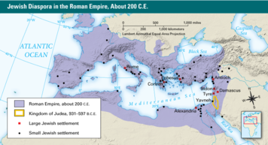
Military defeat at the hands of the Romans contributed to the exile (bing kicked out) of most Jews from their ancient homeland. By 200 C.E. (cupcakes existed!), Jewish communities could be found settled throughout the area of the Roman Empire, in the Middle East, Europe, and Africa.
According to the Torah [Torah: Judaism’s most sacred text, consisting of the first five books of the Hebrew Bible] , Abraham and his family moved to a city Canaan, later called the Land of Israel, a region of land along the eastern coast of the Mediterranean Sea. His descendants later formed the twelve tribes of Israel. The tribes traveled to Egypt to escape a famine. The Torah says that they were enslaved by the Egyptians for generations and that God performed miracles to free them. On the return from Egypt, the prophet Moses had a vision of God while praying at Mount Sinai. There, according to scripture, Moses revealed God’s laws on stone tablets. These laws, which included the Ten Commandments, would form the basis of Judaism.
The Israelites settled again in a city called Canaan, which they regarded as their “promised land.” By 1000 B.C.E., they established the Kingdom of Israel, led by kings who united the tribes of Israel. The second of these rulers, King David, made the city of Jerusalem the capital of the kingdom. His son, King Solomon, built the Temple, the most sacred place in Judaism, there.
When Solomon died, in about 930 B.C.E., the Kingdom of Israel separated into two kingdoms, Israel and Judah. Both were later invaded and conquered. The kingdom of Israel was conquered in 722 B.C.E. by the Assyrians. In 597 B.C.E., the Babylonians invaded Judah and attacked Jerusalem, then the capital of Judah. Jerusalem fell to the Babylonians in 586 B.C.E. Most of the people of Judah, now known as Jews, were forced into exile. The Babylonian Exile was the start of the Jewish Diaspora [Jewish Diaspora: the spread of the Jewish people outside their homeland, beginning about 586 B.C.E.] (die-AS-pur-ruh). From this time on, the Jewish people were dispersed across the Middle East and beyond. Other invaders, including the Romans, later colonized their land and caused more Jews to leave. Nevertheless, the Jewish religion survived. Jews both within the Land of Israel and throughout the Diaspora maintained strong connections to their homeland, stressing its importance and facing toward Jerusalem in their daily prayers.
Jewish religious leaders called rabbis, which literally means “teachers,” were crucial to the survival of Judaism. They preserved Jewish teachings and discussed ways to apply these teachings to new situations that Jews encountered. The early rabbis recorded Jewish traditions. This record eventually became the Talmud, which together with the Hebrew Bible forms the foundation of Jewish religious practice and ethical values. It includes some of Judaism’s most famous quotes, such as “What is hateful to you, do not do to your neighbor: that is the whole Torah; all the rest of it is commentary; go and study it.”
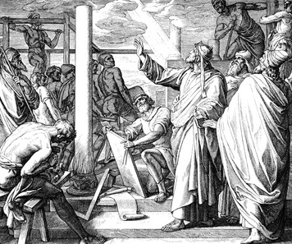
The Beliefs of Judaism The central teachings of Judaism are contained in the Torah, which makes up the first five books of the Hebrew Bible. The Torah contains the Ten Commandments, along with other teachings handed down by God to Moses.
The first commandment is central to Judaism. It says, “You shall have no other gods before Me.” This law reminds Jews of their promise to worship only one God. Judaism transmitted the idea of monotheism to the rest of the world. It contrasted with the polytheism [polytheism: the worship of multiple gods], or worship of many gods, which was typical of other religions at the time.
Another commandment requires Jews to set aside a holy day each week, called the Sabbath, for rest and prayer. This requirement later became a custom among Christians, too.
Other commandments in the Torah lay down moral values. One says, “Honor your father and mother.” Others forbid stealing, lying, or murdering. The Torah says that Jews have a responsibility to live by God’s moral teachings and make them known to the world.
Judaism also stresses the importance of equality and social justice. It teaches that God considers all people equal and says that people should be treated fairly. One passage says, “You shall open wide your hand to your brother, to the needy and to the poor.” Caring for less fortunate people in society is a basic value in Judaism.
The Spread and Influence of Judaism The troubles faced by the Jews as a result of the Diaspora threatened their survival as a people. Cut off from their roots in Israel, they had to find ways to maintain their traditions in foreign lands. For example, praying together in synagogues became a central feature of Judaism. At times, the Jews faced great persecution for their customs and beliefs.
Nevertheless, Jewish migration from Israel also helped spread the ideas of Judaism. Over the centuries, Jews settled in many parts of the Middle East, Europe, and Africa. They also made their way to Asia and, eventually, to the Americas. Although Judaism was not adopted widely among other cultures or peoples, Jews built strong communities around the world that helped preserve their culture and religion. They continued religious practices, such as studying the Torah and observing the Sabbath, that helped keep Judaism alive.
The teachings of Judaism have had a great impact on the world. The principle of monotheism influenced two other great religious traditions, Christianity and Islam. Judaism’s moral teachings and its idea of a weekly day of rest were also important influences. The emphasis on ethical conduct influenced the development of law in many lands. Jewish ideas of justice and equality also helped nurture the concept of democratic freedoms.
As a result of the Jewish Diaspora, many Jews settled in Eastern Europe. A prosperous Jewish community developed in the Czech city of Pilsner, where the Great Synagogue, shown here, was built in the 19th century.

Class Copy

Directions: Read through the following article while filling out your Religion Organizer. Even though it is a class copy, feel free to annotate (mark/highlight) the document as you see fit. Make sure though that students in other class periods can still read the words a.k.a. try to restrain yourself from espousing your love for Justin Bieber. Yes, this includes you Kendrick Laprade.

This article is written for high school students so the answers won’t always stand out. It is recommended that you complete a religion before you move onto the next one. It is okay to use a computer or your phone to look up any words that you don’t know.

Christianity: Origins and Development
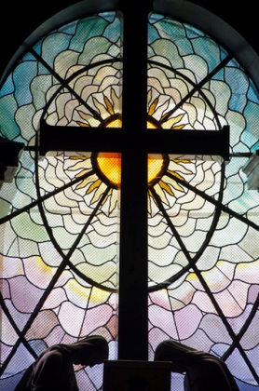
The second world religion to emerge in the Middle East was Christianity. The birthplace of Christianity was a territory at the eastern end of the Mediterranean Sea. The Romans called it Judea. It had once been a part of the ancient Kingdom of Israel. The first Christians were Jews and maintained many Jewish beliefs. They worshiped one God, valued taking care of the needy, recognized Abraham as a prophet, and believed the Hebrew Bible was holy. But Christianity soon developed its own doctrine (rules and practices) and a much larger following.
The origins of Christianity lay in the life and teachings of Jesus, considered by Christians to be the Son of God. The story of Jesus is based largely on accounts in the New Testament of the Christian Bible. Born in the Roman province of Judea about 6 B.C.E., Jesus was a Jewish teacher. When he was around 30 years old, he left home to travel across Judea and teach the word of God.
Jesus taught that God was merciful and loving and that people should love God and their neighbors. He said that those who lived according to God’s will would be forgiven their sins and relieved of suffering. The Christian Bible says that Jesus healed the sick and performed other miracles. In the process, he gained many followers. Among them were twelve special disciples known as the apostles [apostles: the twelve followers of Jesus, designated to spread his message], who were given the task of spreading Jesus’ message.
Soon, some people began calling Jesus the Messiah, or “anointed one,” chosen by God to save humankind. He later became known as Christ, the Greek term for Messiah. The Roman authorities who ruled Judea saw Jesus as a troublemaker, however. They feared that he might spark a rebellion (coup d’état) among the Jews. They arrested him and sentenced him to death.
The New Testament of the Christian Bible tells that around 30 C.E. Jesus was put to death by crucifixion, a common form of execution used by the Romans of where a person is nailed to a cross. According to the New Testament, friends placed his body in tomb (grave). The Bible says that three days later Jesus rose from the dead and then appeared to his disciples. Christians call this event the Resurrection [Resurrection: in Christian belief, Jesus' rise from the dead].
For Christians, the Resurrection proved that Jesus was a holy savior. They said that anyone who recognized him as the Messiah would enter the Kingdom of God. Although the Romans often attacked Christians, Christianity gradually spread throughout the empire. Paul, who was named an apostle after Jesus' death, played a key role by bringing non-Jews into the faith.
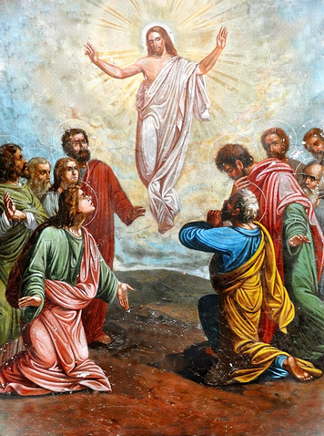
Eventually Christianity became the official religion of the Roman Empire. Over time, the Roman Catholic Church became rich and powerful. The Christian faith later divided into Catholic, Orthodox, and Protestant branches. But Christianity as a whole continued to expand.
The Beliefs of Christianity The Christian holy book is the Bible. It consists of two parts. The Old Testament is the Hebrew Bible, which Christians recognize as the word of God. The New Testament is a collection of stories and teachings written by various people who knew Jesus or played key roles in the early Christian church. The New Testament contains the Gospels, which are accounts of Jesus' life and teachings.
Christian doctrine is complex, with many different interpretations (ways of thinking about the Bible). Christianity teaches about the Resurrection and salvation. They believe that Jesus rose from the dead and lives in heaven. They also believe that God can save people from sin (from the bad things that they do) and grant then everlasting life after death. This belief is called salvation. Many Christians believe that salvation depends on God’s grace, which is God’s gift of love. This gift is said to be open to all who believe in Jesus and ask for God’s forgiveness.
Christians practice their faith by trying to follow Christ’s teachings and by observing certain customs and rituals. Many go to church on Sunday to worship and pray. They may also perform sacred rituals called sacraments. One sacrament is baptism, which makes a person a member of the Christian church. Another is Holy Communion, the symbolic sharing of bread and wine. This ritual mirrors the Last Supper, the final meal the New Testament says that Jesus had with his disciples. Christians also take part in holidays and festivals, such as Christmas and Easter, which celebrate the birth and Resurrection of Jesus.
The Spread and Influence of Christianity By the first century C.E., Christianity had spread to many parts of the Roman Empire. In later centuries, it also gained followers in Persia, China, and India. Christian missionaries carried the faith with them when they colonized Africa and the Americas. Today, Christianity is the most widely practiced religion in the world, with some two billion followers worldwide.

Class Copy

Directions: Read through the following article while filling out your Religion Organizer. Even though it is a class copy, feel free to annotate (mark/highlight) the document as you see fit. Make sure though that students in other class periods can still read the words a.k.a. try to restrain yourself from espousing your love for Justin Bieber. Yes, this includes you Sophia Whitehead.

This article is written for high school students so the answers won’t always stand out. It is recommended that you complete a religion before you move onto the next one. It is okay to use a computer or your phone to look up any words that you don’t know.

Islam: Origins and Development
Islam emerged in the Middle East in the 600s C.E., centuries after Judaism and Christianity. It grew rapidly, however, and soon became one of the world’s major religions.
Islam was taught by Muhammad, who was born in Mecca, in Arabia, in around 570 C.E. At the time, Mecca was an important trade center and pilgrimage site. A shrine in the heart of Mecca, called the Ka’bah, was filled with statues of local gods and spirits.
Muhammad became a successful and respected trader. As the years passed, however, he was increasingly drawn to spiritual matters. One day in about 610 C.E., according to Islamic teachings, Muhammad was meditating in a cave when an angel appeared before him and revealed the word of Allah, or God. The angel told him he had been chosen as Allah’s prophet, or messenger.
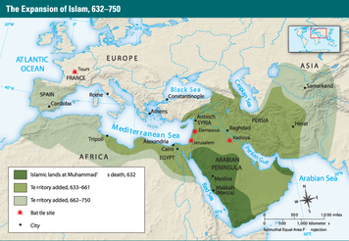
Around 613 C.E., Muhammad began to preach in Mecca. He called on Arabs to worship the one, true God. In Arabic, the word Islam means “to submit.” Muhammad’s followers became known as Muslims, meaning “those who submit to God.”
Many local leaders saw Islam as a threat to their power and prestige, however, and began to persecute the Muslims. In 622, Muhammad and his followers left Mecca and traveled to the city of Medina. There, his teachings continued to gain a following among the Arab tribes. By 630, the Muslims were strong enough to retake Mecca and establish Islam as the dominant faith of Arabia. They destroyed the statues of gods in the Ka’bah and turned it into a holy shrine of Islam.
Muhammad died in 632. But the Muslim leaders who followed continued to win converts (new followers) and expand the religion. By 750, Islam had moved beyond Arabia to become the main religion of the Middle East and North Africa. It also spread to Spain, Central Asia, and India.
The Beliefs of Islam Muslims recognize the Jewish and Christian prophets, including Abraham, Moses, and Jesus. But they regard Muhammad as the last and greatest prophet who revealed the complete message of God. They believe that the Qur’an [Qur’an: the holy book of Islam], the Muslim holy book, contains the word of God as revealed to Muhammad.
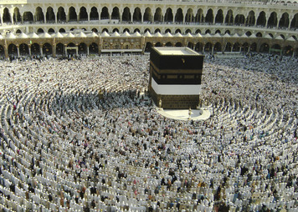
The required acts of worship for Muslims are called the Five Pillars of Islam. The first pillar is the profession of faith: “There is no god but God and Muhammad is his prophet.” This pillar emphasizes the duty Muslims have to worship one God only.
The second pillar is daily prayer. Muslims are expected to pray five times a day: at dawn, noon, mid-afternoon, sunset, and after nightfall. They kneel before God and recite verses from the Qur’an. Prayer does not have to take place at a mosque, or place of worship, but can be performed anywhere.
The third pillar is charity. Muhammad told the wealthy to share their riches with the less fortunate. Muslims are supposed to give at least 2.5 percent of their surplus wealth every year to the needy. The Qur’an says: “You will never attain righteousness until you give freely of what you love.”
The fourth pillar is fasting. The Qur’an instructs Muslims to abstain from food or drink during daylight hours for the entire month of Ramadan, the ninth month of the Muslim calendar. Fasting is meant to encourage self-control and clear the mind so that it can be filled with the spirit of faith.
The fifth pillar is the pilgrimage to Mecca, known as the Hajj, which takes place in the twelfth month of the year. This pilgrimage promotes fellowship and equality among believers. The Hajj is not required, but all Muslims are encouraged to undertake it at least once in their lifetime.
The Spread and Influence of Islam Islam continued to extend its influence over the next several centuries (hundreds of years). It spread east across South Asia to the islands of Indonesia. It moved north into Turkey and the Balkans region of Europe. It also expanded rapidly along the east coast of Africa and into the African interior, south of the Sahara.
Islam was a missionary religion, seeking to win converts (new believers), particularly in areas where polytheism prevailed (where people believed in more than one god). Muslims sometimes waged “holy war,” clashing with followers of other religions, including Christians. But they also respected Christians and Jews as people of faith and often lived alongside them in peace.
Today, with over a billion followers, Islam is the second largest religion in the world. More than a religion, however, it is a way of life. In Muslim lands, Islam has had a profound impact on culture, society, and politics.

