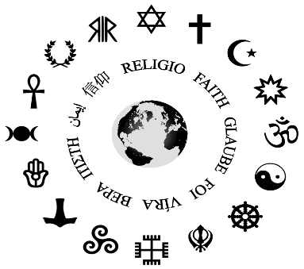
Name:_____________________________________
Core:____________
Belief Systems Project
How can belief systems shape what people think is right and wrong?
Are we more alike than we are different?
Directions: We will be studying different belief systems. You will choose a belief system from the list provided. You will then create a poster representing your belief system. You must include the following information:
Title of Belief System:_________________________________________
1) Basic Beliefs:
________________________________________________________________________________________________________________________________________________________________________________________________________________________________________________________________________________________
2) Books or writings: __________________________________________________
3) God (s)/ Goddess If Any: __________________________________________________________________________________________________________________________________________________________________________________________________________________
4) Ceremonies/Holidays : ______________________________________________________________________________________________________________________________________________________________________________________________________________________________________________________________________________________________________________________________________________________________
5) Religious Symbols

6) Key Figures in History of Faith: __________________________________________________________________________________________________________________________________________________________________________________________________________________

7) Known History of Religion:
____________________________________________________________________________________________________________________________________________________________________________________________________________________________________________________________________________________________________________________________________________________________________________________________________________________________________

8) Beliefs and Traditions Surrounding Birth and Death

____________________________________________________________________________________________________________________________________________________________________________________________________________________________________________________________________________________________________________________________________________________________________________________________________________________________________

9) Geography: Where did this belief system begin? _____________________________________________________________________Where do most of those practicing this belief system live or where did they live (shade in on map)?

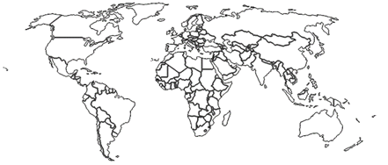

10) If this belief system is still in around today? How many people consider themselves practitioners?

____________________________________________________________

List of Resources (website, book, etc. NOT A SEARCH ENGINE)
________________________________________________________________________________________________________________________________________________________________________________________________________________________________________________________________________________________________________________________________________________________________________________________________________________________________________________________________________________________________________________________________________________________________________________________________________________________________________________________________________________________________________________________________________________________________________________________________________________________________________________________________________

Grading Name:____________________________________
Core:__________
Topic | 2 | 3 | 4
Behavioral Science | Foundational Concepts  Beliefs  Monotheism  Polytheism  Non Theism  Equality  Inequality | 3A: Explain factors that influence our thoughts and behaviors. (SS.7.13)  Guiding Question: How can belief systems shape what people think is right and wrong?  3B: Form conclusions about the causes of inequality within a society. (SS.7.14)  Guiding Question: Are we more alike than we are different?  Is everyone equal? | In addition to meeting the learning goal, the student demonstrates in-depth inferences and applications that go beyond the goal.  (Potential Level 4 Task: Create a peace proposal that would prevent different belief systems from fighting/warring. The proposal should respect different belief systems while promoting equality.
Behavioral Science SRG

IB Criterion D: Thinking Critically

Achievement Level | Level descriptor
0 | The student does not reach a standard described by any of the descriptors below.
1–2 | The student:  - begins to analyze concepts, issues, models, visual representation and/or theories in a limited way
3–4 | The student:  - completes a simple analysis of concepts, issues, models, visual representation and/or theories
5–6 | The student:  - completes a substantial analysis of concepts, issues, models, visual representation and/or theories
7–8 | The student:  - completes a detailed analysis of concepts, issues, models, visual representation and/or theories
Students should be able to analyze concepts, issues, models, visual representation and/or theories

Belief System Choices

Any Christian denomination. Ex: Catholic, Protestant, Lutheran, Baptist, etc.
Judaism
Islam
Hinduism
Buddhism
Confucianism
Shinto
Taoism
Platonism
Animism
Rastafarian Movement
Baha’i Faith
Hellenism (Greek Gods and Goddesses)
Ancient Egyptian religion
Ancient Roman Religion
Agnosticism
Atheism
Humanism
Deism
Jainism
Native American Belief Systems (Choose Any)
Aztecs
Incans
Mayans
Paganism (Any kind)
Christian Science
Stoicism
Platonism
(Another Belief System of Your Choice with Teacher Approval)

Behavioral Science Assessment Name:____________________ Core:__

Part 1: With a partner, create a Venn Diagram comparing and contrasting your belief systems.

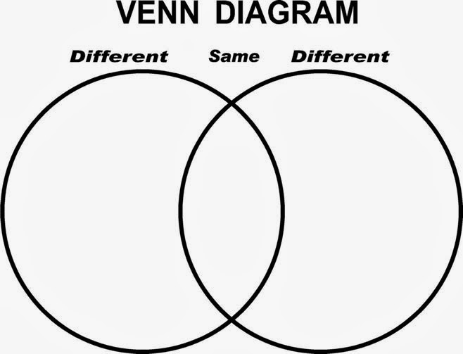

Part 2: Using evidence gathered above, explain and provide examples of factors that can influence a persons’ thoughts and behaviors.

__________________________________________________________________________________________________________________________________________________________________________________________________________________________________________________________________________________________________________________________________________________________________________________________________________________________________________________________________________________________________________________________________________________________________

Name:________________________ Core:_________

Belief System Researched:_______________________________________
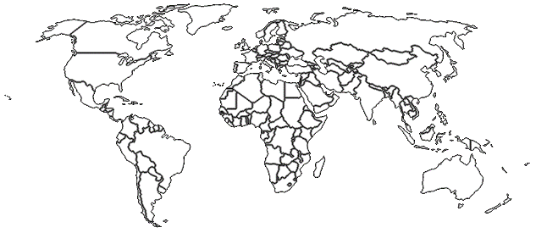
Symbol (s)
Followers are called

Practicing Areas
Key Figures
Practitioners World Wide
Ceremonies/Holidays
God (s)/ Goddesses
Books or Writings
Known History
Basic
Beliefs

