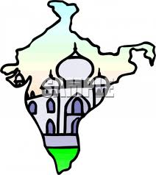
Name:______________________________
Prd:______________ Date:_____________
Population of India
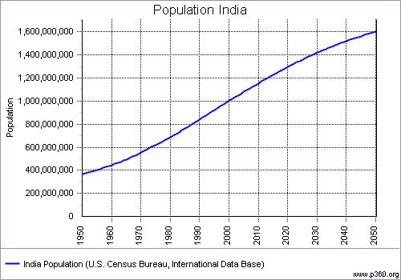
1.6 Billion
1.5 Billion
1.4 Billion
446 Million
1.3 Billion
1.2 Billion
555 Million
687 Million
1 Billion
842 Million
- What is the title of the graph? ____________________________________________________
- What was the population in 1960? _________________________________________________
- What was the population in 1980? _________________________________________________
- How much did the population increase from 1980 to 1990? _____________________________
- How much is the population predicted to increase from 2010 to 2020?____________________
- How much is the population predicted to increase from 2020 to 2050?____________________
- Using the graph, predict what the population will be in 2060.____________________________
- Using the graph, what conclusions can you draw about India’s population?
__________________________________________________________________________________________________________________________________________________________________________________________________________________________________________
- Write your own question and answer using the information from the graph.
____________________________________________________________________________________________________________________________________________________________
- Write your own question and answer using the information from the graph.
___________________________________________________________________________________________________________________________________________________________
Name:______________________________
Prd:______________ Date:_____________
Population of India
1.6 Billion
1.5 Billion
1.4 Billion
446 Million
1.3 Billion
1.2 Billion
555 Million
687 Million
1 Billion
842 Million
- What is the title of the graph? Population of India
- What was the population in 1960? 446 Million
- What was the population in 1980? 687 Million
- How much did the population increase from 1980 to 1990? 155 Million
- How much is the population predicted to increase from 2010 to 2020?100 Million
- How much is the population predicted to increase from 2020 to 2050? 300 Million
- Using the graph, predict what the population will be in 2060. 1.7 Billion
- Using the graph, what conclusions can you draw about India’s population?
That the population will steadily increase by 100,000,000.

- Write your own question and answer using the information from the graph.
____________________________________________________________________________________________________________________________________________________________
- Write your own question and answer using the information from the graph.
___________________________________________________________________________________________________________________________________________________________

