Food Safety: How to Avoid Getting Sick While Traveling

Part 1

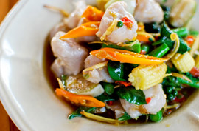
If you love to sample foods around the world -- but while your palate may be game, your stomach isn't always up to the challenge. To prevent spending half your trip running to the bathroom, it's important to find a middle ground between sampling local food and treating your belly well.
First, understand that the food you eat at home isn't necessarily "safer" than food abroad; it's often simply that your body isn't accustomed to it. One important difference between home-grown and foreign foods is the use of more "natural" fertilizers abroad, which can carry bacteria that could cause intestinal distress -- also known as traveler's tummy.
Your best defense against foodborne illnesses is not to panic, but to use common sense -- and with that in mind, we've compiled these tips for eating well and eating safely no matter where you travel.
What (Not) to Eat and Drink
• The most common source of dietary problems while traveling is drinking water, including ice.
• Cold meat platters, cheese, buffet foods and unsealed mayonnaise are often home to rampant bacteria.
• Seafood dishes are notorious for causing intestinal problems, as fish accumulate contaminants from a wide variety of sources. Smaller fish tend to be safer. Fish organs and shellfish (such as clams, mussels and oysters) are usually best avoided.
• Avoid unpasteurized dairy products, including cheese and yogurt. Check labels for evidence of pasteurization; most canned milk is safe.
• Nuts and other shelled foods are usually a good choice.
• Coffee and tea are generally harmless, but it's best to take your hot drinks black, without potentially contaminated milk. Cream from sealed containers, if pasteurized, is usually safe.
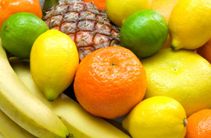
• The traveler's mantra, attributed to colonial explorers, goes something like this: "Cook it, wash it, peel it or forget it." Freshly cooked foods are less likely to acquire airborne contaminants, and raw foods such as salads, and fruits and vegetables without peels, are often likely culprits for trouble. Fruits and vegetables you can peel yourself are usually safe.
• Condiments such as mayonnaise, ketchup and salad dressings are safest in sealed packages.
• Order portions "well done" or at least "medium well," and eat them only if served hot. Be careful especially of runny eggs and sandwiches with lots of raw vegetables.
• Beer in other countries may contain more or less alcohol content than in the United States. This is because beer is cheaper to make and safer to drink than water in most 3rd world countries.
Questions- Answer the below questions, in complete sentences, on the Vietnamese culture handout.

1. What is the most common source of dietary (stomach) problems when traveling?
2. Explain the travelers’ mantra of “cook it, wash it, peel it or forget it."
3. If you can’t drink water and you don’t have a lot of money what else could you drink if you were traveling abroad?

