Middle East Peace Debate
Middle East
Revise test with student answers from debate
Revise articles/directions with fresh eyes
Export student OneNote pages
Patterson

(W) Means on website
Underline what should be said to the class
If there is a blue word click on it while holding down “ctrl”

Standards: SS.7.13. Identify social, political, and economic factors that can influence our thoughts and behavior. SS.7.14. Examine what causes inequalities and how they exist within a society.
District Suggested Language: SS.7.13 Identify factors that influence our thoughts and behaviors. SS.7.14 Examine the causes of inequality within a society.

Callanan Specific: Students will identify the (social, political, and economic) issues that prevent the Israelis and Palestinians from getting along. Students will examine how these issues result in inequality.
Overview: Students will learn about the social, political, and economic issues that prevent the Israelis and Palestinians from getting along. As a culminating activity, students will have a peace summit to come up with a plan based on evidence to end the conflict. A small group of students in each class have been asked to adopt radical views to challenge more moderate viewpoints in the debate.

For this unit, I usually use an online program called Microsoft OneNote that allows me to post links, questions, and have a virtual place for students to answer questions. (This program is very similar to Google classrooms.) I’m including a brief of descriptions of each issues/category that students learn about along with the resources and videos that they use on the following pages.

There are a total of ten steps or issues for students to study. Some of these steps take 15 minutes to complete, some take several days. It is natural for students who are more disciplined to create separation from their peers. This is okay. Students can participate in the debate without completing all of the steps.

Steps | Description
Maps of the Region | Create series of maps showing border changes
Creation of Israel | History of Israel’s creation
Six Day War | History of Six Day War
Standard of Living | Use data to compare quality of life
Imbalance of Power | Compare militaries/tactics of Israel/Palestine
Settlements | Examine why settlements are controversial
Flags | Identify ideas behind each country’s flag
Propaganda Video | Create 30 second video for debate
Arguing for Israelis | Debate prep for Israelis
Arguing for Palestinians | Debate prep for Palestinians
Assessment | Summative Assessment

Maps of the Region
Students will create a series of political maps that track changes in who controlled land in this area of the Middle East.
_________________________________________________________________________________

Each table/group will need to create a series of maps that show how the borders between Israel and Palestine have changed overtime. This will help us understand what has happened between the two countries.

It is recommended that you use the same colors for all of your maps. Israel should always be the same color. Palestine should always be the same color.

For each map on your paper, you will need a brief explanation of why those borders exist. This require some research and reading. Was there a war? Was there some sort of agreement? There is an example map up front.

1946 - Search on Google: Palestine Israel 1946

1947 - Search on Google: Palestine Israel 1947

1967 - Search on Google: Israel Palestine Map 1967

Today - Search on Google: Israel Palestine Map Today

When your group is finished with your maps, turn the maps in to the back bin and write your names on the board.

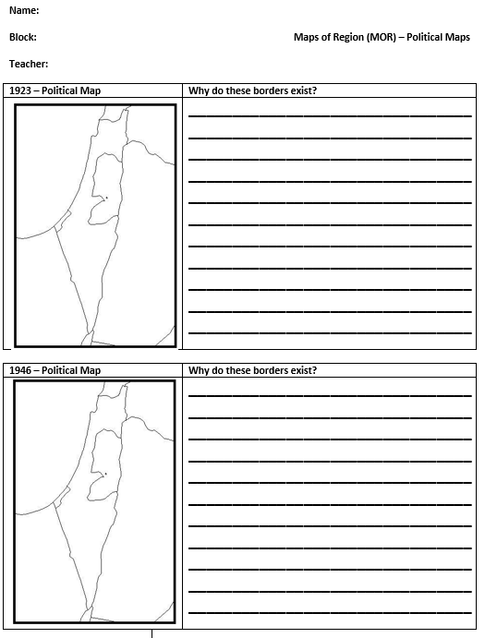

Maps are in Palestine_Israsel_Conflict_Documents on the Weebly.
Creation of Israel
Readings
Read document A also called The Creation of Israel. On OneNote, answer the following questions. Make sure to include text evidence in your answers.

- Why do Arabs (Palestinians) and Israelis not get along?

TYPE ANSWER HERE

- Why did Jews want to move to Palestine? Who colonized/controlled the area that became Israel/Palestine? According to the article, why did that country eventually leave.

TYPE ANSWER HERE

Videos
The video below that provides an overview of the Arab-Israeli Conflict. Create a list of bullet points of the most important ideas that you want/need to remember (have at least five).

For some reason, this video is restricted. You will need to make sure that you are using Internet Explorer. If you use Internet Explorer, the video will no longer be restricted.

https://www.youtube.com/watch?v=4r1EmEni2Rw

When you are completed with these two steps, please write your name on the board and move on.

- TYPE ANSWER HERE
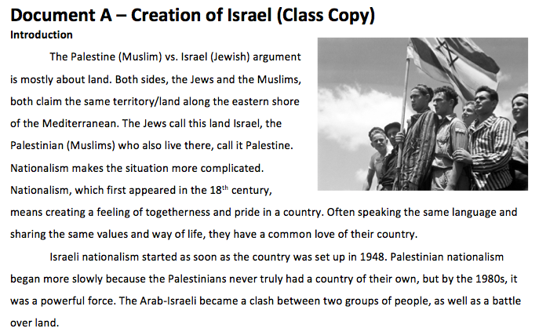
- TYPE ANSWER HERE
- TYPE ANSWER HERE
- TYPE ANSWER HERE
- TYPE ANSWER HERE

Reading is in the Palestine_Israsel_Conflict_Documents on the Weebly.
Six Day War
Readings
Read the article called the Six Day War. In your Six Day War page on OneNote, individually respond to the following questions. Make sure to include text evidence in your answers. Make sure you mark your answers with a title.

Who fought in the Six Day War? Who won? How/why did they win?

TYPE ANSWER HERE

Explain how the Six Day War in 1967 changed the Middle East.

TYPE ANSWER HERE

Watch parts of this video about the Six-Day War: https://www.youtube.com/watch?v=fSCryr_WkeY&t=2810s

You can watch all of it or just part of the documentary. Almost all footage from the Six Day War is in black and white because of the time period and how fast the war was over. If you just want to watch the part of the documentary, I would watch the following timestamps:
- 0-3 minutes, this gives you an introduction
- 46 - 50 minutes, explains the moments right before the fighting
- 1:37:00 minutes, discusses the end of the war

If the video comes up as restricted, try opening it up using Internet Explorer. Add something that you learned from the video to your Six Day War page on OneNote. When you are completed with these two steps, please write your name on the board and move on.

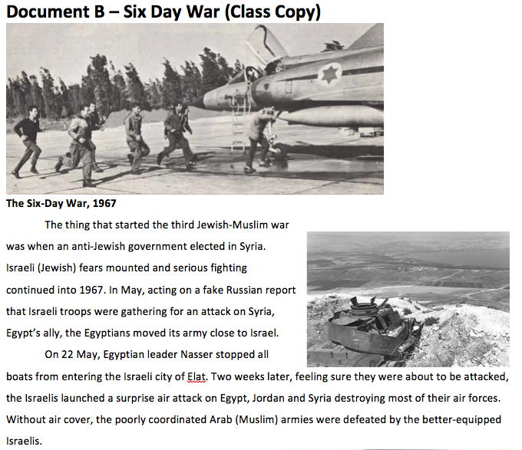
- TYPE ANSWER HERE
- TYPE ANSWER HERE
- TYPE ANSWER HERE
- TYPE ANSWER HERE
- TYPE ANSWER HERE

Reading is in the Palestine_Israsel_Conflict_Documents on the Weebly.

Standard of Living

Directions: Use the CIA World Fact Book to collect information about the countries on this sheet. Look for the category labels that are in bold; this will be how it is labeled on the website. The words not in bold are there to help you understand what the category means. Each category will be answered in order; make sure you are taking your time, completely finish a country before moving to another.

Mr. Patterson suggests that you use CTRL - F to help with your search. All answers can be found in either the Economic or the People and Society sections.

When you are finished, check your answers with another person. Please turn the sheet into the black box. If there are a couple of boxes where you can't find the information, search for the answers on Google.

Need help accessing the right information?
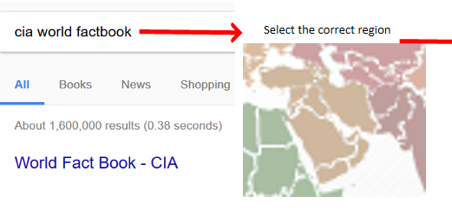

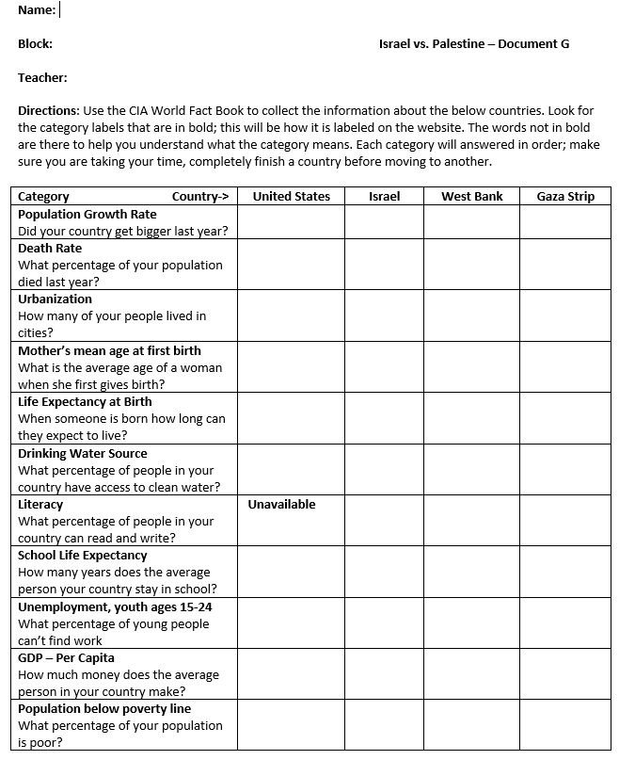
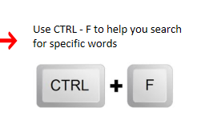
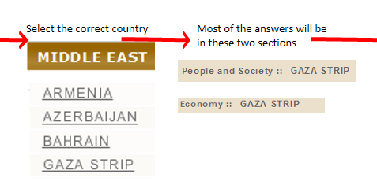
Chart is in the Palestine_Israsel_Conflict_Documents on the Weebly.
Imbalance of Power
Step 1
Ever since the country of Israel was created, it has fought numerous wars while also being outnumbered. Every single war has ended as a tie or victory. Using Google, figure out how strong the Israeli and the Palestinian militaries are. In a page on OneNote, write what you found.
Israeli Military
TYPE ANSWERS HERE
Palestinian Military
TYPER ANSWERS HERE
Is it a fair fight? What tactics/strategies have the Palestinians used to attack Israel? Why would they choose these strategies? How could these tactics or ways of attacking lead to innocent people dying?
TYPE ANSWERS HERE

Step 2
Readings

Read Document F which is also called the Cycle of Violence. In your Cycle of Violence page on OneNote, respond to the bullet points below. Make sure to include text evidence in your answers. Make sure you mark your answers with a title:
- Why is the violence between Israelis and the Muslims often described as a cycle?

TYPER ANSWER HERE

When you are completed with these two steps, please write your name on the board and move on.

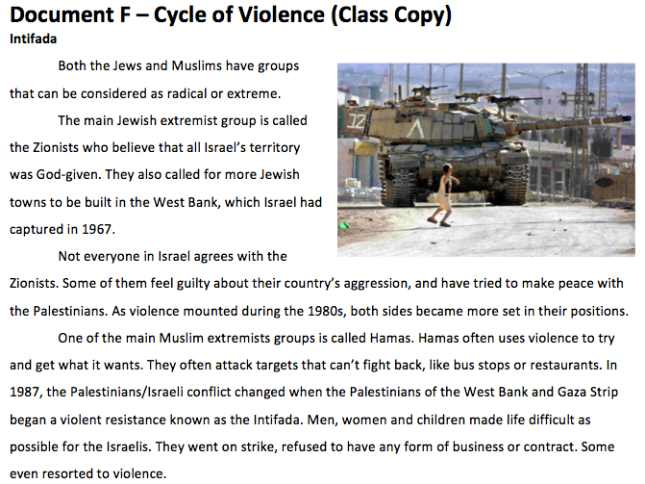
Reading is in the Palestine_Israsel_Conflict_Documents on the Weebly.
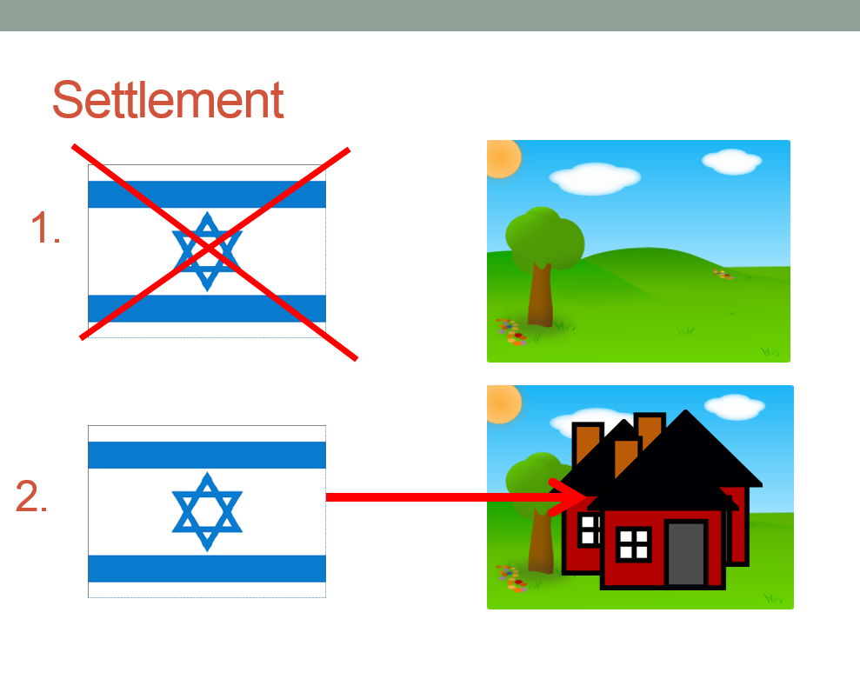
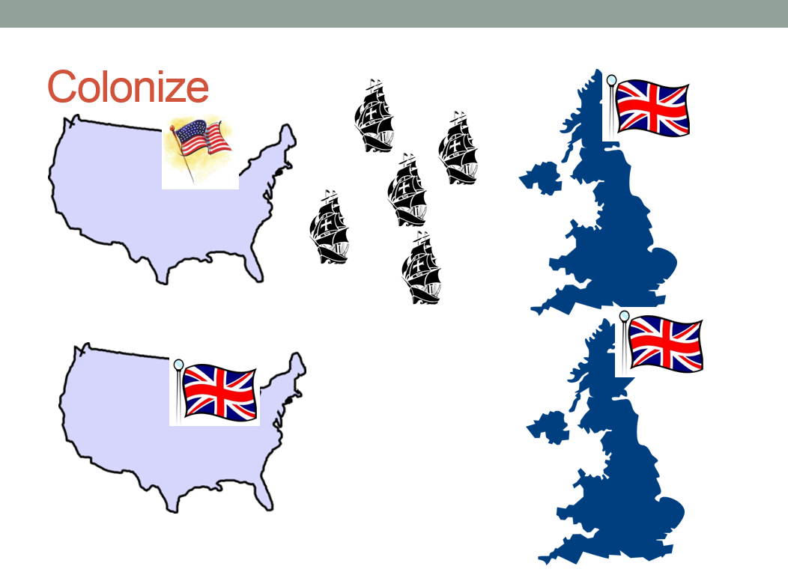
Settlements

In the documentary Five Broken Cameras, we watched Palestinian villagers protesting against Israeli settlements in Palestine. Watch the video below:

Israeli settlements, explained | Settlements Part I

In OneNote, write down the following:

Three Things I Learned
- TYPE ANSWERS HERE
- TYPE ANSWERS HERE
- TYPE ANSWERS HERE

Two things you thought were important
- TYPE ANSWERS HERE
- TYPE ANSWERS HERE

One question that you still had
- TYPE ANSWERS HERE

Flags
National anthems and flags have long been used to inspire a sense of pride. By examining (looking critically) these two important symbols, it reveals a lot about what is important to both countries.

Using Google, try to figure out the meaning behind the colors and design for each country's flag. Write down what you found in OneNote.
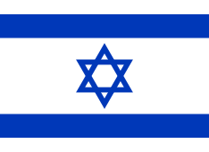
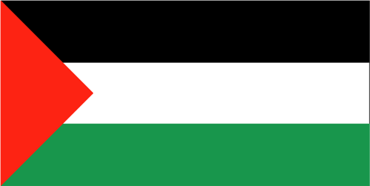
Palestinian Flag
TYPE ANSWERS HERE

Israeli Flag
TYPE ANSWERS HERE

Propaganda Video
Information that is biased/misleading is called propaganda. When done correctly, propaganda can manipulate (shape) how a person feels about a subject. Watch the video that I linked below. Through the use of pictures and music, most people who see this commercial want to help save the animals and feel sad.

Sarah McLachlan Animal Cruelty Video

Your job is to create a propaganda video that you can show during the summit/debate between the Israelis and Palestinians. What this looks like is up to you and whoever you want to work with (groups can not be larger than three).

Mr. Patterson has video cameras for you to use. In the past, students have used Windows Movie Maker to edit and add music to their videos before uploading them to YouTube.

Before you film, you need to have a script of what each person is going to say. You should also start to collect pictures that will serve as visuals for your commercial. The videos/commercials can't be longer than 30 seconds.

Debate Prep Videos

Relatively Non-Biased Overviews
Why Are Israel and Palestine Fighting?
Israel and Palestine Explained
Conflict in Israel and Palestine: Crash Course World History 223

Pro-Israel Video
the reason Why Israel can't withdraw to its pre '67 borders line

Pro-Palestinian Video
Israel and Palestine Conflict - Palestine Point of View

Apartheid (Arguing for the Israelis)
Directions: Tomorrow, we are going to have a debate about how to achieve peace in the Middle East. You will need to complete the following steps in order to be ready.

Step 1
Create a sign with the name of the group that you are supporting (Israel) and their religious symbol (six pointed star).

Step 2
Gather evidence to prove why you are right and other people should agree with your borders. You should use some of the work that you have already done to help you. You will need to have citations for each point that you gather (tell Mr. Patterson where you got your information from).

Watch this pro-Israel video:
the reason Why Israel can't withdraw to its pre '67 borders line

Here is a video that provides a general overview:
Israel and Palestine Explained

Remember, if these videos comes up restricted, copy and paste the website links into FireFox or Internet Explorer.

Mr. Patterson also found a super biased (pro-Israeli article) that will help you prove your point. These are located on the windowsill. Make sure you grab the correct article.

Step 3
Create a map where your group thinks that the borders should be located. Make sure you have a title and key.
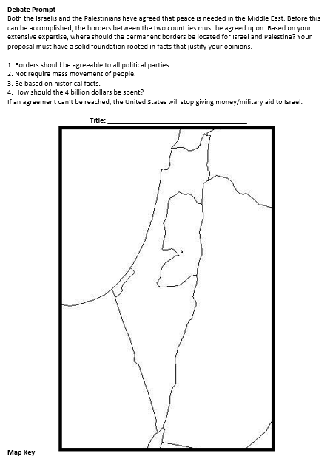
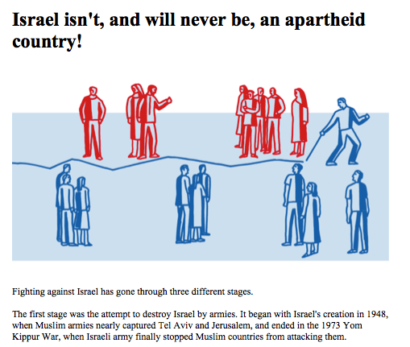

Article and map are located in the Palestine_Israel_Conflict_Documents on the Weebly.
Apartheid (Arguing for the Palestinians)

Directions: Tomorrow, we are going to have a debate about how to achieve peace in the Middle East. You will need to complete the following steps in order to be ready.

Step 1
Create a sign with the name of the group that you are supporting (Palestinians) and their religious symbol (crescent moon).

Step 2
Gather evidence to prove why you are right and other people should agree with your borders. You should use some of the work that you have already done to help you. You will need to have citations for each point that you gather (tell Mr. Patterson where you got your information from).

Watch this pro-Israel video:
Israel and Palestine Conflict - Palestine Point of View

Here is a video that provides a general overview:
Israel and Palestine Explained

Remember, if these videos comes up restricted, copy and paste the website links into FireFox or Internet Explorer.

Mr. Patterson also found a super biased (anti-Israeli article) that will help you prove your point. These are located on the windowsill. Make sure you grab the correct article.

Step 3
Create a map where your group thinks that the borders should be located. Make sure you have a title and key

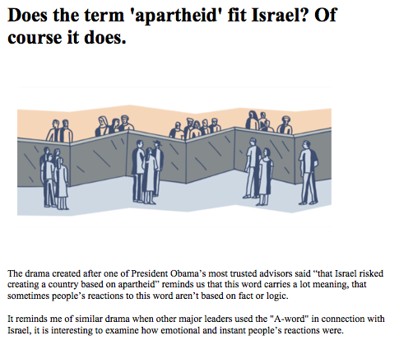

Article and map are located in the Palestine_Israel_Conflict_Documents on the Weebly.
Debate Prompt
Both the Israelis and the Palestinians have agreed that peace is needed in the Middle East. Before this can be accomplished, the borders between the two countries must be agreed upon. Based on your extensive expertise, where should the permanent borders be located for Israel and Palestine? Your proposal must have a solid foundation rooted in facts that justify your opinions.

1. Borders should be agreeable to all political parties.
2. Not require mass movement of people.
3. Be based on historical facts.
4. How should the 4 billion dollars be spent?
If an agreement can’t be reached, the United States will stop giving money/military aid to Israel.

Title: _____________________________________
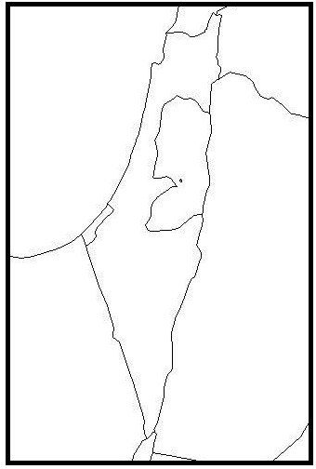

Map Key
Name: SEE LAST QUESTION, UPDATE VISUALS

Block: Middle East Assessment

Teacher:

Goal: I will identify the (social, political, and economic) issues that prevent the Israelis and Palestinians from getting along. Students will examine how these issues result in inequality.
____________________________________________________
Directions: For the following statements, write either P for Palestine or I for Israel.

1. This country is Jewish.  2. This country is Muslim.  3. This country gets a large amount of money from the United States.  4. This country has a strong military compared to its neighbors.  5. This country has low standard of living compared to its neighbors. | ________  ________  ________  ________  ________
____________________________________________________
6. Make a list of the things that Christianity; Islam, and Judaism have in common.

7. On a separate piece of paper, explain why hundreds of thousands of Jews moved to the Middle East, after the end of World War II? Why did this lead to fighting?
____________________________________________________
8. On a separate piece of paper, explain how religion makes the Israeli-Palestinian conflict complicated.
____________________________________________________
9. On a separate piece of paper, explain why ever since 1946 the territory (land) controlled by Palestinians has gotten smaller. In your answer, please do the following:

- Explain the history of why/how the Palestinians land has disappeared.
- Explain how fighting/walls have separated the Palestinians and Israelis socially. How has the fighting separated the communities/people?
- Describe the quality of life of the two countries. Are they the same or different? Why is this happening?
- Why is the Palestinian government not as strong as the Israeli government? Why would/could this make Palestinians turn to groups that use violence instead of peace?

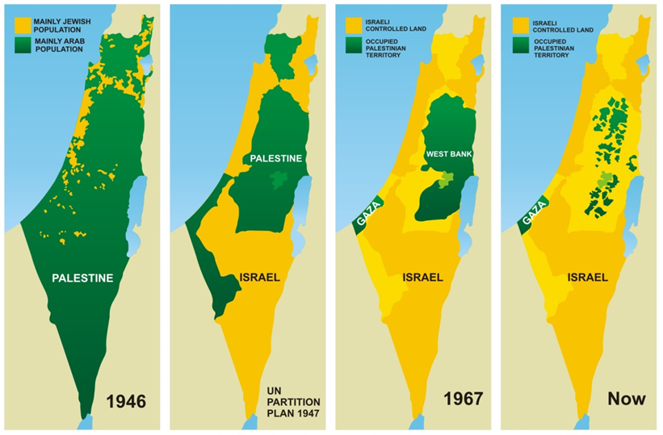

_________________________________________________
10. On a separate piece of paper, respond to the following prompt. We watched the documentary Five Broken Cameras in class. Was this documentary fair to both sides or was it biased? (Did the author’s want the viewer to like one side more than the other?) What were they fighting about? How did this impact Gabreel?
____________________________________________________
Level 4 – Optional REWRITE QUESTION &UPDATE VISUALS BEFORE PRINTING, STUDENTS WILL CRITQUE A CLASS PROPOSAL ABOUT ITS LIMITATIONS
Directions: Create a plan for that will establish (make) peace between Israel and Palestine. Explain how your plan will get both sides to agree to it and raise the standard of living of both sides.
In order for you to get credit for your level 4, you will need to use both citations and text evidence in your writing. If your plan changes the current borders of Israel and Palestine, you need to create political map and staple it to your answer sheet.

Name:

Block: OneNote Feedback

Teacher:

Over the last couple of days, you have used a program called OneNote to complete a “leveling” unit on Palestine and Israel.

What was one thing that you liked about the unit?
__________________________________________________________
__________________________________________________________
__________________________________________________________
__________________________________________________________
What was one thing that you would like Mr. Patterson to change?
__________________________________________________________
__________________________________________________________
__________________________________________________________
__________________________________________________________

Name:

Block: OneNote Feedback

Teacher:

Over the last couple of days, you have used a program called OneNote to complete a “leveling” unit on Palestine and Israel.

What was one thing that you liked about the unit?
__________________________________________________________
__________________________________________________________
__________________________________________________________
__________________________________________________________
What was one thing that you would like Mr. Patterson to change?
__________________________________________________________
__________________________________________________________
__________________________________________________________
__________________________________________________________

The End of Apartheid (OneNote)

Cedric Diggory
Block 7
Mr. Patterson

Reading
Apartheid ended in 1990 when the South African government released Nelson Mandela from prison. Nelson Mandela had “been in prison for 27 years” (Doc A). There was a deal between the whites and blacks. Every person in South Africa was allowed to vote, which meant that the next president of South Africa was going to be a native African. The whites were able to keep their homes and businesses.

Video
Video showed Mandela walking to freedom. You can see that he is walking next to his wife and that there are cameras/journalists present. I have included a picture that shows Mandela on his walk.

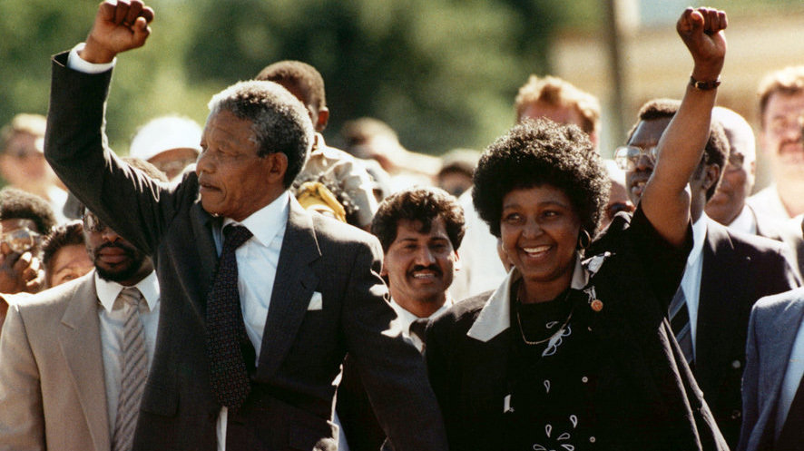

Proper Heading
Notice how the person has put their name, block, and teacher on the page.

Section Titles
Notice how for each section the person has put a separate title in

Text Evidence
The author included text/picture evidence to add strength to their writing.

Throwback Questions
The author underlined what question they threw back.

Pictures/Extra Information
The author added pictures/extra information to help illustrate/show what they were writing about.
Palestinian Opening Remarks for Debate
We thank you for traveling all this way to the Middle East peace conference. We want to start the conference by making several reasonable demands.
- We want everyone to agree that the Palestinians have a lower standard of living than the Israelis.
- This standard of living difference is because the Israelis have created a system of apartheid that keeps Palestinians poor.
- The United States is wrong to support a country (Israel) that treats people differently due to their religion and ethnicity.
- We demand that all Israelis leave occupied Palestine and pay for the damages that they have caused.

- Who has the right to live on and control the land?
- Who are the historical victims? Who are the people starting the violence?
- Do the Palestinians or the Israelis have a higher standard of living? Why is this important?
- Every year, the United States gives Israel and Palestine $500 million dollars. What should happen with the money?

Israeli – Palestinian Conflict
(Block 2)
Goal
No Music
No Music

Creation of Israel | Six-Day War | Standard of Living | Imbalance of Power | Settlements |  | Flags | Video/Summit Prep

General Musings
-Propaganda video, 30 seconds, PowerPoint mixer, show how to make
-Have the maps be first column, everyone feels like they accomplished something. Possibly create columns on the work chart as people start them.
-Do not have students create their own learning target, you are going to want to debrief/use warm ups
-Check visuals for changes
-Make the earliest map colored in for Palestine, order more Yellow and Green Markers
-Distribute student pages
-Give students apartheid articles during debate prep

When you distribute pages in OneNote, make sure you include questions, too much going back and forth. Show where the documents are. No video longer than four minutes.

When you sign off for Imbalance of power, talk with students about the cartoon from page 4
Use work completion chart starting day 2, make sure that you move the blue text. Remind students that this isn’t a race but it is important to understand where they are working in relation to everyone else.
Staple calendar to one warm up, calendar should be a different color.
Possibly assess: central idea of cartoon, author’s POV, paragraph outline.
On posted schedule on whiteboard and on warm up displayed on TV, write down what number day it is.
During debate prep day, explain what you want. Show Palestinian video, this is what you are arguing for. Israelis should also watch video about 1967. Figure out how to counter arguments.
Display example OneNote page with Nelson Mandela Apartheid
Make sure all documents are labeled.
Discuss sample OneNote page.
If possible, use small groups to teach outline of paragraphs.

DO SOMETHING WITH BIAS

To Do
-Distribute pages, clean up OneNote
-Have names ready in work completion document
Type/scan, revise different readings, add snip to OneNote

Document List
Document A - Creation of Israel Reading
Document B - Six-Day War Readings
Document C - Maps of Region
Document D – OneNote
Document E – Google
Document F – Cycle of Violence
Document G – Standard of Living Analysis

Revision

OneNote Planning Outline

Creation of Israel
PowerPoint
Reading

Watch
https://www.youtube.com/watch?v=4r1EmEni2Rw
Maps of Regions

Six-Day War
Reading
Six Day War Video needed

Maps of Region

Pro-Israel Video
https://www.youtube.com/watch?v=_rusj4yrV4Y

Pro-Palestinian Video
https://www.youtube.com/watch?v=AHjwVRBk5UA

Relatively Non-Biased Overviews
https://www.youtube.com/watch?v=4r1EmEni2Rw
https://www.youtube.com/watch?v=1wo2TLlMhiw

Cycle of Violence
Station Five, political cartoon

Imbalance of Power
Station 2, Document A and B

Settlements
Station 4
Textbook with atlas, war and peace

Nationalism/Flags
Station 3

Propaganda Video
-Roles/Ideas
Screen shot o-matic, movie maker, office mix

