Opium (Afghanistan)
Callanan Middle School
Patterson

(W) – separate resource on weebly
Underline- rationale the students should walk away with
Blue Word – Click on blue word and hold down “ctrl” button

The purpose of this lesson cycle is for students to understand why farmers in Afghanistan are growing opium and the costs of that decision.

Level 2 | Level 3 | Level 4
Specific vocabulary such as:  cash crop, scarcity, sustainability, opium | Why are Afghanistan farmers growing opium? Use cash crop within answer  How is the government trying to stop growing the drug? Use sustainable and scarcity in answer | How is the opium trade affecting the daily lives of people living in Afghanistan?  In your answer you need to use cash crop, scarcity, and sustainability

Day 1
Understanding the problem
Warm Up  What do you know about the war in Afghanistan? Why did we go there in 2001? Why do we still have troops in 2014?  Afghanistan and Opium PowerPoint (W)  Understanding Afghanistan  -page 4  South Asia Central Idea of Source Assessments (W)  -Model a think out loud for the students as you fill out a sample skill assessment | Understanding the problem  Afghanistan History  Sides  Taliban, Al Qaeda, ISAF, Afghan Government  Problems  Low Standard of Living, Violence, Corruption

Day 2
Warm Up  South Asia Central Idea of Source Assessments (W)  ISAF Casualties Thematic Map  -page 5,6 | What provinces (areas) in Afghanistan are the most dangerous?

Day 3
Warm Up  Opium Production by Province Thematic Map  -page5,7  Opium production by year in Afghanistan  -page 8  Exit Slip  What can you infer about Afghanistan using the ISAF thematic map and the opium production map? | What makes the Southern provinces so dangerous?  Hectare  Data of Growing patterns  Provinces with opium, attacks  Casualties Statistics - Link

Day 4
Warm Up  What does this quote mean?  “If you want to be a powerful in Afghanistan, much … it is important to be able to bring profit to your community. There are two ways to get access to get such access to money: one is to get access to foreign aid; the other is to get profits from opium poppy.”  Afghanistan Station Readings  -page 11-18  Students rotate thru the four stations, answering the bold questions in each article.  NPR Clip  -Link | What is opium and why are Afghans growing it?  Information, what is opium, problems  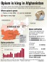  Eradication Plan  Cost of health to society  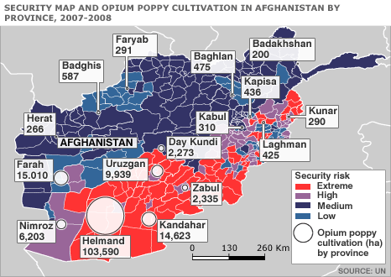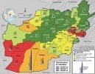  Opium is a cash crop  Scarcity of opportunities to improve lives  Sustainable plan is needed to change the lives of Afghanistan.  What is being done to solve the problem?  What alternatives can the farmers choose

Day 5
Warm Up  Have students grab a piece of paper and make a t-chart. On one side have problems and other side solutions. Have students write down problems preventing Afghanistan from solving the opium crisis. At the end of the documentary have groups brainstorm solutions.  Exit Slip  How does the Opium trade affect the daily lives of Afghans? | How is this affecting the daily lives of Afghans?  Documentary Opium Brides Link  This 35 minute documentary shows how the opium is affecting the daily lives of  Skip 6-7 minutes Opium use, Skip 16 minute mark sexual assault discussed, skip 25 minute heroin use  T-Chart list of problems facing Opium eradiation

Day 6
Warm Up  Finish the sentence  1. Afghanistan relies on cash crops because…  2. Scarcity affects Afghanistan by…  3. In order for the standard of living for Afghans to rise a sustainable…  Bannakti Review Game  -page 19  Economic Interdependence Assessment  - page 10-11  CNN News | Assessment

Resources
Why eradication won’t solve Afghanistan’s Poppy Problem - Link

Name:

Block: Understanding Afghanistan

Teacher:

Taliban/Al Qaeda
Goals:

Strengths:

Weaknesses:
ISAF (USA)
Goals:

Strengths:

Weaknesses:
Afghanistan Government
Goals:

Strengths:

Weaknesses:

Afghanistan History
Sides
Issues
Standard of Living:

Violence:

Corruption:

Name:

Block: Afghanistan Map

Teacher:
Title:

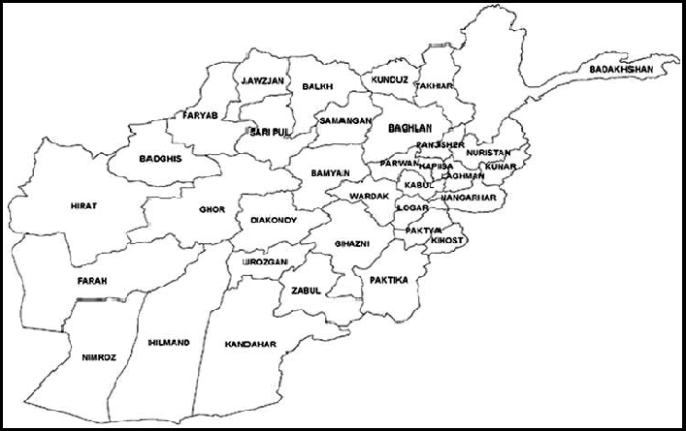

Map Key:

ISAF Casualty Map  Directions: Using the data to the right, make a thematic map of ISAF casualties in Afghanistan provinces from 2001-2011. Make sure you include a map title and key.  Casualty is a person killed in a war or conflict.  Color # of Casualties  Green Yellow Orange Red 0-25 26-100 101-150 201+ | Province Total  Badghis 35  Baghlan 17  Bamyan 10  Farah 53  Faryab 17  Ghazni 113  Ghowr 2  Helmand 944  Herat 52  Kabul 175  Kapisa 61  Lowgar 66  Nangarhar 53  Nimruz 6  Kandahar 543  Kunduz 30  Takhar 3  Wardak 130  Zabol 118  Paktika 145  Balkh 22  Jowzjan 4  Samangan 1  Konar 177  Laghman 26  Paktia 29  Khost 47  Nurestan 36  Oruzgan 69  Parvan 71  Panjshir 3

Opium Production Thematic Map
Directions: Make a thematic map from the data below to show what provinces in Afghanistan grow the most opium in 2007. Make sure you include a map title and key.
Color | # of Hectares growing opium
Green  Yellow  Orange  Red | Poppy free  1-600  601-14,000  14,001+
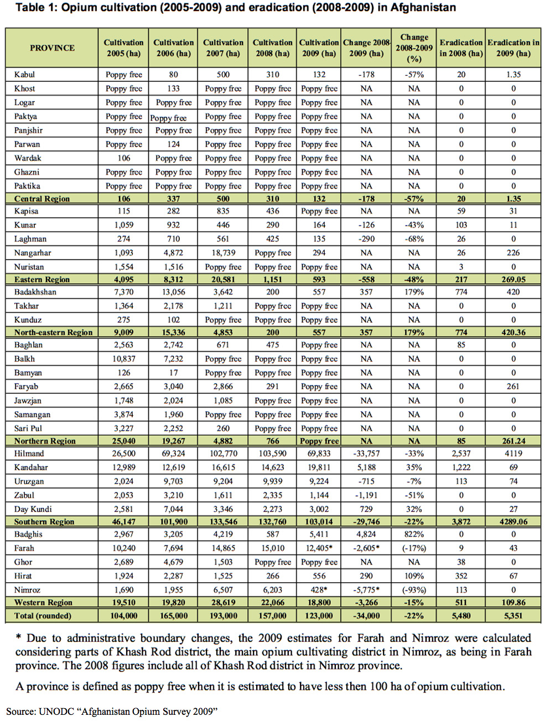

Directions: Using the data below make a graph of opium production in Afghanistan. The “Y” axis will be tons of Opium grown and the “X” axis will be the year.

Year Tons of Opium Grown  1994  1995  1996  1997  1998  1999  2000  2001 | Year Tons of Opium Grown  2002  2003  2004  2005  2006  2007  2008  2009

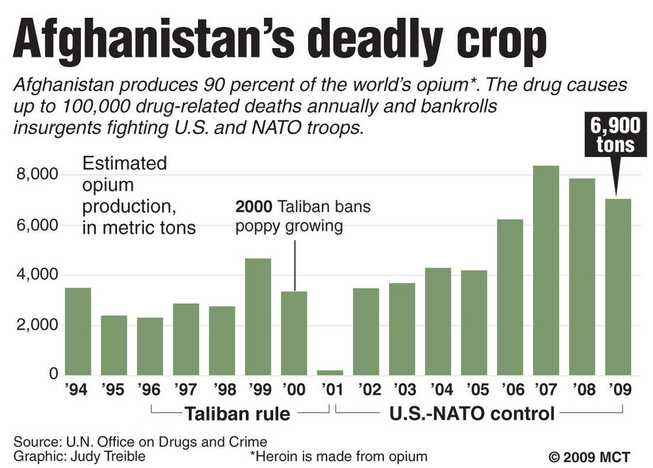
Name:

Block: Econ. Interdependence - Assessment

Teacher:

Level 2 | Level 3 | Level 4
Specific vocabulary such as:  cash crop, scarcity, sustainability, opium | Why are Afghanistan farmers growing opium? Use cash crop within answer  How is the government trying framers from stop growing the drug? Use sustainable and scarcity in answer | How is the opium trade affecting the daily lives of people living in Afghanistan?  In your answer you need to use cash crop, scarcity, and sustainability

Level 2 Understanding/Skills_____________________________________________________________
Directions: Define the below vocabulary words using complete sentences. Your answer must show mastery of the word.

1. Cash Crop-
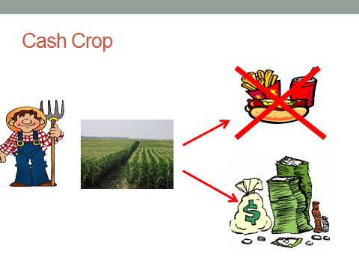

2. Scarcity-
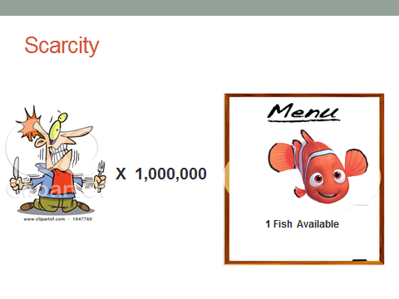

3. Sustainability-
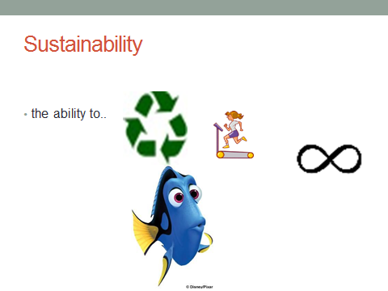

4. Opium-
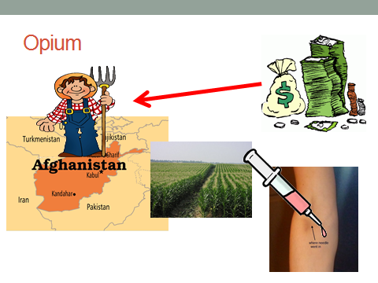

Level 3 Understanding/Skills_____________________________________________________________
Directions: Answer the following questions in complete sentences. Your answer must show mastery of the material.

5. Why are Afghanistan farmers growing opium? Use and underline cash crop within answer.

_____________________________________________________________________________________________

_____________________________________________________________________________________________

_____________________________________________________________________________________________

_____________________________________________________________________________________________

6. How is the government trying to stop farmers from growing the drug? Use and underline sustainability and scarcity cash crop within answer.

_____________________________________________________________________________________________

_____________________________________________________________________________________________

_____________________________________________________________________________________________

_____________________________________________________________________________________________

_____________________________________________________________________________________________

_____________________________________________________________________________________________

Level 4 Understanding/Skills_____________________________________________________________
Directions: Write a response to the prompt below. To receive credit for having level 4 understanding, you must show your mastery of the material and of the questions being asked. Responses are not necessarily limited to paragraph form and can include maps, charts, graphs, etc. You are assessed on the quality of your ideas, not your use of punctuation, grammar, etc.

How is the opium trade affecting the daily lives of people living in Afghanistan? With In your answer you need to use and underline cash crop, scarcity, sustainability, and opium.

Station 1
Opium & Afghanistan: Before 2001
Afghanistan produces 90 percent of the world’s illegal opium, bringing billions of dollars a year into the country’s economy, fueling the global heroin trade, funding both the Taliban and making government corruption worse. But the United States attempt to end opium production has been ineffective and have even hurt the goals of gaining peace and growing the economy.
Why did Afghanistan become the supplier of 90 percent of the world’s opium?
“If you want to be a powerful in Afghanistan, much … it is important to be able to bring profit to your community. There are two ways to get access to get such access to money: one is to get access to foreign aid; the other is to get profits from opium poppy.”
In the 1980s several important changes took place in the international market and in Afghanistan to cause a rise in opium production.
In Afghanistan in the mid-80s, the Russian Army ended up adopting a “scorched earth” which meant they would destroy farmland that grew opium. That is because while the Russian were able to control the cities, they were never able to control the countryside. The people fighting the Russians always attacks from the country areas around the cities. The Russians tried military operations in the countryside, which didn’t control the problem; so they decided to destroy the farmland in the countryside with the idea that this would drive the country people into the cities.
The effect was the complete collapse of farming production of Afghanistan: the destruction of orchards (apples) and the ability to water plants. The only thing the population could grow was opium poppy, which didn’t require irrigation, fertilizers or transportation, because Pakistani traders would come to the farm and pick up the opium.
At the same time, there was a growing demand for opium in the world. Production from the traditional suppliers was slowing. None of the farming infrastructure was rebuilt in the 1990s, following the Russian retreat out of Afghanistan.
What effects did opium production have on Afghanistan?
From the mid-80s through the mid-2000s, opium poppy was the main source of livelihood (income) for the population.
Even today opium poppy production is still very important. It is still, at minimum, makes up around 20 percent of the what the country makes in an entire year. It is one of the big sources of economic activity in Afghanistan, along with foreign aid. If foreign aid diminishes significantly post-2014 [when U.S. troops are set to withdraw], it will have an even larger impact.
But there are other effects beyond economic effects. One of them is that since the mid-80s, political power is heavily associated with access to both foreign aid and opium poppy. If you want to be a leader in Afghanistan much … is dependent on being able to bring some profit to your community. There are two ways to get access to money: one is to get access to foreign aid; the other is to get profits from opium poppy. So political power, at least until the mid-2000s, and in a more covert way since the mid-2000s, has been very strongly associated with access to the drug trade. …

Station 2
The Taliban appeared in 1994 and, at first, stopped the growing of opium on religious grounds. But by 1996, they changed their minds. Why? How has opium production helped them?
At the time, even more than today, there were two ways to make money was to smuggle across the border, or trade in poppy. When the Taliban outlawed poppy [in early 1995] and told the people they could not grow it, they very quickly realized that in the key provinces where they needed support, Kandahar, and especially Helmand — all of a sudden they had lots of rebellions and people fighting on their hands. The population was not willing to put up with it.
[But by 1996,] the Taliban [decided] they did not have enough power to make people hate them. So they said that while the use of hashish or opium was still ilelgal, we understand that we cannot starve you. They said the Quran says you are not supposed to eat pork, but if you are to die of hunger, you can eat pork. They used the same logic to say that we understand that you would be starving without opium poppy, so you can grow opium. …
Soon the Taliban began taxing (making money off of people growing) opium. It was one of their big sources of income because there was no other economic activity, and they taxed cultivation between 10 and 20 percent.
Then in late 1999/2000, they changed their mind and brought in a new ban, a very large ban and growing crashed by 90 percent. This was arguably the largest policy-driven reduction of any cultivation anywhere in the world.
Why did the Taliban decide to ban opium again in 1999/2000?
While they controlled much of Afghanistan at the time, no international governments except Saudi Arabia, the United Arab Emirates and Pakistan recognized them. But they really wanted international recognition.
Throughout the 1990s, the U.N. had told them to stop growing opium, so they bet on the idea that if they stopped the growing of opium, they would then get international recognition as the official government in Afghanistan and a seat at the U.N.
The ban worked because the population at this point was scared by them, and the government had promised they would receive money and jobs from other countries that would allow them to live. But these gifts never came, and a few months down the road, you had massive economic trouble happening in Afghanistan — drops of income by 95 percent, starvation conditions, huge debt for many people, and in some instances, even “opium brides,” young girls given to money lenders when their families could not replay loans.
In 2001, the second year of the ban, many farmers violated the ban and went back to the growing poppy, despite the risks that the Taliban would punish them. And when the Taliban were overthrown in 2001, interestingly, there was no support for the Taliban, in part, because people were so angry that the Taliban’s ban on opium had caused them to become poor.
Today the Taliban makes money from taxing the drug trade, as well as taxing a lot of other activities or production in any areas where they have strong influence, be it foreign aid or opium poppy. They also get people to support them by offering themselves as protectors of the poppy farmers against the evil government.

Station 3
Opium & Afghanistan: After 2001
Tell us about U.S. policy on opium production since the war began in late 2001.
Between 2001 and 2004, the U.S. very much had a hands-off policy towards the opium poppy, partially because Northern Alliance warlords, [whom the U.S. was] using for intelligence and for direct military operations against Al Qaeda and the Taliban, were growing tons of opium. … So the U.S. said the main thing was to defeat the Taliban and their human rights problems.
That changed in 2004, when the United States, thinking that the Taliban had been defeated, [decided] now we can expand the our goals; now we want to end the drug trade. … So from about 2004 to 2008, the U.S. government had been pushing towards greater and greater stoppages of opium growth. … The Afghan government wasn’t necessarily interested in doing so.
The Americans thought that if they stopped people growing opium it would lessen the corruption of the Afghan officials and the Taliban would have no more money. Neither goal happened. Corruption kept increasing and increasing, and the Taliban became stronger and stronger, for many different reasons, [including] that the Taliban drew a lot of support from the poppy farmers who were outraged by the anti-opium movement.
So what happened in 2009?
The big change comes in 2009, when the Obama administration says, stopping the growing of Opium is not doing what we wanted. There is no decrease in corruption; in fact, there is a huge amount of corruption relying on us trying to stop growing. It’s not taking money from the Taliban and it’s causing people to like them instead of us. So we are going to need a new plan.
The U.S. government decided to stop paying the people who were supposed to destroy the drugs. But the Obama administration wanted to compromise somewhat, and they said if the Afghan government, local governors, want to destroy the drugs, that’s their choice
What often happens is that when the governors push ahead with eradication, they lose the support of the population.
There are different types of poppy farmers in Afghanistan. Some who are close to the Afghan market — like 20 miles or less from the capital — who could other things besides drugs. So if these governors go after these opium farmers with threats and force, they can get them to switch to other crops. Many of these farmers found that they actually make more money growing things like okra and vegetables other than opium.
Now you have other farmers who are further away from big cities, in areas of insecurity and poor governments, who rely on opium to feed their family. So if the government forces them to destroy their crops than they have a hard time surviving.

Station 4
Which countries and organizations still support opium destruction policies?
The most countries have not come out for or against the issue. During the height of U.S. ant opium policy most countries were against it but now most countries aren’t saying a whole lot.
Certainly Russia is the only big country calling for all opium growing to stop.
Russia has been a very angry actor. The main country opposing Russia has not been the Europeans, but with the U.S.
The Obama administration has really tried to engage the Russians on the issue, trying to explain to the Russians why destroying opium will be ineffective and counterproductive, trying to explain that if their main concerns are use and disease, they need to focus on treatment and prevention, rather than believe than stopping opium in Afghanistan.
The Russians have not been taking well to the U.S. story and still do not agree.
The more extreme Russian story is that the U.S. does not stop farmers from growing opium in the hopes that more Russians would get addicted to the drug. The official Russian position is that the U.S. is failing on its major position to stop opium poppy and that someone needs to be stopping opium poppy in Afghanistan.
If the destroying of opium is not working what other things can the U.S. do to help Afghan farmers? How long could it take for the new plan to be effective?
Rather than focusing on destroying opium in Afghanistan the U.S. should try and encourage different ways to make money that wouldn’t hurt the country.
There have been problems with this new plan.
Efforts to help small towns and famers need to be improved. Some provinces like Kandahar and Helmand have been flooded with so much money since 2009 that they don’t know what to do with it..
Most of the money was spent on unsustainable, short-term, cash-for-work programs that amount more to giving money to friends. Thus, two years later, Afghans have little to show for themselves. Such a handout plan has failed to fix the problem that Afghans still need opium once the money has gone.
Country projects should instead focus on sustainable programs, and focus at least as much on secure areas as on the insecure ones. Critically, money should not be spent on programs that cannot be carefully monitored.
But any progress on fighting opium will take a lot of time — many, many years. Country development programs in much less destroyed areas often take several decades. And any policy and law will require security to be pulled separately.

Bannakati Review Game

Split the class into two different groups. I usually split the class into boy and girl groups because it encourages competition.

Pictionary
Level II Knowledge

Have students play Pictionary on the whiteboard with vocabulary words from this unit. Give a point to the team that gets the answer correct first. I usually have them write the down their guess on a sticky note and hold it in the air.

Vocab List
Cash Crop-  Scarcity-  Sustainability-  Monsoons-  Typhoons-  Standard of Living- | Opium-  Upper Class-  Middle Class-  Lower Class-  Vocab List  Caste System-

Charades
Level III Knowledge

Give each group a question below and have them act it out without talking. The group with the best skit receives three points.

Scenarios
Show how the Afghan government tries to stop farmers from growing opium and it failing.

Show the Afghan government stopping farmers from growing opium and providing them with a sustainable solution.

Double Jeopardy
Level IV Knowledge

Give both teams the below statement. Tell both teams that they have three minutes to discuss their answer. After three minutes randomly select a student from each side and have them write down the answer. As a class discuss which answer was more persuasive and why (this is where you can encourage students to use specific examples from the unit within their answer).

Statement
Make an argument against the following quote. “Banning/destroying opium in Afghanistan should be the United States’ number one goal because it is so easy.

