-incorporate revisions/suggestions into level 4s from pd ,level 4 evidence
-Revision suggestions on assessment, level 4reword change format
-make sure it is explicitly tied to the scale

Oil Lesson Cycle
Southwest Asia Task 4 – (Level 4)
Patterson

(W) Means on website
Underline what should be said to the class
If there is a blue word click on it while holding down “ctrl”

Individual and Econ. Standard | How standard will be assessed | Potential Level 4 Ideas
a) Understand the role of scarcity and economic trade-offs and how economic conditions impact people’s lives.  b) Understand the functions of economic institutions. | a) Understand what factors determine a person’s quality of life (standard of living).  a) Are low oil prices going to have a negative effect on the country’s economy?  a) Should the country’s money be spent on other issues effecting their daily lives?  b.) Determine whether the potential host country would benefit from hosting an international sporting event. | Thematic Map of Oil for Budget  Venezuela Example  What happens to an oil dependent country when the price of oil goes down?  Extension: Should Qatar host the 2022 FIFA World Cup?

Musings
- Find article/videos to preview problems about South Africa World Cup
- Mark what boxes/questions go with what document
- Add check boxes to make to do list
- Double Entry Journal for initial research
- Random country generator
- Change Doc D, trackstar
- Have them compare GDP per Capita to US
- Academic controversy for final paper
- Bring in climate/elevation
- If time allows, different mediums instead of paper (say make a presentation, a tourism video, portfolio, a photo essay of the city etc).
- Zane “Advancing Differentiation (Richard Cash) has a good selection of graphic organizers if you’re interested. I have a copy at Brody I can loan you.”
- Brazil Article - Link
- Student Guide While Research - Link

Topic | 2 | 3 | 4
Individual and the Economy | Basic Knowledge/skill such as:  -standard of living, economy, supply, demand, opportunity cost | a) Understand what factors determine a person’s (standard of living).  a) Are low oil prices going to have a negative effect on the country’s economy?  a) Should the country’s money be spent on other issues effecting their daily lives?  b.) Evaluate the pros and cons of different economies working together. | Exceed the criteria of column three.  District Level 4  Does there have to be poor people?  Determine whether the potential host country would benefit from hosting an international sporting event.
_____________________________________________________________________________________
Memo: Identifying Potential Host Countries

Name:

Due to the fact that crude oil prices are declining, Brazil has decided that it can no longer host the 2016 summer Olympics. When this news eventually becomes public, the Olympic Committee needs to have already identified potential alternate locations for the summer games. If we don’t get this accomplished, some of our sponsors will want their money back!

The Olympic Committee has a news conference on Thursday, so time is of the essence. You, and at most have two other coworkers, need to choose a country and research answers to the following points:
- Does this country have a high or low standard of living?
- Will low crude oil prices affect this country’s standard of living?
- Are there any problems that could potentially disrupt the Olympics? Should the money that would go to building new stadiums be spent on other things?
- Your recommendation of either yes, or no should this country should host the Olympics?

While you and your team should work together to gather research, you are each required to turn in your own final report. As of course you know, your final report should make use of the evidence that you gathered during your research, along with proper citations.

It is our recommendation that you follow this day by day checklist to remain on track to completing the deadline by the necessary deadline.

Day 1
- Choose who, if anybody, you want to work with.
- Decide on what country you want to research.
- As a group, collect data to answer the above four points.

Day 2
- Finish country data collection
- Make sure you’ve used information from all documents

Day 3
- Fill out essay frame
- Revise work with a writing checklist

It is our recommendation that you make use of the following research databases to guide your research. While you’re not required to use these databases, they are an excellent place to start. You shouldn’t spend any time on Google Images. With the complex nature of the questions you’re trying to answer, it would be more productive to throw ice cubs at the sun.

Sincerely,
International Olympic Committee
_____________________________________________________________________________________
Olympic Resource Databases
BBC Country Profile – Doc A - http://bbc.in/1E8Dmcb
This website will give an overview of the country you’re researching. It should also provide a list of problems issues.

CIA World Fact-Book – Doc B - http://1.usa.gov/1A5ceXE
The CIA World Fact-Book has all of the information you need to determine the standard of living in your country.
People and Society | - Population growth rate  - Urbanization  - Mother’s mean age at first birth  - Drinking water source  - Literacy  - School Life Expectancy  - Unemployment, youth ages 15-24

Economy | - GDP – per Capita  - Population below poverty line
*If you don’t understand a category, ask Mr. Paterson for the document that explains what each category means.

Does your country rely on oil? – Doc C - http://bit.ly/1xal3hK
This document shows what percentage oil money makes up the economy. When the price of oil is high, it’s a good thing to have a high number on the document. When the price of oil is low, it’s a bad thing to have a high number. If you have time, look up to see at what price does oil have to be balance the country’s budget.

What does the Olympic Committee looks for? -Doc D- http://bit.ly/1Ad9NBB
This document outlines what the Olympic Committee usually looks for in a host city.

Culture Grams – Doc E - http://bit.ly/1E2QQDI
This website outlines basic country information. It helps the reader make sense of the research they have gathered on other documents. Make sure you use the kid’s version of the site.
Login: 1737callan
Password: haea11

Is your country developed (rich) or developing (a nice way of saying poor)?

Most countries that are developed (rich) have these things:
- Population growth (how fast your country is growing) rate is small
- Urbanization rate is high (percentage of people who live in cities, better access to schools and hospitals).
- Mother’s median age at birth is the average age at when she has her first child, this number should be in the upper 20’s (young mothers sometimes aren’t prepared to take care of a child).
- Life expectancy at birth is really high (how long the average person lives).
- Everyone in your country has access to clean drinking water.
- Literacy rate is high (almost everyone can read).
- School life expectancy is high (the number of years the average person goes to school).
- The higher the amount of GDP Per Capita the better (average amount of money a person makes)!
- Unemployment rate is as low as possible (what percentage of people who can’t find jobs).
- Population below poverty line is small (percentage of population that is really poor).

Most countries that are developed (poor) have these things:
- Population growth (how fast your country is growing) rate is high
- Urbanization rate is low (percentage of people who live in cities, better access to schools and hospitals).
- Mother’s median age at birth is the average age at when she has her first child, countries want to have a number in the high 20’s (young mothers sometimes aren’t prepared to take care of a child).
- Life expectancy at birth is really low (how long the average person lives).
- Not everyone in your country has access to clean drinking water.
- Literacy rate is low (almost everyone can read).
- School life expectancy is low (the number of years the average person goes to school).
- Low number for the GDP Per Capita the better your country is (average amount of money a person makes)!
- Unemployment rate is high (what percentage of people who can’t find jobs).
- Population below poverty line is high (percentage of population that is really poor).

Name: Block: Teacher: Olympics – Host Site

Have you identified an alternative host country for the summer Olympics?

Paragraph #4
Your recommendation of either yes, or no this country should host the Olympics.

Paragraph #3
Should the money that would go to building new stadiums be spent on other things?

Paragraph #2
Are there any problems that could potentially disrupt the Olympics?

Paragraph #1
Does this country have a high or low standard of living? Will low crude oil prices affect this country’s standard of living?

EVIDENCE
EVIDENCE
EVIDENCE
EVIDENCE

Name: Block: Teacher:
Why are you writing this proposal? What did Brazil do? Which country did you research?
Topic Sentence:

Detail 1:

Detail 2:

Does this country have a high or low standard of living? Will low crude oil prices affect this country’s standard of living?
Topic Sentence:

Detail 1:

Detail 2:

Detail 3:

Transition:

Are there any problems that could potentially disrupt the Olympics?
Topic Sentence:

Detail 1:

Detail 2:

Detail 3:

Transition:

Should the money that would to building new stadiums be spent on other things?
Topic Sentence:

Detail 1:

Detail 2:

Detail 3:

Transition:

Your recommendation of either yes, or no this country should host the Olympics?
Topic Sentence:

Summarize Details:
1.

2.

3.

Name:

Block: Olympic Political Cartoon

Teacher:

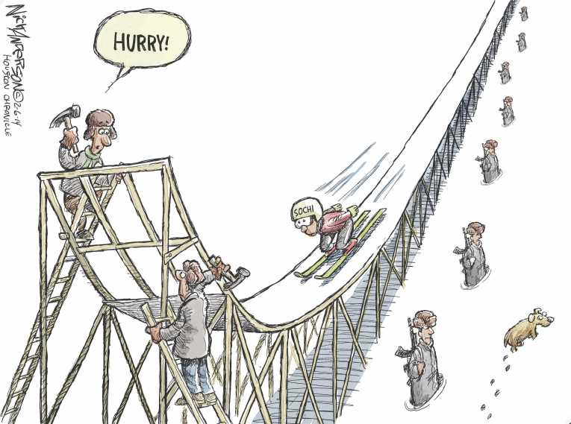
1. Political cartoon artists often use symbols to get their points across. A symbol is a something that stands for something else. For example, the American flag often stands for America. Circle and number any symbols you recognize in the cartoon above.

2. What point is the artist trying to make in this political cartoon? In your response you should explain and cite the symbols found in the cartoon.
____________________________________________________
____________________________________________________
____________________________________________________
____________________________________________________
____________________________________________________
____________________________________________________
____________________________________________________
____________________________________________________

