Name:

Block: Oiligarchy! Game

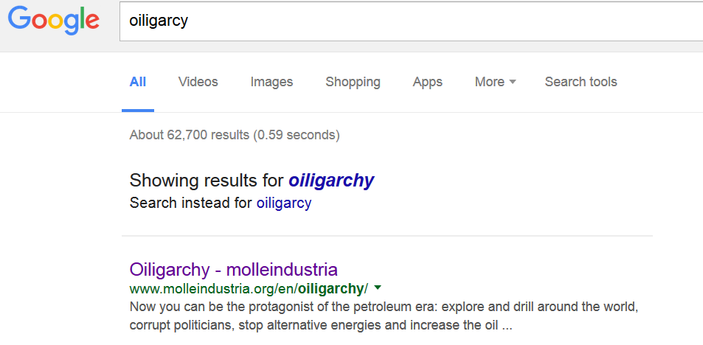
Teacher:

Part 1 – Open the Game
1. Go to Google
2. Search for Oiligarchy
3. Click on the top result
4. You will have to watch an ad before you can start playing the game.

Part 2 – Playing the Game
There is no way for you to save the game. If you log off the computer or click the refresh button, all of your progress will be erased.

Tutorial Questions – You do not need to write in complete sentences.
What is your job? Who do you work for?

“Politics is the shadow cast on society by big business.” What will the “oiled” representatives help you do?

Map of the World
Why can’t you drill in Alaska at the beginning of the game?

Why can’t you drill in Iraq at the beginning of the game?

How to Play the Game
What does this button do?

What does this button do?

What does this button do?

There are villagers in Nigeria who don’t like it when you drill in their country. What can you do to stop them?

Bills that Congress passes
Name of Law/Act | Purpose (How does this affect oil addiction?)
1.

2.

3.

4.

5.

Part 3
After finishing the game, play it again but concentrate on paying the politicians.
What does this button do?

What did you have to do get Iraq open for drilling?

What does Venezuela do to your oil wells?

What is a M.A.D. world? Why are people fighting?

What you high score that you finished with? Did you beat Mr. Patterson?
Name:

Block: Oiligarchy! Reflection

Teacher:

List five terrible things you did as a CEO of an oil company.

Do you think that these things happen in real life? Explain your answer.
____________________________________________________________________________________________________________________________________________________________________________________________________________________________________________________________________
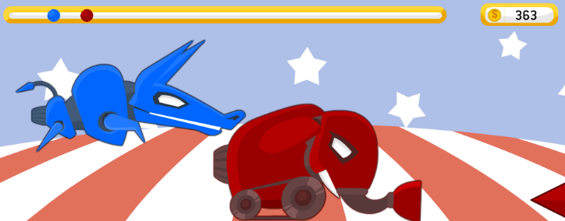
During this part of the game, what were supposed to do?
____________________________________________________________________________________________________________________________________________________________________________________________________________________________________________________________

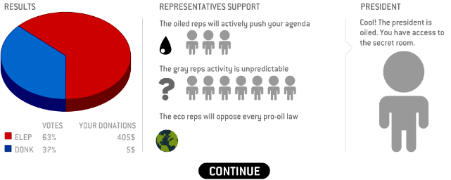
Why did you want to get the politicians to like you?
________________________________________________________________________________________________________________________________________________________________________________________________________________________________________________________________________

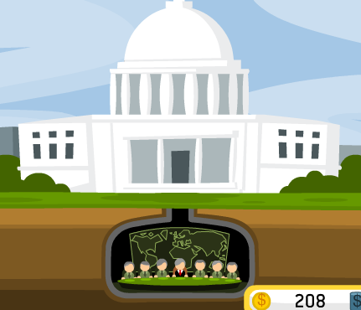
What could you get this group of people to do?
________________________________________________________________________________________________________________________________________________________________________________________________________________________________

An oligarchy is a government controlled by a small group of people. Why did the game designers call this game Oiligarchy?
________________________________________________________________________________________________________________________________________________________________________________________________________________
________________________________________________________________________________________________________________________________________________________________________________________________________________

