Name:

Block: The End of the Emperors

Teacher:

Step 1: Previewing Text- Look over what you are about to read; in order to better prepare yourself for success. Highlight the answers to the below questions.
Highlight Color | 1. If there is an article title, what is it?
 | 2. If there are sections titles, what are they?
 | 3. What vocabulary words are in the article? Vocab words are underlined.
Step 2: Read Text- Read the documents either by yourself or out loud with your group.

Step 3: Text Evidence – After reading, go back through the text and highlight the part of the text you would use to answer the following questions.
Highlight Color | 1. What had made China a powerful country?
 | 2. What happened between China and Britain? Why were they fighting?
 | 3. What did this then lead to?

Step 4: Writing to Inform- Use the highlighted text to respond to the prompt below in paragraph form. Make sure that you use proper citations.

Explain how China went from being a powerful country to a relatively weak one in only a couple of years.
_____________________________________________________________________________________

The End of the Emperors/Kings – Document A
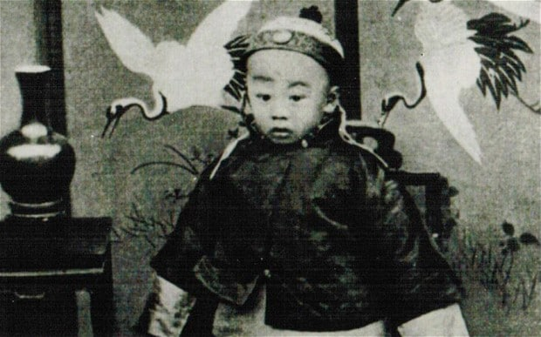
For China, the 1800s was a time period marked by disaster and drama. For long periods in human history, China had led the world, but by 1900s the country had reached a low point.
By 1900, China’s history already stretched back almost 4,000 years. For more than half that time, China had been united under the rule of emperors or kings who called their land the “ Middle Kingdom” because they thought it was the center of the world. People who didn’t live in China were thought of as barbarians and uncultured. People outside of China were allowed to visit the emperor/king, but only to pay money and give gifts. To show respect, the visitors had to kowtow, kneeling on their hands and knees to touch their foreheads to the floor before the king.
Leading the world
For much of China’s history, the country’s rulers had reason for their pride. China was a world leader. Paper, cast iron, gunpowder, porcelain, paper money and the compass were all Chinese inventions. Books, art and education were important in China at a time when many Western peoples were still living in grass-and-mud huts. The nation also achieved great feats or acts of engineering and building. One of the most impressive was the Great Wall, which was built to keep out enemy forces more than 2,200 years ago.
By the 1800s, little was left of China’s glorious and powerful past. China’s early kings had been effective, but their successors (or the kings that came after them) were less so. The country whose technology had once led the world, had gradually fallen behind
A Land Of Peasants
At the time when European countries started making things in factories, China remained a land of farmers. When European countries started using railways and building metal boats, the Chinese still used sailing boats called junks. In the Chinese countryside, most of those who worked the land did not own it. Instead, they rented land from rich landowners who often demanded half of all they grew as rent. Seeing China’s weakness, other countries decided that they wanted to take advantage.
During the 1800s, China fought and lost two wars against the British, who took up weapons to protect their trade in opium or heroin trade. As the price of victory, Britain demanded huge amounts of money to cover the costs of the war. The British also insisted on special rights for British traders and took control of the island of Hong Kong off China’s southern coast.
The Unequal Treaties
After China’s defeat in the Opium Wars, other countries including France, the U.S., Russia, and Germany demanded special rights for their own traders. These countries were granted special trading rights in the “unequal treaties,” signed by the Chinese government under threat of force and violence.
The final humiliation or embarrassment came in the 1890s, when China found itself at war with its Asian neighbor, Japan. The conflict or fight centered on whom would colonize the country of Korea. Although much smaller than China in land and population Japan had a better army. When Japan started to defeat the Chinese armies, it was obvious to everyone involved that China was super weak. People in China wanted change and they were angry at the emperor for all of the bad things that were happening.

Class Copy - Opium, the Mandate of Heaven, and Emperors…

Directions: Watch the below John Greene video about Opium, the Mandate of Heaven and Confucius. When you are finished watching the video, respond to the prompt below by adding a second paragraph to your The End of Emperors paper. Make sure you have both text evidence and citations.

Up until 1911, China had been ruled by a series of emperors for thousands of years. Why did this dynastic system come to an end?

Document B – 12-minute video http://bit.ly/1IHJeuA
This document is a 12-minute video that covers the mandate of heaven and a brief history
of ancient Chinese history. The most important part is 0-6:35. There is also a link to the video
in OneNote.

John Green Transcript (Mandate of Heaven) - Document B
So the idea of the Mandate of Heaven dates from the Zhou Dynasty (dynasty means line of kings from the same family). TIMESTAMPS
But the Zhou Dynasty believed in heaven, so they came up with the idea of the Mandate of Heaven. They claimed that the reason that they came to power was the dynasty before them had lost the Mandate of Heaven.
The historical writings are pretty clear about what caused the dynasty before the Zhou (the Shang), stating that they weren’t faithful to their wives. As a result, the Mandate of Heaven was passed on to a new family.
The last Shang emperor/king was reported to have roasted and eaten his enemies, which, you know, bit of a deal breaker as far as the Mandate of Heaven is concerned.
So basically the fact that one dynasty falls and is replaced by another in a cycle that lasts for 3,000 years is explained, in the eyes of early Chinese historians, by god’s work based on whether the ruler behaves in a proper, upright manner.
But first, let’s see an example of the Mandate of Heaven in action:
The Qin Dynasty lasted only 38 years, but it's one of the most important dynasties in Chinese history, so important in fact that it gave the place its name, “Chin- uh” (laughing).
The accomplishment of the Qin was to re-unify China under a single emperor for the first time in 500 years, ending the warring states period. As you can imagine, the making of that particular omelets required the cracking of quite a few eggs, and the great Qin emperor Qin Shi Huangdi and his children developed a reputation for brutality that was justified.
But it was also exaggerated (not true) for effect so that the successor dynasty, the Han, would look better in the eyes of Heaven.
So the Mandate of Heaven turned away from these suicidal emperors, which set up a nice contrast with the early Han emperors, such as Wen, who came to power in 180 BCE and ruled nicely, avoiding spending tons of money on himself and was an overall good guy.
Under Emperor Wen, there were no more harsh punishments for attacks of the government, the number of killings went down, and, most importantly for the Confucian students who were writing the history, and the government stopped burning books. Thus, according to the ancient Chinese version of history, Emperor, by behaving as a wise Confucian, maintains the Mandate of Heaven.

Transcript (Chinese Revolutions) - Document C – Class Copy
So the 1990s were an important time for China because it saw not one but two revolutions/wars.
1. China’s communism became a really big deal during the Cold War (1945-1990), and… timestamps
2. Mao Zedong, the father of Communist China, was really good at self-promotion (making himself look cool). Like, you know his famous book of sayings? Pretty much everyone in China just had to own it. And I mean, had to.
So as you no doubt recall from past episodes and readings, China lost the Opium Wars in the 1800s, resulting in European armies defeating the Chinese military, all of which was deeply embarrassing. However, not everyone could agree on how China should improve.
One idea called for China to copy how the Europeans set up their education system and their military. However, this wasn’t a very popular idea.
Instead, China experienced the disastrous anti-Western Boxer Rebellion (war) of 1900. Many young leaders in China, including a dude named Sun Yat Sen, started to plan a coup d’état in order to get rid of the king/emperor.
The 1911 revolution that led to the end of the Qing dynasty (line of emperors) started when a bomb accidentally exploded, at which point the people planning the coup d’état were like, “we’re probably going to be arrested, so we should just start the uprising now”. The coup probably would’ve been destroyed like many before it, except this time the army joined in the on the coup, because they wanted to become more modern (like the Europeans).
The emperor (king) left his throne, and the rebels chose a general, Yuan Shikai, as leader, while Sun Yat Sen was declared the President of China on Jan 1, 1912. A new government was created with a Senate and a Lower House, and it was supposed to write a new constitution (plan of government). And after the first elections, Sun Yat Sen’s party, the Nationalists were the largest, but they weren’t the majority. So Sun Yat Sen said that Yuan could take power, which turned out to be a huge mistake because he then outlawed the Nationalist party and ruled as dictator (just like Mr. Patterson!).
But when Yuan Shikai died in 1916, China’s first non-emperor government completely fell apart. Local landlords and small armies controlled different parts of China.
So the period in Chinese history between 1912 and 1949 was chaotic because no one was truly in charge of China.
By the 1920s, the Nationalists and the Communists were the two main groups in China. They tried to work together but eventually broke up (just like One Direction ).
Anyway, this turned out to be a bad break up for a bunch of reasons, but mainly because it started a civil war between the Communists and the Nationalists. We’re not going to get into exhausting detail on the civil war but, spoiler alert: the Communists won. But there are a few things to point out:
First, even though Mao ended winning the war, he and the communists were almost wiped out in 1934 except that they made a miraculous escape.
Second, for much of 1925 - 1949, large parts of China were being occupied and/or invaded by Japan.
Thirdly, the Communists were just better at fighting the Japanese than the Nationalists were. In spite of the fact that Chiang Kai-Sheik had got a lot of money and guns from the U.S. And each time the Nationalists failed against the Japanese, it made them look weak and pathetic. It wasn’t helped by Nationalist corruption (people stealing money), or their taxes from Chinese farmers, or stories about Nationalist troops putting on civilian clothes and abandoning the city of Nanking during its awful destruction by the Japanese army in 1937. Meanwhile, the Communists were winning over the farmers in their northwestern China by making sure that troops didn’t rob people and by giving farmers a greater say in local government.
Now, that isn’t to say everything was rosy under Mao’s communist leadership, even at its earliest stages.
In a preview of things to come, in 1942 Mao initiated a “rectification” program, which basically meant students and intellectuals were sent down into the countryside to give them a taste of what “real China” was like in an effort to re-educate them.
But anyway, within four years of the end of World War II the Communists routed Chiang Kai-Shek’s armies and sent them off to Taiwan, and these military victories paved the way for Mao to declare the People’s Republic of China on October 1, 1949.
So once in power, Mao and the PRC were faced with the task of creating a new, socialist state. And Mao declared early on that the working class in China would be the leaders of a “people’s democratic dictatorship.” Oh democratic dictatorships. You’re the BEST. It’s all the best parts of democracy, and all the best parts of dictatorship. You get to vote, but there’s only one choice. It takes all the pesky thinking out it.
The Communists promised equal rights for women, rent reduction, fair land use, new heavy industry (factories) and lots of freedoms, including freedoms of “thought, speech, publication, assembly, association, correspondence, person, domicile, moving from one place to another, religious belief, and the freedom to hold processions and demonstrations.”
Overtime the government became powerful and the rights of individuals were squashed. This was put to use when Mao started using the government to carry out campaigns or missions in order to inspire nationalism in people.. Designed to encourage support for the Korean War, the campaign was called the “Resist America and Aid Korea campaign,” and it resulted in almost all people who were not Chinese, to be kicked out of China.
A second campaign/movement, against “capitalists” was much worse. People suspected of liking the USA or anyone not happy communism, were subjected to humiliation and violence. Between October 1950 and August 1951, 28,332 people accused of being spies or capitalists were killed in Guandong city alone.
A third mass campaign/movement, the “Three Anti Campaign/movement” was aimed at reforming (improving) the Communist party itself. And the final mass campaign/movement, the Five Anti Campaign was an assault on capitalism, which effectively killed private businesses in China.
Mao and the Communists set out to turn China into an industrial powerhouse by following the Soviet model of improving their standard of living. We haven’t really talked about this, but under the Soviet system, Russia was able to accomplish massive industrialization-- not to mention tens of millions of deaths from starvation-- through centralized planning (government deciding what to make) and collectivization of farming, following what were known as Five Year Plans.
The Chinese adopted (stole) the model of Five Year Plans beginning in 1953 and the first one worked, at least as far as industrialization (factories) was concerned. In fact, the plan worked even better than expected, with industry increasing 121% more than projected. In order for this to work though, the farmers had to grow lots of grain and sell it at extremely low prices. So far, Mao’s plan seemed to be working, but there was no way that China could keep up that growth. So Mao came up with a terrible idea called the Great Leap Forward.
Among many other bad ideas, he famously ordered that individuals build small steel furnaces (ovens) in their backyards to increase steel production. This was not a good idea. First off, it didn’t actually increase steel production much. Secondly, it turns out that people making steel in their backyard who know nothing about making steel… make bad steel.
But the worst idea was to pay for heavy machinery from the USSR with grain/food. This meant there was less for peasants/farmers to eat — and as a result, between 1959 and 1962, 20 million people died, probably half of whom were under the age of 10. And then in happier news came the Cultural Revolution! Just kidding, it sucked. By the middle of the sixties, Mao was afraid that China’s communists revolution was running slowing down. And the Cultural Revolution was an attempt to capture the glory days of the revolution and fire up the people, and what better way to do that than to empower the kids.
Frustrated students who were unable find decent, fulfilling jobs jumped at the chance to denounce their teachers (booo!!!!), employers, and sometimes even their parents and to tear down tradition, which often meant demolishing (destroying) buildings and art. The ranks of these “Red Guards” grew and anyone representing the so-called “four olds” — old culture, old habits, old ideas, and old customs — was subject to attacks and violence. People who went to college were again sent to farms as they were in 1942; millions were attacked; and countless historical and religious artifacts were destroyed.
But the real aim of the Cultural Revolution was for Mao’s to become powerful, and while his image still looms large, it’s hard to say that China these days is a true communist country.
Great Leap Forward Reading – Document D – Class Copy
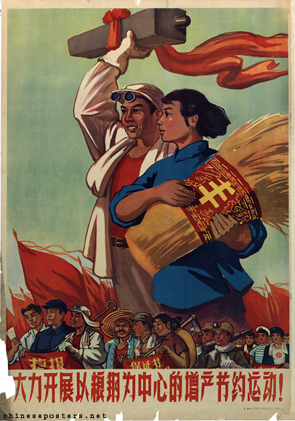
As 1957 came to a close, Mao decided to start a new plan that would raise China’s standard of living. He decided to get the country to work together in an effort called The Great Leap Forward. The project was to last for just three years, not five, and it was intended to achieve HUGE rates of growth.

Becoming Self-Sufficient
To achieve these goals, China’s 600 million people were expected to more than just work hard: they were expected to change their way of life. Farmers were grouped together into communes containing thousands of people. Each one was encouraged to be self-sufficient, not just in growing their own food, but in making essential materials like steel. The backyard furnace was to become the Great Leap Forward’s most familiar symbol.
Early Hopes
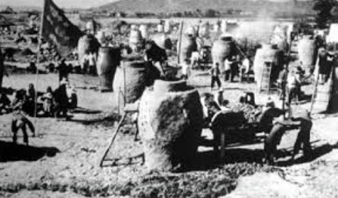
In the first year of the Great Leap Forward, progress was made, and large projects were started. In the communes, too, great advances seemed to be under way, but the appearances were hiding the truth. In order to meet the goals set by Mao and the government, farmers were asked to jobs that they weren’t trained for. Because Mao wanted to see growth in the amount of wheat and rice productions, farmers were encouraged to fill in ponds so there was more space to grow.
Even so, the 1958 farming season was a good one. Eager to make Mao and the government happy, local communist leaders didn’t report the many problems of the Great Leap Forward. As it happened, they had good reason for not speaking out. Mao usually threw people who were critical of his ideas into prison.
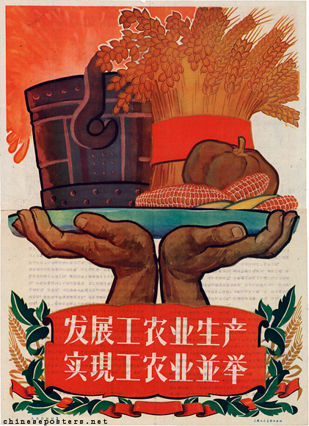
Catastrophe
In 1960, the unreliable Chinese weather turned against the farmers. Floods in China’s south and drought (lack of rain) in the north severely affected the country. Food production fell. Yet Beijing officials, fooled by the false reports that were still reaching them, failed to realize the extent of the problem. They continued to take large amounts of grain from the farmers as taxes. This caused massive starvation throughout China.
Defeat of Mao
By late 1960, the extent of the tragedy was clear and Mao had to take responsibility. For him, it represented a considerable defeat and he went on a vacation/retirement for a while. Ironically, the Great Leap Forward turned out really to have been a giant step backward for the Chinese standard of living.

Cultural Revolution Reading – Document E
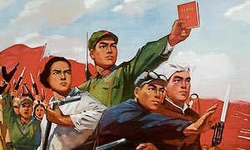
Thinking about his problems, Mao became convinced that they were the same as those facing the entire country. The commitment to Communism that he had dreamed of was not happening. The reason for this, he though, could only in lie in traditional Chinese culture and the respect for old things. An entirely new attitude was needed, he decided, if he was to create the perfect communist country!

In 1964 Mao created a Cultural Revolution group to attack old and traditional habit, but its first leader, the mayor of Beijing, did little. So Mao turned to his own wife, Kiang Qing, a former actress, who flung herself into the task of transforming Chinese culture with enthusiasm.

A Coded Message

All heck broke lose when there when a play was put on in Beijing. In the play, an honest government worker was fired for attempting to stand up to his boss. However, people interpreted the play as an unfair attack on their beloved leader, Mao!
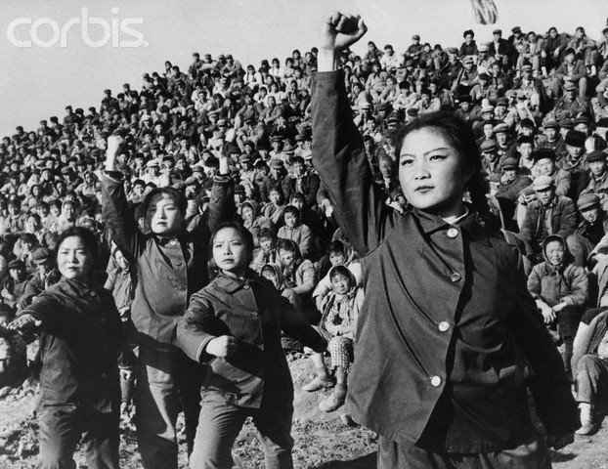
The Red Guards

During the controversy, Mao joined the people attacking the play. He said that there was a group of people in China that were trying to have a coup d’état against the communists running the country. Many students took Mao’s lead, and posters attacking people started appearing. At school, students calling themselves Red Guards dedicated themselves the communist revolution. People started to wear red armbands to show that they were true communists!

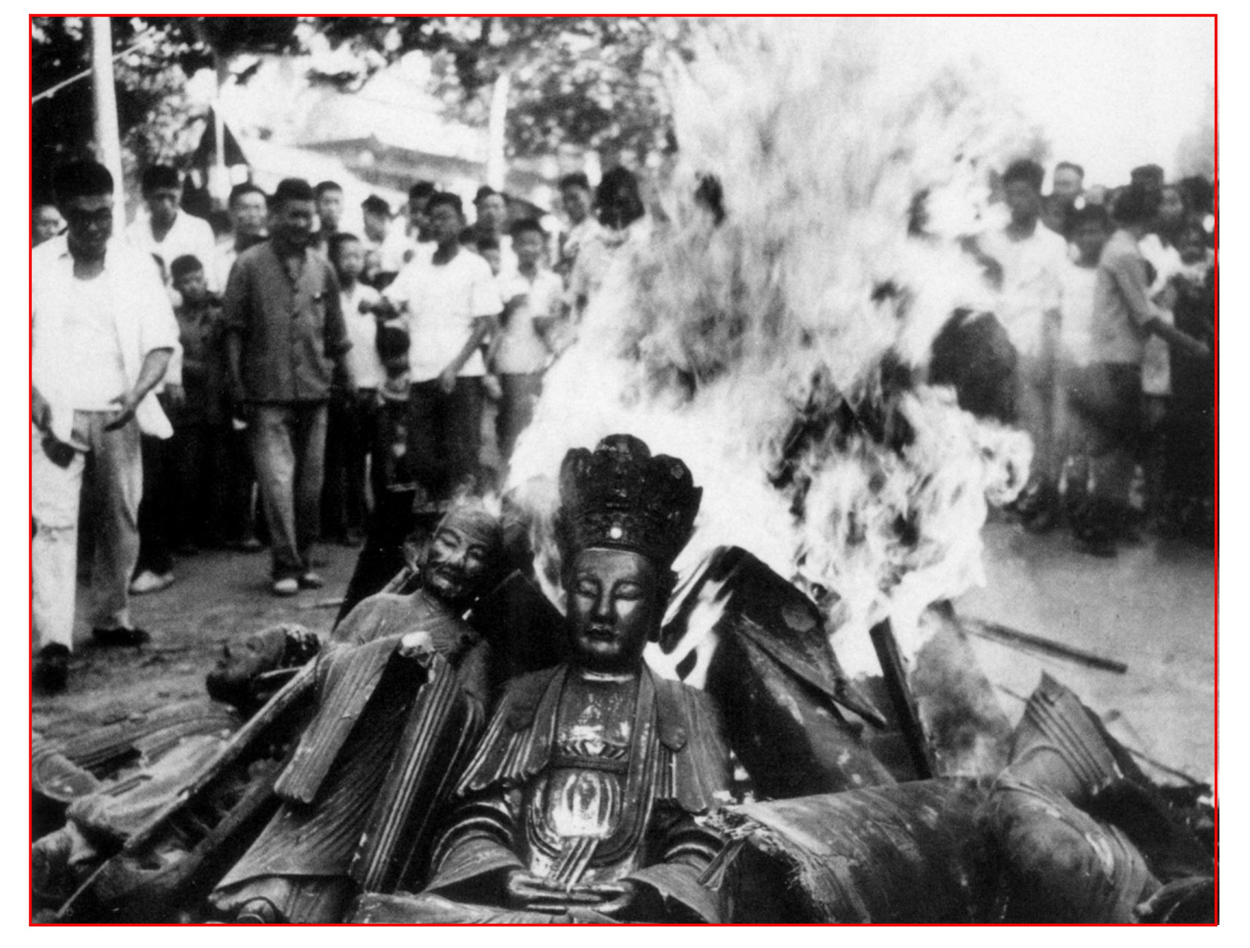
Attacking the “Four Olds”
At Mao’s suggestions, Red Guards were allowed to travel free on the railways and were given free hotels across the country. The students traveled the country looking for the “Four Olds” to destroy. These included cultured, ideas, customs, and habits. People associated with the old were ways were targeted for attack. Often they publically humiliated and forced to confess to their “crimes.” Many were than beaten up or killed.

Among the chief victims of these actions were Mao’s rivals/enemies.

Spreading Chaos
By mid-1967 the violence was increasing. A confrontation between Red Guards and angry workers/soldiers took place in the city of Wuhan. Mao decided to call of his attackers.
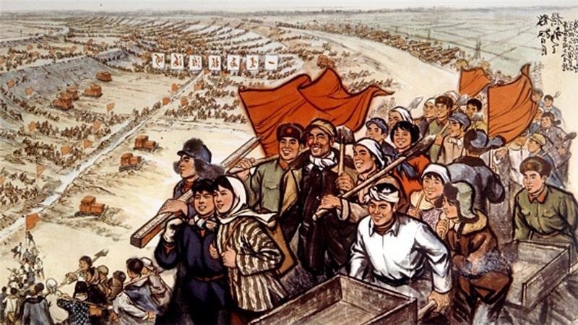
Half Open Door Reading – Document F – Class Copy

At the same time as he allowed profits in Farming, Deng (the leader of China) wanted to bring back industry (the making of things). All workers had once been paid the same amount whether they did a good or a bad job. Now there were extra wages for the most productive workers. Once jobs had been for life, but now managers were given the power to hire and fire people. Prices of goods had formerly been set by the Chinese government, but now they were allowed to change.
The Open Door Policy
Leader Deng decided to try something called The Open Door Policy. This was to encourage people and companies around the world to invest in China. This new approach or idea was a sharp break from the past. Deng sent thousands of students to European and American universities to study and learn. Technology from around the world came into the country as part of the drive to modernize Chinese industry. To encourage outside investment (giving of money), four areas were set up in the southeastern part of the country, where China’s export industries were concentrated.
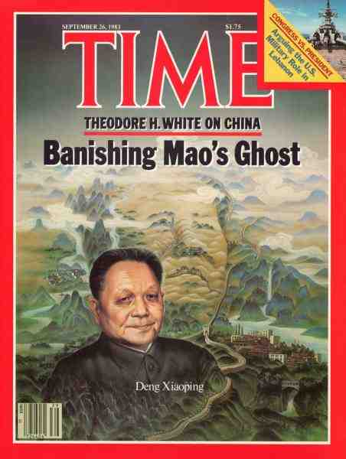
A Rush to the Towns
As far as raising the standard of living of the country was concerned, the new program was a success. One result was a rush of people to the towns. From 1980 to 9186, the urban population grew from 200 million to 371 million. This was not much more than third of the total population, but was still a huge increase. New companies grew and China became the world’s largest maker of different things.
Even so, the new openness of allowing money to come in had its limits. Along with the Four Modernizations, Leader Deng also promoted what he called the Four Rules: sticking to communist ideas, protecting the government, making sure the communist party was powerful and following the ideas of Mao Zedong. In this way, change was balanced in stability.
Deng’s Balancing Act
Leader Deng’s balancing act proved difficult to control. Opening up China to the outside investment of money also exposed it to new ideas. Businesses from the United States brought their own ideas of how things should organized. Student sent around the world to study came back longing for the freedom of expression they had experienced outside of China.

Demanding Democracy
The result was a rise in demand for what became unofficially known as the Fifth Modernization, democracy or the right to vote for your leader. This movement first found expression in the Democracy Wall movement of the late 1970s. Following a tradition dating back to the day of the 100 Flowers, protestors put up handwritten posters attacking the communist part on a wall in Beijing, China. The government soon cracked down on the protestors.
However, people still longed for freedom and democracy. As along as the nation was getting richer, as it was in the first year’s of Leader Deng’s changes, people seemed satisfied. However, they when people’s standard of living started to go down, people wanted to bring about change.

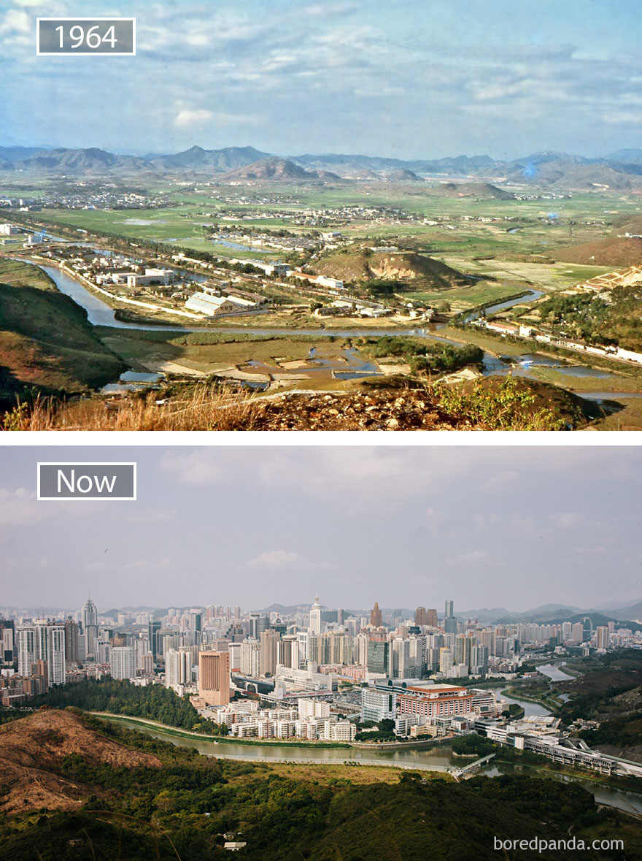

Tiananmen Square – Document G – Class Copy
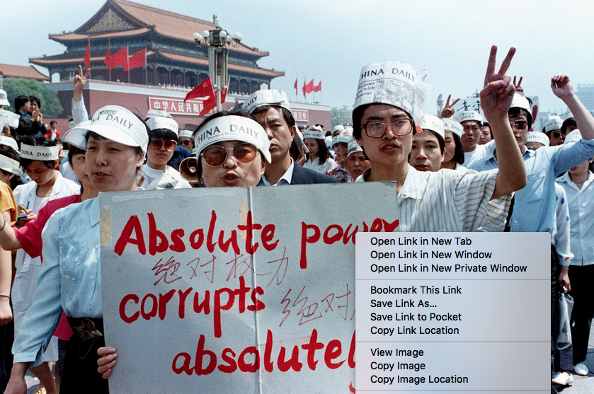
By the mid-1980s, ten years after Mao’s death, problems in Leader Deng’s plan to raise the standard of living in China were showing. The amount of food that people were growing stopped rising since farmers decided to move to the cities. In the cities, people were making things but jobs were paying less. Crime was on the rise, and more and more people were becoming homeless. There were thought to be 670,000 beggars across the nation.
Campus Protests
In 1986, the public’s unhappiness with the changes surfaced in a wave of protests and demonstrations, mostly centered on university campuses. The Chinese government responded by throwing people in jail. People were told not wear long hair and that women should stop wearing high heels. These were styles that were associated with people from the USA.
The Death of Hu Yaobang
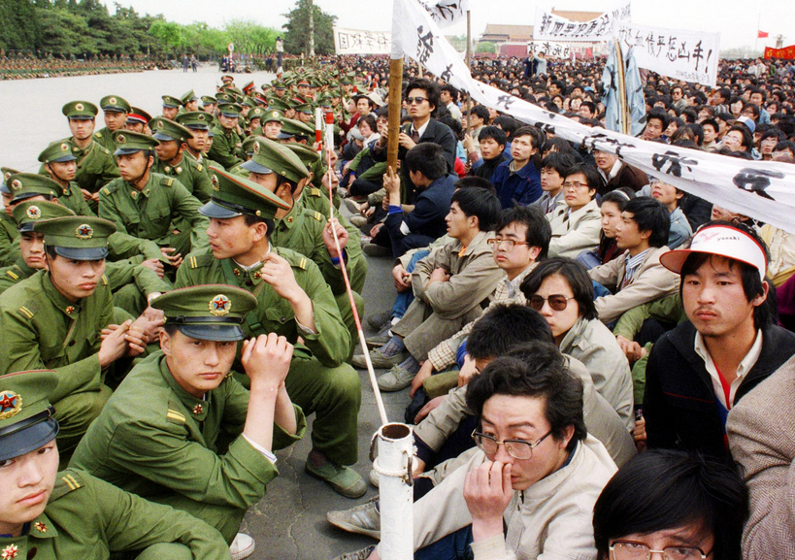
For a time the protestors were silenced, but that changed with the death of Hu Yaobang in April 1989. Posters soon appeared comparing the dead man’s values with the failings of the rest of the leaders in China. “A true man has died; false ones are still living,” one poster said. Then, as had happened following Jou En-lai’s death in 1976, people from around China came to a place called Tiananmen Square.
At first the government took no action, even though such demonstrations (protests) had been declared illegal (against the law). The students set up a temporary camp in the square and announced that they were going on a hunger strike in demand of being able to pick their own leaders.
The protestors controlled Tiananmen Square for almost a month while the government argued over how to respond to the situation. Leader Deng wanted to send in the army. Eventually, everyone in the government agreed with Deng. Thousands of Beijing citizens blocked the path of the army, and the troops had no orders to shoot their way through.
T(here is a poster in the back of Mr. Patterson’s room showing a man standing and stopping tanks from getting to Tiananmen Square.)
Meanwhile, the students in the square were becoming more outspoken in their demands. They created a version of the Statue of Liberty, openly saying that wanted to vote for their own leader. On the night of June 23, 1989, tanks and army soldiers moved in on the square, and this time the soldiers had orders to shoot. There was some fighting. One troop tank was partially destroyed by a firebomb, and a crewmember that escaped from the flames was killed. Other troops started shooting at the crowd of people. By morning, the students had been moved out and the square was empty except for the dead bodies.
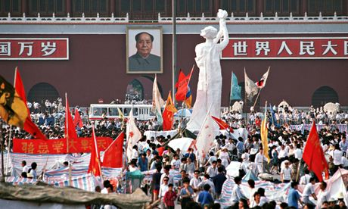
A Hollow Victory
In all, the fighting in Tiananmen Square caused several hundred Chinese civilians to lose their lives. There was never any doubt how would win, as the students couldn’t not hope to match the firepower of the Chinese Army. To this day, countries around the world attack the Chinese government for attacking people that were mostly people.

