Modern China (Population Growth and Migration)
(11 Days set aside)
One Child Policy - Bookmark
Extension: Searching for Syria
Check bookmarks
On YouTube, search Soviet Union grocery store
-Add opium wars to Hong Kong/China
tariffs and exchange rate through Lord of War?
Incorporate People and Movement Readings
DBQ Extra day for Jeopardy
Growing too big DVD

Callanan Middle School
Patterson

(W) Means on website
Underline what should be said to the class
If there is a blue word click on it while holding down “ctrl”

Purpose
The purpose of this lesson cycle is for students to learn about population changes and migration patterns in modern China. Students will learn about Chairman’s Mao use of propaganda to implement policies like the Great Leap Forward and how this impacted the Chinese population. Students will also learn about rural to urban migration and the impact of the One Child Policy.

Standards
Population Changes
3A – Evaluate why some populations are increasing and some are decreasing. (SS.7.26)
3B – Compare and contrast the effects of increasing and decreasing demographics on countries. (SS.7.24)

Students will learn how social programs (One Child Policy, Great Leap Forward, etc…) resulted in population changes in China. Students will examine the impact of increasing and decreasing demographics in Japan/China.

Migration
3A - Describe connections between push and pull factors involved in migration. (SS.7.21)
3B - Differentiate types of migration, applying contemporary patterns and examples. (SS.7.21)

Students will learn about the push/pull factors leading to rural to urban migration.

Topics | Resources
End of Emperors | Link
Mao and His Great Ideas | Link
One Child Policy | Link
Rural to Urban Migration | Link
Stock Market Game | Link
Propaganda Posters | Link
Assessments | Link

End of Emperors – 2 Days Home Next

Students will answer who, what, when, and where questions using text evidence to add strength to their writing. Retrieval – Recalling/Executing

Students will play a game by following specific rules. Retrieval – Executing

Students will make connections between the game we played in class and real life. Analysis - Generalizing

Day 1
Opening Discussion – Ask students, why did Europeans colonize Africa? (Natural resources, power) In doing so, they conquered all of Africa and where the European countries stopped, that’s where/how borders were created. So why are most African countries connected to water? (Transport, boats with sails)

Students should watch this video, what do you notice about China and Africa? Link Why do you think that China wasn’t colonized, if I told you that it did have resources? (It was powerful, big, organized through King/Emperors, and super far away. Europeans wanted Chinese goods but they had to trade, show with pennies how this lead to wealth leaving Britain and going to China. So Britain came up with a smart/messed up plan to get money out of China that changed the course of history. Explain how the opium trade worked and its devastating impact using pennies. Mankind Story of Us Link

Modern China Readings (W)  -End of Emperors  -page 1 and 2 | Resources/Materials/Extension  Highlighters

Day 2
Opening Discussion –
Starburst Communism Game  -page 9  Debrief with visuals/ w/ Cartoon, if need be actually use the reflection sheet.  Reflection/ discuss and show political cartoon  -page 10/11 | Resources/Materials/Extension  Dixie Cups, Starbursts  Flocabulary Video link  Login Rachel.smith@dsmchools.org  Password callananflo

Videos about great wall and terracotta warriors
https://www.youtube.com/watch?v=BpEWKBB6lYw
https://www.youtube.com/watch?v=23oHqNEqRyo
https://www.youtube.com/watch?v=mP5p4QbvPtc

Starburst Simulation

Rock vs. Paper
Activity helps students understand why poor people like the idea of wealth distribution.

Randomly pass out Dixie cups filled with varying amounts of Starburst candies. Fill 2-3 cups up to the top and give the rest smaller amounts (some cups only put one piece).

Tell the students to do the following things:

1. Do not eat the money until told to do so.

2. Do not trade, steal, or borrow money. Once you run out of money, sit down at your desk.

3. Play rock-paper-scissors with your classmates. Loser gives up a piece of “money.”

Let the game go until half of the class is sitting down. Ask the students how the game went. Inevitably the students that started off with little money will complain that they were at a disadvantage. Explain redistribution of wealth and link back to conditions in China during World War II to what they just went through.

Redistribute candy and let the students play.

Discuss how Communists in China promised to do this with money, power, education, land… etc.

*Label the bottom of the cups with LO for landowners and E for emperor
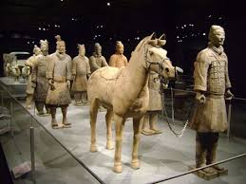
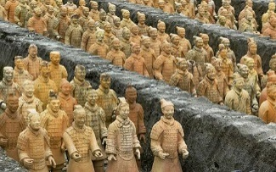
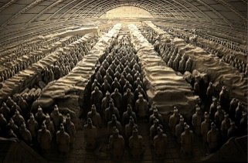
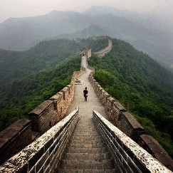

Name:

Block: Starburst Game

Teacher:

1. Describe the game we played today in class.
____________________________________________________
____________________________________________________
____________________________________________________
____________________________________________________
2. What did the starbursts represent or stand for?
____________________________________________________
____________________________________________________
____________________________________________________
____________________________________________________
3. Why did certain people start with more starbursts than others?
____________________________________________________
____________________________________________________
____________________________________________________
____________________________________________________
4. What did Mr. Patterson do after a couple of minutes? Why did he do this?
____________________________________________________
____________________________________________________
____________________________________________________
____________________________________________________
5. What happened to the total number of starbursts when Mr. Patterson collected them and then redisrubted them? Why did this happen?
____________________________________________________
____________________________________________________
____________________________________________________
____________________________________________________

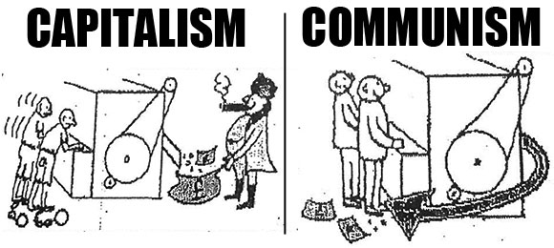

4. Political cartoon artists often use symbols to get their message across to the viewer. A symbol is a something that stands for something else. For example, the American flag often stands for America. Circle and number any symbols you recognize in the cartoon above.

5. What point is the artist trying to make in this political cartoon? In your response you should explain and cite the symbols found in the cartoon.
____________________________________________________
____________________________________________________
____________________________________________________
____________________________________________________
____________________________________________________
____________________________________________________
____________________________________________________
____________________________________________________

6. What does this cartoon have to do with starburst game we played in class?
____________________________________________________
____________________________________________________
____________________________________________________
____________________________________________________
____________________________________________________

Mao and His Great Ideas – 3 Days Previous Home Next

Students will answer who, what, when, and where questions using text evidence to add strength to their writing. Retrieval – Recalling/Executing

Students will evaluate Mao’s claim that the Great Leap Forward would help China. Analysis – Analyzing Errors

Students will examine raw data to identify patterns of when Mao’s radical programs stopped. Analysis - Generalizing

Day 3
Opening Discussion – Why did most people in China like the idea of communism? Connect the warm up to the ideas in the Starburst game yesterday. Show display and discuss vocabulary words of communism and capitalism.
Modern China Readings (W)  -Students should finish their paragraphs from day 1 along with reflection from the game on day 2. When students have finished, have them work on page 3/4 of the communist John Green reading (insert link into OneNote).  John Green Video Ancient Chinese History - Link | Resources/Materials/Extension  Include pictures/questions accordingly, transcript is already created.

Day 4
Opening Discussion – Ask students, what do Judaism, Christianity, and Islam have in common? They all have a symbol, book, and a main prophet. Write symbol, book, and leader on the white board. Explain that you are going to show some YouTube videos showing what life was like under Chairman Mao. After watching the videos, you are going to have them try and identify what symbol, book, and leader are parts of the “communist” religion. Mention that you will hear how Mao wanted to people to have a common enemy to work against. It unified them. Show students this video clip: Link

Warm up question, what is the symbol of communism?
Symbol – Red Book - Little Red Book Leader - Chairman Mao
On Grade Level  China Revolution/Video/Reading Needed  Advanced Group  -John Green China’s Revolutions  -pages , need time stamps Link  Cultural Revolution - Link | Resources/Materials/Extension  Computers/headphones  Rise of Modern China – page 28-29  ISBN: 15881092-6  Make sure you underline Mao, Little Red Book, Red, vocab in reading.  Political Cartoon/Videos  -page , post link in OneNote  If students finish, have them start on the GLF.

Day 5
Opening Discussion – If we wanted to figure out how rich a country was, what things/numbers should we look at? How long people live and how much they make, not steel and wheat
Modern China Readings – (W)  -page , Great Leap Forward  Watch the videos and show the below Great Leap Forward videos (actually watch them and adjust questions accordingly).  https://www.youtube.com/watch?v=v6Y4Ce5aeXQ  Great Leap Forward Videos: Link | Resources/Materials/Extension  Communism Visuals (W)

3A – Evaluate why some populations are increasing and some are decreasing. (SS.7.26)
Mao’s Communist Religion
Great Leap Forward

Extensions
Setup the video, talk about how large numbers are hard to think about. The video that we are going to watch is a focus is about WWII but it helps us visualize how many people died under Mao’s world. Link Discuss Mao’s complicated legacy in China.
Name:

Block: The Great Leap Forward

Teacher:

Part 1
Besides being monotheistic (believing in one God), what do Judaism, Christianity, and Islam all have in common?
____________________________________________________
____________________________________________________
____________________________________________________
____________________________________________________
Some people have accused the communist leader, Mao Tse Tung, of creating a religion in China. Why did they believe this?
____________________________________________________
____________________________________________________
____________________________________________________
____________________________________________________
____________________________________________________

Part 2
Step 1: Previewing Text- Look over what you are about to read; in order to better prepare yourself for success. Highlight the answers to the below questions.
Highlight Color | 1. If there is an article title, what is it?
 | 2. If there are sections titles, what are they?
 | 3. What vocabulary words are in the text? Vocab words are underlined.
Step 2: Read Text- Read the documents either by yourself or out loud with your group.

Step 3: Text Evidence – After reading, go back through the text and highlight the part of the text you would use to answer the following questions.
Highlight Color | 1. What was the purpose of the Great Leap Forward?
 | 2. Scared of disappointing Mao, what good things did people say were happening?
 | 3. What bad things were actually happening in China?

Step 4: Writing to Inform- Use the highlighted text to respond to the prompt below in paragraph form. Make sure that you use proper citations.

What was the purpose of the Great Leap Forward? How did Mao accidentally kill millions of people?

Name:

Block: Propaganda Poster

Teacher:

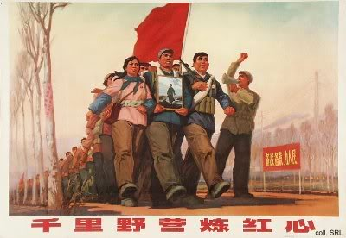

1. Political cartoon artists often use symbols to get their message across to the viewer. A symbol is a something that stands for something else. For example, the American flag often stands for America. Circle and number any symbols you recognize in the cartoon above.

2. What point is the artist trying to make in this poster? In your response you should explain and cite the symbols found in the cartoon.
____________________________________________________
____________________________________________________
____________________________________________________
____________________________________________________
____________________________________________________
____________________________________________________
____________________________________________________
3. After you get your answer to number 2 checked by Mr. Patterson, grab a computer and watch the video at the following website link: http://bit.ly/19w6pvm

Mr. Patterson would suggest you start watching it at 4:30. The link is also posted on OneNote. You do not need to write in complete sentences.

Three Things I Learned From the Video…

Two Things That I Found Interesting…

One Question I Still Have…

One Child Policy - 1 Day Previous Home Next

Students will examine an article and video to answer who, what, when, and where questions about population growth (Retrieval – Recalling).

Students will make and defend predictions about the shape of population pyramids for specific countries (Analysis – Specifying).

Day 6
Opening Discussion –
Modern China Visuals (W) | Resources/Materials/Extension

Read introduction to Population Growth, page 7, common reading for all colors. Have students make a t-chart with these two questions.

Why would it be bad to have too many young people?
What would it be bad to have too many old people?

ISBN: 978-07362-9769-1, Green (Above), page 10–15, South Korea, Too many old people
ISBN: 978-07362-9768-4, Orange (At), page 16-21, Pakistan, Too many young
ISBN: 978-07362-9770-7, Blue (Below), page 10-15, China, A success?

Chinese government responsible, Mao’s propaganda. Too many males in China.

Gap minder population. Link
Population Pyramid – Ted Ed, 4 minutes, Link

Musings
3B – Compare and contrast the effects of increasing and decreasing demographics on countries. (SS.7.24)
Gap Minder Population
One Child Policy/Documentary/Positive/Negative
DBQ Advanced students
China vs Japan, too many young people and too few

Rural to Urban Migration - 1 Day Previous Home Next

Students will examine an article and a video to answer who, what, when, and where questions about migration (Retrieval – Recalling).

Students will assess/critique the impact of different countries’ policies on rural to urban migration (Analysis – Analyzing Errors).

Day 7
Opening Discussion –
Modern China Visuals (W) | Resources/Materials/Extension

3A - Describe connections between push and pull factors involved in migration. (SS.7.21)
3B - Differentiate types of migration, applying contemporary patterns and examples. (SS.7.21)

Read introduction to migration, pages 5-7. Common reading for all colors. Migration Video Link

ISBN: 978-07362-9769-1, Green (Above), page 10–15, Toronto
ISBN: 978-07362-9768-4, Orange (At), page 10-15, Mexico City
ISBN: 978-07362-9770-7, Blue (Below), page 16-21, London

Push Pull Factors to move cities/countries
What is life like in the new country/city?

Day 8
Opening Discussion –
Modern China Visuals  Exit Ticket/OneNote Video  -page | Resources/Materials/Extension  Rural to urban migration in China.  Male vs. Female Disparity in China

Page 9, thematic map of world immigration. Same in all books. Interpreting the map and what it means for China. China has 150,000,000 million internal migrants. How can this statement and the map both be true?

ISBN: 978-07362-9769-1, Green (Above), page 10–15, Toronto
ISBN: 978-07362-9768-4, Orange (At), page 10-15, Mexico City
ISBN: 978-07362-9770-7, Blue (Below), page 16-21, London

Exit ticket for groups that don’t share out something meaningful. Sharing tokens. Video in OneNote for students to watch after

Video – 24 minutes, Too Many Men in China Link
Video – 4 minutes, Propaganda video made by China about workers link

Name:

Block: Migration and Population

Teacher:

Would you rather be in charge of a country with too many young people or too many old people? What problems would your country have? How would you go about fixing it?
________________________________________________________________________________________________________
____________________________________________________
____________________________________________________
____________________________________________________
____________________________________________________
____________________________________________________
____________________________________________________

Name:

Block: Migration and Population

Teacher:

Would you rather be in charge of a country with too many young people or too many old people? What problems would your country have? How would you go about fixing it?
________________________________________________________________________________________________________
____________________________________________________
____________________________________________________
____________________________________________________
____________________________________________________
________________________________________________________________________________________________________

What would the government have to give you for you to live in a small town out in the country? What would have to happen in Des Moines for you to want to leave the city?
____________________________________________________
____________________________________________________
____________________________________________________
____________________________________________________
____________________________________________________
Watch the video about Too Many Men in China. There is a link posted in OneNote. What are five things that you found interesting in the video? You don’t need to write in complete sentences.

What would the government have to give you for you to live in a small town out in the country? What would have to happen in Des Moines for you to want to leave the city?
____________________________________________________
____________________________________________________
____________________________________________________
____________________________________________________
____________________________________________________
Watch the video about Too Many Men in China. There is a link posted in OneNote. What are five things that you found interesting in the video? You don’t need to write in complete sentences.

Stock Market Game - 1 Day Previous Home Next

Teams will create a strategy to win an academic game when all options appear equal. Retrieval – Executing, Knowledge Utilization – Decision Making

Students will make connections between the game we played in class and real life. Analysis – Generalizing

Day 9
Opening Discussion –
Stock Market Game (W) | Resources/Materials/Extension  Video of Chinese Economy Transition  https://www.youtube.com/watch?v=fZwEDa9TrfE

Propaganda Techniques/Everyone have babies
Show with gap minder, how China’s bubble is large and rising. Debrief Stock Market game. Link

Propaganda Poster - 2 Days Previous Home Next

After watching World War II footage, teams will identify critical elements of effective propaganda. Analysis - Generalizing

Students will create a communist propaganda poster that uses symbols/slogans to manipulate the public. Comprehension - Symbolizing

Day 10
Opening Discussion – See below *
Education for Death - Link  Propaganda Video – page 6/7  Propaganda Posters visuals | Resources/Materials/Extension  CNN Student news?  Students can identify specific time stamps of when Education for Death uses elements of effective propaganda. No need to for headphones.
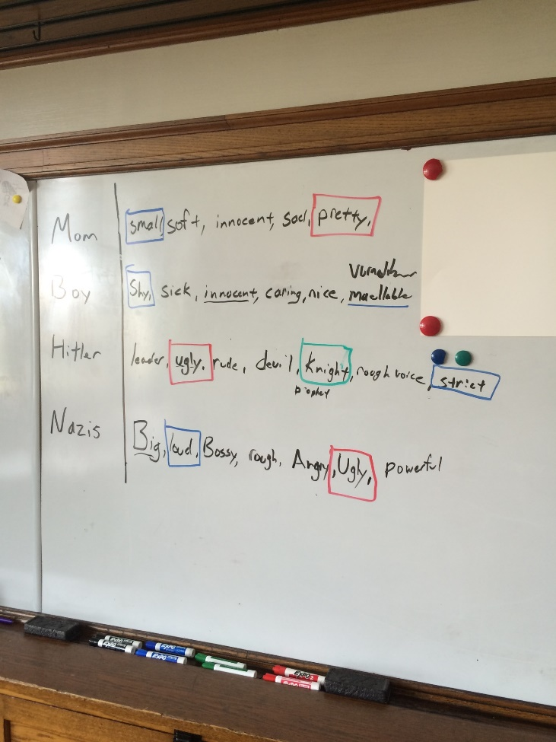
*Be up front with the students that you are going to show the Nazi video twice. The first time through, have the students write down all the bad things that the Nazi’s (Hitler) are doing to the little boy to shape his thinking. Have the students share out their answers. Ask them is this fair or right for people to be manipulated?

Tell the students that you are going to play the video a second time. Write a list of the main characters on the board. Have them jot down lists of adjectives that describe the character. Give examples. Have students share out their findings. Talk about how Disney is trying to manipulate the viewers. Including the manipulation of religious symbols.

What makes a piece of propaganda effective? Message that is easy to understand, biased, targets emotions

Introduce Propaganda Posters
For the propaganda posters, explain that the Chinese lettering system is really, really complicated. It doesn’t neatly match up with the English alphabet. The cheat sheet is helpful. If they want, they could use Google Translate for a more accurate translation. Google Chinese Propaganda Posters, walk the students through raised arms, red books, smiles, looks of determination, red books, Mao and massive amounts of people! All symbols that the students could include in their posters.

Day 11
Opening Discussion – North Korean Link Is this an effective piece of propaganda? Revisit student generated definition of effective propaganda.
Propaganda Poster  -page | Resources/Materials/Extension  Extension: Political map of East Asia  D.A.R.E Video - link

Name:

Block: Propaganda Video
Teacher:

Mom
Boy
Hitler
Nazis (Teacher)

Name:

Block: Propaganda Video
Teacher:

Mom
Boy
Hitler
Nazis (Teacher)
North Korean Propaganda Video
1. What is the video trying to make America look like?
____________________________________________________________________________________________________________________________________________________________
2. How are they trying to accomplish this? What do you see? Does the commentary (words) match the pictures?
________________________________________________________________________________________________________
________________________________________________________________________________________________________
3. In your opinion, who is the target for this video propaganda? The anti-Drug video was targeted to young people who skateboard. ________________________________________________________________________________________________________
____________________________________________________

North Korean Propaganda Video
1. What is the video trying to make America look like?
____________________________________________________________________________________________________________________________________________________________
2. How are they trying to accomplish this? What do you see? Does the commentary (words) match the pictures?
________________________________________________________________________________________________________
________________________________________________________________________________________________________
3. In your opinion, who is the target for this video propaganda? The anti-Drug video was targeted to young people who skateboard. ________________________________________________________________________________________________________
____________________________________________________

Propaganda Poster – Class Copy

Directions: Grab a poster paper and fold it in half. Half of the paper will be a poster and the other half will be your explanation.
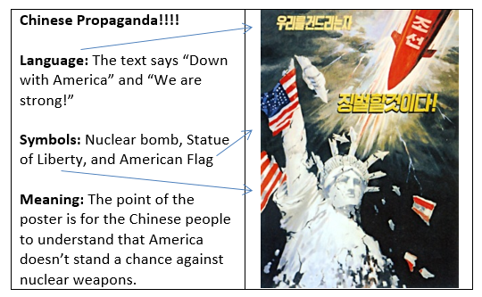

Create a propaganda poster that could have been found in China. Just like my example above, you will need to explain what the Chinese letters mean (language), what symbols you included, and the meaning of the poster.

In the past, most students searched on Google for Chinese propaganda posters for ideas. Students in years past have created propaganda posters that urged people to make steel so they could raise the standard of living.
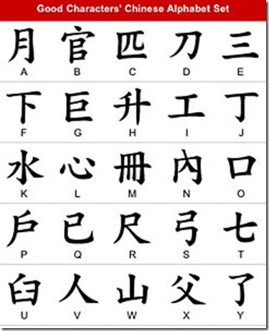

Assessment - 1 Day Previous Home

Students will answer who, what, when, and where questions about population growth and migration in modern Chinese history. Students will connect the games/activities we played in class to patterns in Chinese history. Retrieval - Recalling

Students will investigate rural to urban migration in Iowa. Students will construct an argument, debate, investigate, research, and take a position on how/if this trend should be stopped. Knowledge Utilization - Investigating

Day 12
Opening Discussion –
China Review (Traditional Assessment)  Level 4 Research (Rigorous Task)  Bourdain Parts Unknown Amazon  Season 8, Episode 3 | Resources/Materials/Extension

Add this question to Traditional Assessment?
After you left school today, you were so excited to go home and stalk that one person on Instagram, you hardly noticed where you were walking. BAM! Out of nowhere a car comes and hits you.

Beep… beep… beep…

When you suddenly wake up, you realize that something has gone terribly wrong. The bad news is that you’ve been in a coma (asleep) for four whole years! So much has changed since you were last awake.
Kanye is now president!?! Iowa State had a winning in season in football?!? Even more important is that the person that hit you with the car four years ago offered to buy you a house. There is an important decision you have to make; do you want to buy a house/live in a communist or a capitalist country? Regardless of which option you choose, you need to explain why.

Name:

Block: China Review

Teacher:

1. Why did China stop having emperors? In your answer, you could write about: colonization, opium wars, starburst game, the definition of communism
______________________________________________________________________________________________________________________________________________________________________________________________________________________________________________________________________________________________________________________________________________________________________________________________________________________

2. Explain why Mao’s great ideas, weren’t so great. In your answer, you could write about: Great Leap Forward, communism, steel furnaces, famine
______________________________________________________________________________________________________________________________________________________________________________________________________________________________________________________________________________________________________________________________________________________________________________________________________________________

3. Give your opinion, was the One Child Policy a good or bad idea? In your answer, you could write about: what happens if there are to few and too many young people
______________________________________________________________________________________________________________________________________________________________________________________________________________________________________________________________________________________________________________________________________________________________________________________________________________________

4. Why are people moving from the country to cities? In your answer, you could write about: push/pull factors, life in a new city
________________________________________________________________________________________________________________________________________________________________________________________________________________________________________________________________________________________________________________________________________________________________________________________________________________________________________________________________________________

5. Why would Chinese leaders be worried about a stock market crash? In your answer, you could write about: the stock market game we played in class, the videos
______________________________________________________________________________________________________________________________________________________________________________________________________________________________________________________________________________________________________________________________________________________________________________________________________________________

6. On the T.V. there is a screen shot from a video we watched in class, why is this video considered effective propaganda? In your answer, you could write about: symbols, being biased
__________________________________________________________________________________________________________________________________________________________________________________________________________________________________________________________________________________________________
________________________________________________________________________________________________________________________________________________________________________________________________________________________________________

Level 4 - Research Question
Congratulations, due to your hard work and the quality of assignments that you turned in, you don’t need to take the test the rest of the class is going to work on. Instead, Mr. Patterson is going to have you try and find the answers to the questions below. You can type your answers in OneNote, online word, or you can handwrite it on a piece of paper. The important thing is that you need share it with Mr. Patterson, when you are finished. Andrew.patterson@dmschools.org. If you want to work together with other students that received this paper, that is up to you.

Why is rural to urban migration happening? Is it a good or bad thing? How does it impact Iowa? If you were a congresswoman representing a rural area of Iowa, what action plan would you take to get people to move to your communities?

Level 4 - Research Question
Congratulations, due to your hard work and the quality of assignments that you turned in, you don’t need to take the test the rest of the class is going to work on. Instead, Mr. Patterson is going to have you try and find the answers to the questions below. You can type your answers in OneNote, online word, or you can handwrite it on a piece of paper. The important thing is that you need share it with Mr. Patterson, when you are finished. Andrew.patterson@dmschools.org. If you want to work together with other students that received this paper, that is up to you.

Why is rural to urban migration happening? Is it a good or bad thing? How does it impact Iowa? If you were a congresswoman representing a rural area of Iowa, what action plan would you take to get people to move to your communities?

Level 4 - Research Question
Congratulations, due to your hard work and the quality of assignments that you turned in, you don’t need to take the test the rest of the class is going to work on. Instead, Mr. Patterson is going to have you try and find the answers to the questions below. You can type your answers in OneNote, online word, or you can handwrite it on a piece of paper. The important thing is that you need share it with Mr. Patterson, when you are finished. Andrew.patterson@dmschools.org. If you want to work together with other students that received this paper, that is up to you.

Why is rural to urban migration happening? Is it a good or bad thing? How does it impact Iowa? If you were a congresswoman representing a rural area of Iowa, what action plan would you take to get people to move to your communities?

