Name: Block: Teacher:

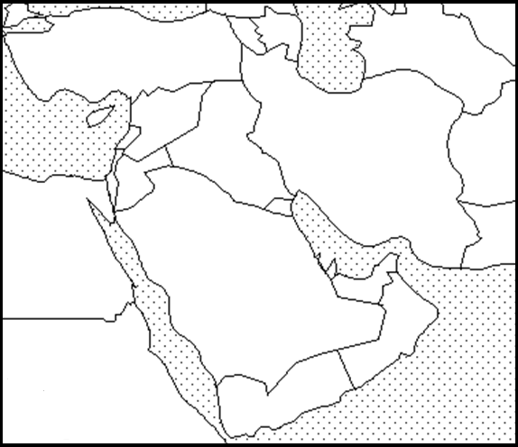
Map Key
(Title) _______________________________________________

Southwest Asia - Political Map

Directions: Include the below details on your Southwest Asia political map. To help you label these details you may use a purple Africa book using page 260. If the color you are supposed to use is being used by someone else than use a different color.

Make sure your map is presentable. Please do not rush while doing this assignment. Make sure you include a map title and key. Names of countries should be in CAPS. Capitals should be marked with a small star and circle around it.
Example:

Color | Label Country & Capital
Orange | Israel
Yellow | Saudi Arabia
Orange | Yemen
Purple | Iraq
Orange | Iran
Green | Oman
Green | Kuwait
Yellow | Syria

Latitude and Longitude
1. Ankara, Turkey Latitude- Longitude-

2. Sanaa, Yemen Latitude- Longitude-

3. Muscat, Oman Latitude- Longitude-

4. Tehran, Iran Latitude- Longitude-

5. Kabul, Afghanistan Latitude- Longitude-

6. Mecca, Saudi Arabia Latitude- Longitude-

7. Des Moines, Iowa Latitude- Longitude-

