Name: Block: Teacher:

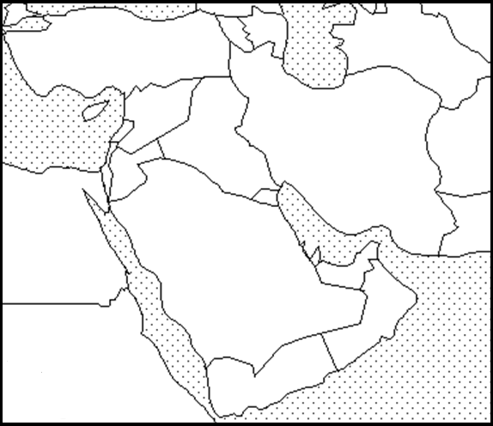
Map Key
(Title) _______________________________________________

Southwest Asia - Climate Map
Part 1
Directions: Include the below details on your Southwest Asia political map. To help you label these details you may use a purple Africa book using page 38. If the color you are supposed to use is being used by someone else than use a different color.

Make sure your map is presentable. Please do not rush while doing this assignment. Make sure you include a map title and key. Names of countries should be in CAPS.

Climate | Color
Semiarid | Brown
Arid | Yellow
Mediterranean | Blue
Humid Subtropical | Green
Highland | Purple

Part 2
Read pages 35 -38 and answer the questions below in complete sentences.

Page 35
1. How many years can pass between rainfalls in the Rub’ al-Khali?

Page 36
2. What is an Oasis?

Page 37
3. What two rivers in Iraq allowed civilization to flourish?

4. What was this civilization called?

Page 38
5. List all countries of the Middle East that have a Mediterranean climate.

