Is Mansa Musa the richest man who ever lived?
Amazon founder Jeff Bezos is the richest man in the world. With an estimated fortune of $131bn, he is the wealthiest man in modern history. But he is by no means the richest man of all time.
1

That title is believed to belong to Mansa Musa, the 14th Century West African ruler/king. Modern rumors of Musa's wealth are so breathless that it's almost impossible to get a sense of just how wealthy and powerful he truly was. Mansa Musa was "richer than anyone could describe.” A website recently estimated his wealth at $400bn, but most historians agree that his wealth was much higher.

The Golden King
Mansa Musa was born in 1280 into a family of rulers. His brother, Mansa Abu-Bakr, ruled the empire of Mali until 1312, when he decided to go off exploring.

Mansa Musa took over/controlled the kingdom he left behind. Under his rule, the kingdom of Mali grew significantly. He colonized/conquered 24 cities, including Timbuktu.
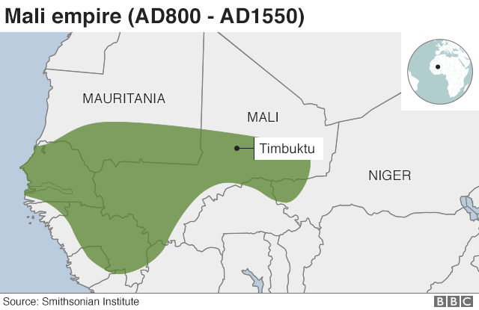
The kingdom was very large. I went for about 2,000 miles, from the Atlantic Ocean all the way to modern-day Ivory Coast.
2

With such a big area of land came valuable resources such as gold and salt. During the time of Mansa Musa, the empire of Mali controlled half of the world’s gold. And all of it belonged to the king.

The Journey to Mecca
Though the empire of Mali was home to so much gold, the kingdom itself was not well known.
This changed when Mansa Musa, a Muslim, decided to go on a trip to Mecca, passing through the Sahara Desert and Egypt.
3
The king reportedly left Mali with a group of 60,000 men. He took his friends, government workers, soldiers, griots (entertainers), merchants, camel drivers and 12,000 slaves, as well as a long train of goats and sheep for food. It was a large group of people, who all the way down to the slaves, were wearing gold and finest Persian silk. A hundred camels were in tow, each camel carrying hundreds of pounds of pure gold.

It was an impressive sight to see, especially when they got to Cairo where there were things to buy.

The Cairo Gold Crash
Mansa Musa left such a impression on the city of Cairo that people talked about him for years.

He gave out so much gold to people, that it lost its value. People decided that they didn’t need to work anymore.

On his way back home from Mecca, Mansa Musa passed through Egypt again, seeing that people weren’t working, offered to borrow their money and promised to give them back more of it the future.
4

Some Malian griots, who are singing historian storytellers were upset with him. He gave out so much Malian gold along the way that griots don't like to praise him in their songs because they think he wasted local resources outside the empire.

Education at Heart
There is no arguing that Mansa Musa spent, or wasted, a lot of gold during his trip. But the world took notice of him and his wealth.

Mansa Musa had put Mali and himself on the map. In a Catalan Atlas map from 1375, a drawing of an African king sits on a golden throne atop Timbuktu, holding a piece of gold in his hand.

Timbuktu became an African El Dorado and people came from near and far to have a glimpse of it for its wealth. In the 19th Century, it still had a legendary status as a lost city of gold at the edge of the world, a rumor that attracted hunters and explorers, and this was largely down to the actions of Mansa Musa 500 years earlier.
5

Mansa Musa returned from Mecca with several Islamic teachers, including direct descendants of the prophet Muhammad and an Andalusian poet and architect by the name of Abu Es Haq es Saheli, who is widely credited with designing several beautiful mosques.

In addition to encouraging the arts and building, he also built schools and libraries. Timbuktu soon became a center of education and people travelled from around the world to study at the college there. The rich king is often thought of as the father of education in West Africa.

Mali’s Decline
After Mansa Musa died in 1337, aged 57, the empire was supposed to be ruled by his sons who could not get along. Parts of the empire started to fight each other.
____________________________________________________________________________________
Directions: The questions below correspond with the big numbers. in the reading above. Underline or highlight where in the reading you found the information to answer the question. Then, use the highlighted text in your writing.

1. How does Mansa Musa’s wealth compare to the richest person in the world right now?
2. How did taking over more cities/land make Mansa Musa more powerful?
3. What did Mansa Musa take with him on his trip?
4. What did Mansa Musa do once he got to the city of Cairo? Why are griots upset with the king?
5. Why is Mansa Musa viewed as the father of education in West Africa?

6. Opinion Question: In your opinion, how should Mansa Musa be remembered? Should the students in Mali learn about him? Was his trip to Mecca a good or bad thing? Explain your thining.

