Name:

Block: The Individual and the Economy – Level 2

Teacher:

Directions: Define the following vocabulary words. You can but are not required to connect the word with something we did in class. Write the definitions on a lined piece of paper and then staple it to this page.

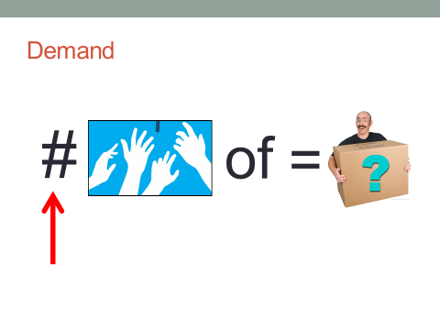
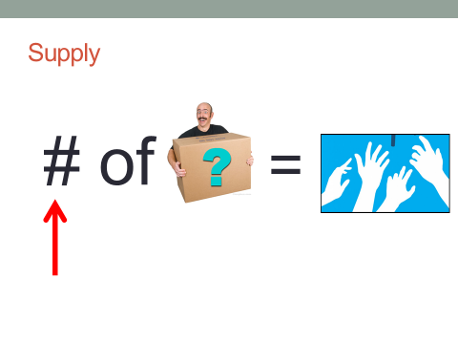
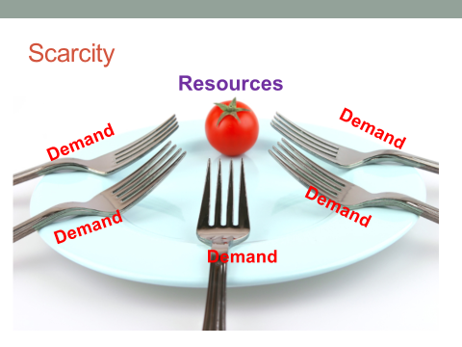
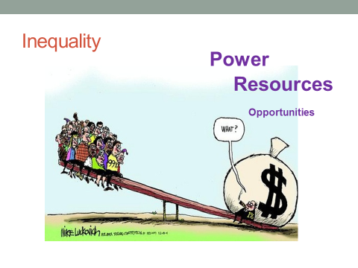
3
4
2
1

Name:

Block: The Individual and the Economy – Level 2/3

Teacher:

Topic | 2 | 3 | 4
Individual in the Economy | A.) scarcity, supply, demand, inequality  B.) economic institutions | A1.) Understand how resource imbalance leads to economic problems within a region.  A2.) Understand what determines a person’s quality of life.  B1.) Evaluate an organization/group that is trying to bring about change. | Is your future determined at birth?

Directions: Define the following vocabulary words. You can but are not required to connect the word with something we did in class.

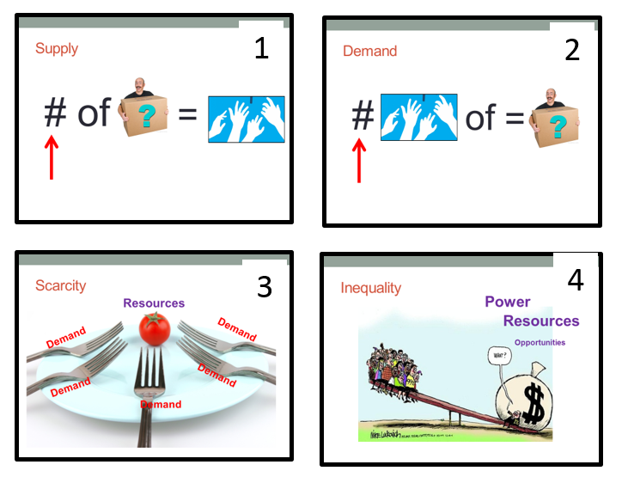

1. Supply
____________________________________________________
____________________________________________________
____________________________________________________
____________________________________________________
____________________________________________________

2. Demand
____________________________________________________
____________________________________________________
____________________________________________________
____________________________________________________
____________________________________________________

3. Scarcity
____________________________________________________
____________________________________________________
____________________________________________________
____________________________________________________
____________________________________________________

4. Inequality
____________________________________________________
____________________________________________________
____________________________________________________
____________________________________________________
____________________________________________________

5. How has South Asia’s past created inequality for its people?
In your response, you can but are not required to describe the problem that you’ve been looking at for the last two weeks. You can use vocabulary words like scarcity, inequality, supply, and demand to help focus your writing.
____________________________________________________
____________________________________________________
____________________________________________________
____________________________________________________
____________________________________________________
____________________________________________________
____________________________________________________
____________________________________________________
____________________________________________________
____________________________________________________
____________________________________________________
____________________________________________________

6. What are some of the barriers (things preventing) the problem that you described from being fixed?

____________________________________________________
____________________________________________________
____________________________________________________
____________________________________________________
____________________________________________________
____________________________________________________
____________________________________________________
____________________________________________________
____________________________________________________
____________________________________________________
____________________________________________________

7. How can financial instruments (money) like microloans, grants, affirmative action, foreign aid, or scholarships help fix the problem that you described?

____________________________________________________
____________________________________________________
____________________________________________________
____________________________________________________
____________________________________________________
____________________________________________________
____________________________________________________
____________________________________________________
____________________________________________________
____________________________________________________
____________________________________________________
____________________________________________________

