Human Rights Lesson Cycle
Daddy’s Life – Commercial - Link

Southeast Asia
Patterson

(W) Means on website
Underline what should be said to the class
If there is a blue word click on it while holding down “ctrl”

Civics - Iowa Core Language
SS.7.15. Distinguish and apply the powers and responsibilities of global citizens, interest groups and the media in a variety of governmental and nongovernmental contexts.
SS.7.16. Examine the origins, purposes, and impact of laws, treaties, and international agreements.
SS.7.17. Describe the roles of political, civil, and economic organizations in shaping people's lives.
SS.7.27. Analyze the role that Iowa plays in contemporary global issues.

Civics - Student Friendly Language
SS.7.15, 7.17 Explain how and why individuals, governments, and other groups, bring about positive change in the world.
SS.7.16 Examine how laws and agreements between countries and businesses can bring about positive change.
SS.7.27 Analyze how Iowa is helping bring about meaningful change in the world.

The primary focus of this unit is to introduce students to the idea that there are guaranteed rights that every human should have access to. Students will play an investment game to understand why products are made outside of the United States. They will trace items at Callanan back to the source of origin and analyze the corresponding data. Students will watch parts of the Netflix documentary True Cost and analyze the broad themes present in the documentary, working conditions, environment, and manipulative advertising. This work falls within the Civics scale provided by the district.

Topic LINKS | Estimated Length
Global Scavenger Hunt | 1 Day
Investment Game | 2 Days
True Cost Documentary | 4 Days
Human Rights PowerPoint | 2 Days
Summative Assessment | 1 Day

Global Scavenger Hunt Home Next
Taxonomy Level | Learning Targets (What are students learning?)
Retrieval – Executing  Retrieval – Executing  Analysis - Classifying | Students will gather items and identify their country of origin.  Students will gather data about that country’s economy.  Students will analyze the data to determine if they notice any trends/patterns.

Day 1
Opening Discussion: Show intro pictures of where Southeast Asia is located, set parameters/suggestions of where/how to find items, set a timed goal, student will collect data about they have and then go find the rest. Possibly go over Investment game at the end
Human Rights Visuals (W)  Global Scavenger Hunt  -Gather information | Resources/Materials/Extension  Computers for each team

Name:

Block: Scavenger Hunt Data

Teacher:

Item | Country | Estimated Value | Minimum Wage | Corporate Taxation Rate | Industry % of Econ.
Chair | United States | $40.85 | $7.25 | 21% | 19.7%

Investment Game Previous Home Next
Taxonomy Level | Learning Targets (What are students learning?)
(Knowledge Utilization – Decision Making) | Teams will create a winning strategy/plan to win an academic game when all options appear equal.

Day 2
Opening Discussion: Make signs, Average ending round bid visual,
Investment Game (W)  -Students will play the investment game. Debrief using cartoon and reflection. | Resources/Materials/Extension  Graph data points from the game

Day 3
Opening Discussion: Using visuals, debrief the investment simulation. Who won the game yesterday? (Nike did) Why don’t countries work together like OPEC to get what they want? (Too many countries wanting the same jobs) Touch upon how extreme competition without regulation isn’t always a good thing. Make sure to include definition of globalization and drawing from visuals that shows where the money from Nike. Examine the last winning bid round slip.
Investment Game (W)  Students will play the investment game. Debrief using cartoon and reflection.  Discuss:  -Who won the game? (Nike)  -Why it would be hard countries to work together? (Too much competition, unlike OPEC, all countries have workers and need good jobs)  -How freedom in the bid is for Nike and not workers | Resources/Materials/Extension  -Finish Scavenger Hunt  -Explain the three categories. Have students look up countries using the Human Index Link  -Any patterns they notice.  Have students graph bids slips, before discussing visuals.  -Create a universal round bids slips for students to graph that focus only two categories. Write down the “winning” bid on the board. Make sure visuals for graphing line up, and count the number of boxes, and reference political cartoon.  -Finish gathering research/data on scavenger hunt from day 1

True Cost Documentary Previous Home Next
Taxonomy Level | Learning Targets (What are students learning?)
Retrieval – Recalling  Analysis – Generalizing | Students will watch parts of the documentary True Cost to learn about global working conditions, healthcare, and persuasive advertising. Students will accurately answer questions about the documentary.  Students will examine a biased claim/argument and determine the validity of the argument.

Day 4
Opening Discussion:
True Cost Documentary (Working Conditions)  0-16:00 Stop watching after the people start making the case for what the people are going through is good.  Article about prison working conditions in the United States. Discussion questions centered on article. Why are prisoners are only getting ten dollars a week if they are getting paid $7.25.  Russian Video Link  Possible Article - LINK | Resources/Materials/Extension  Analysis- Generalizing – Viewpoint of Executives  Discuss faulty logic using Marzano

Day 5
Opening Discussion: Visuals to discuss/student paper/process working conditions.
Netflix True Cost (Healthcare)  30-49 Minutes  Article about Flint Michigan water and healthcare. How will this impact future generations? Why is the United States better equipped than countries to handle this crisis?  Article/Video – Link Link | Resources/Materials/Extension

Day 6
Opening Discussion: Visuals to discuss/student paper to process healthcare/pollution.
Netflix True Cost (Advertising)  52:35 – 1:21  Shampoo Link Funny - Link  Link, Link, Link  Breakdown emotions tied to the product. Students find an example, write about it and copy and paste the link in OneNote. | Resources/Materials/Extension  Finding example of advertising manipulating the viewer  Daddy’s Life – Commercial - Link  My Dad’s a Liar

Day 7
Opening Discussion:
Macklemore Song  Song – Link Lyrics – Link  Have students watch the music video and examine the second verse. As a group discuss and write down, what do you think that Macklemore wanted us to think about? As a teacher, steer the discussion into what does this have to do with True Cost? See visuals | Resources/Materials/Extension  Example of Super Bowl Ads.  Create a poster/picture that ties using a product to emotion.  Start PowerPoint?  Identify human rights?

Name:

Block: True Cost - Documentary

Teacher:

1. What is Lucy Siegle’s job?
____________________________________________________
2. Today, what percentage of clothes are made in America?
____________________________________________________
3. What happened in Dhaka?
____________________________________________________
4. Who does Kate Ball-Young work for?
____________________________________________________
5. How many countries are celebrating the 15th anniversary of fair trade?
____________________________________________________
6. What happened to the woman started a union?
____________________________________________________
7. What plant is used to create the majority of clothes?
____________________________________________________
8. What is the largest seed company in the world?
____________________________________________________
9. What health problems is Dr. Singh tracking in India?
____________________________________________________
____________________________________________________
10. In the last 16 years, how many farmers have committed suicide in India?
____________________________________________________
11. What does successful advertisements do in the United States?
____________________________________________________
12. What is the dirty shadow of the fashion industry?
____________________________________________________
13. How much textile waste does the average American create?
____________________________________________________
14. What company hates the word consumption?
____________________________________________________
15. What are some of the different factors (things) that go into the true cost of what be buy?
____________________________________________________
1
16. What does GDP only measure?
____________________________________________________
17. A woman takes us to visit her family. What does she say she wants?
____________________________________________________
____________________________________________________
18. How much money does H&M make a year?
____________________________________________________
19. What do workers in Cambodia want?
____________________________________________________
20. Why do countries keep their wages low?
____________________________________________________
____________________________________________________
21. What do companies say they do in their voluntary code of conduct?
____________________________________________________
____________________________________________________
22. According to the old dude that graduated from Stanford, what can’t be questioned?
____________________________________________________
____________________________________________________
23. Why is the fashion industry in Bangladesh?
____________________________________________________
____________________________________________________
24. Who gave a speech in America that we need to have a revolution of values?
____________________________________________________
____________________________________________________
2
Name:

Block: Themes in True Cost

Teacher:

1. What are working conditions like in countries that make clothes and other cheap goods? Why are things like this? Who is responsible?
____________________________________________________ ____________________________________________________
____________________________________________________
____________________________________________________
____________________________________________________
____________________________________________________
____________________________________________________
____________________________________________________ ____________________________________________________
____________________________________________________
____________________________________________________
____________________________________________________
____________________________________________________
____________________________________________________
____________________________________________________ ____________________________________________________
____________________________________________________
____________________________________________________
____________________________________________________
____________________________________________________

2. When companies make clothes, there is a lot of waste/pollution. How is this affecting the people that we see in the documentary?
____________________________________________________
____________________________________________________
1
More room on back…
____________________________________________________
____________________________________________________
____________________________________________________
____________________________________________________
____________________________________________________ ____________________________________________________
____________________________________________________
____________________________________________________
____________________________________________________

3. How do advertisers get people to buy more things? (How do they trick people in to needing their products?)
____________________________________________________
____________________________________________________
____________________________________________________
____________________________________________________
____________________________________________________
____________________________________________________
____________________________________________________
____________________________________________________
____________________________________________________ ____________________________________________________
____________________________________________________
____________________________________________________
____________________________________________________
____________________________________________________
____________________________________________________
____________________________________________________
____________________________________________________

Give Working Prisoners Respect and Decent Pay
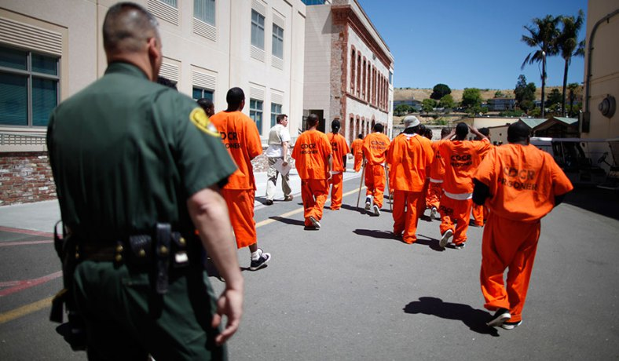
As many as 24,000 prisoners in factories across the country decided to protest the low amount that people in prison are paid per hour. This country’s largest-ever protest now seems to have not worked, with their demands unmet, prisoners have returned to work.
A recent study found that the average inmate/prisoner makes 93 cents an hour, but it can go as low as 16 cents.
I worked for almost six years, working in a prison kitchen. After taxes were taken out, I earned between $5.25 and $8.75 per week. As someone with who knows what prison is like, I know that prison work is mostly misunderstood by the public/people outside of prison. The first misconception is that all prison work is the same. In fact, there are two types of prison jobs. First, there are ones like mine, where inmates/prisoners work for the prison, and the employer — the government — doesn’t make a profit per se off prisoners’ backs, though it holds down expenses by paying little or nothing to get essential tasks done.
Then there are jobs under the Prison Industry Enhancement (PIE) program, in which inmates/prisoners are put to work by a private business. This second type of jobs holds much more potential for reform/change in ways that will help inmates.
All contracts/agreements between private companies and prisons for inmate/prisoner work must follow the PIE program rules. PIE outlines a minimum wage of $7.25 an hour for prisoners. It also says if prisoners are allowed to ask for better working conditions.
The problem is that prisoners are charged special fees that take most of their money. This includes taxes, payment of fines, rent and food, and other costs associated with the prisoner’s criminal processing and incarceration, which the prisoner can be made to repay.
Taking 80 percent of someone’s pay/money seems excessive and unreasonable; even courts don’t take 80% of someone’s money for child support.
The most obvious solution to low wages/pay for prisoners is to change the rules about what can be taken from out of their paycheck. The chance of this happening is low; prisons have become used to the money they make on prisoners and taxpayers outside of prison don’t want to have to pay more.

How tap water became toxic in Flint, Michigan

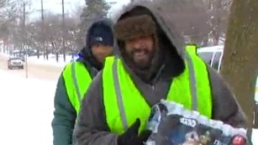
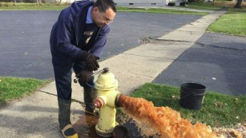
Nearly four years ago, the state of Michigan decided to save money by switching Flint's water supply from Lake Huron (which they were paying the city of Detroit for), to the Flint River, a notorious river that runs through town known to locals for its pollution.

"We thought it was a joke," said Rhonda Kelso, a long-time Flint resident. "People my age and older, thought 'They're not going to do that.' "

The switch was made during a financial state of emergency for the ever-struggling industrial town. It was supposed to be temporary while a new state-run supply line to Lake Huron was ready for connection. The project was estimated to take about two years.

Soon after the switch, the water started to look, smell and taste funny. Residents said it often looked dirty.

"The water would come in brown and my daughter was like 'Mom ... why is the water brown?' "
Kelso thought it was sewage, but it was actually iron. The Flint River is highly toxic: 19 times more so than the Lake Huron supply, according to researchers from Virginia Tech.

According to a lawsuit, the state Department of Environmental Quality wasn't treating the Flint River water with an anti-corrosive agent, in violation of federal law. Therefore, the water was eroding the iron water mains, turning water brown.

But what residents couldn't see was far worse. About half of the service lines to homes in Flint are made of lead and because the water wasn't properly treated, lead began leaching into the water supply, in addition to the iron.

This had been going on for nearly two years, and until September, city and state officials told worried residents that everything was fine. Former Flint Mayor Dayne Walling even drank it on local TV to make the point.

But in August, a group of researchers from Virginia Tech came up and did in-home testing and found elevated levels of lead in the drinking water and made those findings public. State officials insisted their own research was more accurate.

Later it became publicly known that certain laws/rules had not been followed. A 2011 study on the Flint River found it would have to be treated with an anti-corrosive agent for it to be considered as a safe source for drinking water.

Adding that agent would have cost about $100 a day, and experts say 90% of the problems with Flint's water would have been avoided. Just a few weeks later, in October, the city went back to using Detroit's Lake Huron water supply, but the damage was done to the lead pipes.

Even with properly treated water flowing in, Virginia Tech researchers still noticed lead levels in water in Flint homes.

The state is now handing out filters and bottled water to people living in the city.

In 2011, Flint was declared to be in a financial state of emergency (the city was broke), and the state took control. Therefore, all the decisions made during the water pollution crisis were at the state level.

"When the governor appointed an emergency manager (in 2011), that person came here ... to simply do one thing and one thing only, and that is to save money, at any cost," said Michigan Congressman Dan Kildee.

"This case shows that you can't treat cities the way you treat some businesses that you might just sort of sell off," Kildee said.

Lead poisoning is irreversible (not curable). Doctors for small children such as Hanna-Attisha fear the Flint babies who tested with high levels of lead will be sick for the rest of their lives

Lead hurts your IQ, it affects your behavior, it's been linked to breaking the law, it has multigenerational impacts. There is no safe level of lead in a child."

There are environmental actions that can help lower these long-term consequences such as proper nutrition and early childhood education. But that's made more difficult in a city with inadequate resources and without a grocery store.

Human Rights PowerPoint Previous Home Next
Taxonomy Level | Learning Targets (What are students learning?)
Comprehension – Symbolizing | Students will use abstract art to convey the dangers of manipulative advertising on people.

Each student will use abstract art are to convey the dangers of manipulative advertising on people. Comprehension - Symbolizing

Each student will create a presentation that outlines the hidden costs of consumerism (impact on working conditions, environmental issues, and manipulative advertising). Comprehension - Integrating

Days 8-9
Opening Discussion: Review working conditions, human rights, and advertising, define human rights, discuss difference between need and want.

Human Rights PowerPoint.  Expectations.  or  Advertising connection to Emotion. | Resources/Materials/Extension  Brainstorm list of human rights and compare it UDHR online  Discuss, why doesn’t McDonalds send its jobs overseas?  Analyze further examples of advertising and feelings.  What were they trying to get people in Britain to think about? How are they playing with emotions? Link

Human Rights PowerPoint

Human Rights - Requirements
- Explain what human rights are and why they are important for people to know about.
- Pictures related to human rights

Working Conditions – How are the people who make things we buy treated?
- Describe the working conditions in True Cost
- What should the United States government do to help people living in the poor working conditions?
- What can we do as people who buy things? What can we do to help people living in the poor working conditions?
- Pictures related to working conditions

Environment/Health – When products/items are made, pollution is created. How does this affect the people living there?
- Describe the environmental and health impact of factories around the world.
- Describe what life is like for farmers that use chemicals. Why does this occasionally lead to suicide?
- Pictures related to taking care of the environment

Advertising – How do companies try and sell their products/items to us?
- Describe how advertisers trick people to buy their products
- Provide an example from YouTube of how companies try to connect their products to emotions
- Pictures related to advertising

Human Rights PowerPoint

Human Rights - Requirements
- Explain what human rights are and why they are important for people to know about.
- Pictures related to human rights

Working Conditions – How are the people who make things we buy treated?
- Describe the working conditions in True Cost
- What should the United States government do to help people living in the poor working conditions?
- What can we do as people who buy things? What can we do to help people living in the poor working conditions?
- Pictures related to working conditions

Environment/Health – When products/items are made, pollution is created. How does this affect the people living there?
- Describe the environmental and health impact of factories around the world.
- Describe what life is like for farmers that use chemicals. Why does this occasionally lead to suicide?
- Pictures related to taking care of the environment

Advertising – How do companies try and sell their products/items to us?
- Describe how advertisers trick people to buy their products
- Provide an example from YouTube of how companies try to connect their products to emotions
- Pictures related to advertising

Summative Assessment Previous Home
Taxonomy Level | Learning Targets (What are students learning?)
Retrieval – Recalling  Analysis - Specifying | Students will explain through writing how and why individuals, governments, and other groups, bring about positive change in the world.

Day 10
Opening Discussion: Show visuals of assessment, explain expectations when finished. (If being observed, rewrite to better fit the definition of analysis.)
Summative Assessment | Resources/Materials/Extension

Name:

Block: Human Rights Assessment

Teacher:

SS.7.15, 7.17 Explain how and why individuals, governments, and other groups, bring about positive change in the world.
SS.7.16 Examine how laws and agreements between countries and businesses can bring about positive change.
SS.7.27 Analyze how Iowa is helping bring about meaningful change in the world.

Directions: Define the following vocabulary words. You can but are not required to connect the word to something we did in class.

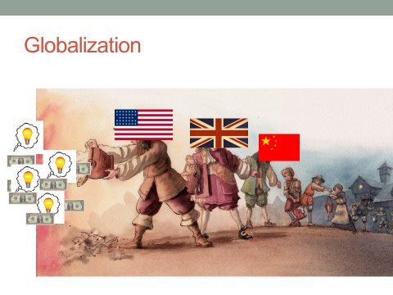
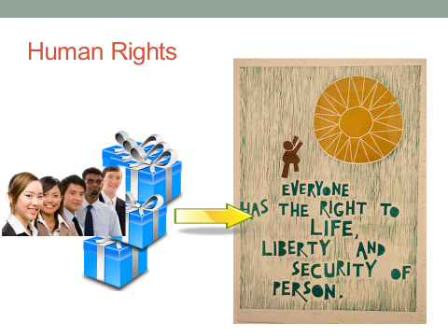

1. What are human rights?
________________________________________________________________________________________________________________________________________________________________________________________________________________
2. Explain the idea of globalization.
________________________________________________________________________________________________________________________________________________________________________________________________________________

We are all Born Free and Equal | We’re Always Innocent Till Proven Guilty | The Right to Democracy  (Choose their leaders)
Don’t Discriminate  (Don’t target people) | The Right to Privacy | Social Security  (Be taken care of when older)
The Right to Life | Freedom to Move | Worker’s Rights  (Safe and welcoming place to work)
No Slavery  (People should be paid for their work.) | The Right to Seek a Safe Place to Live | The Right to Play  Play
No Torture  (Don’t hurt people you have control over) | Right to a Nationality  (People should be able to form their own country). | Food and Shelter for All
You Have Rights Everywhere | Marriage and Family  (People should be able to choose who they marry.) | The Right to Education  (For everyone, regardless of identities)
We’re All Equal Before the Law | The Right to Your Own Things | Copyright  (Your ideas should be protected)
Your Human Rights are Protected By Law  (If people break these rules, there should be a punishment.) | Freedom of Thought  (People shouldn’t be brainwashed or tricked into believing something.) | A Fair and Free World
No Unfair Detainment  (Shouldn’t be put in jail for no reason.) | Freedom of Expression  (People should be able to choose what they write.) | Responsibility
The Right to Trial  (Everyone has a right to prove their innocent) | The Right to Public Assembly  (Get together to protest.) | No One Can Take Away Your Human Rights

3. Explain, with examples, how different countries treat their citizens differently when it comes to human rights. Think of the investment game we played, the documentary watched, the articles we have read, and what you learned about breaking your
___________________________________________________
4. What should the United States do about human rights violations happening around the world? No country is perfect. The United States government has been accused of human rights violations. As people who buy things, what is our responsibility to people who live around the world? You will need to state your opinion and then justify it with examples from class and/or the news.
___________________________________________________
5. Write a response to the question below. In your response, you can but are not required to use the following phrases: human rights, outsourcing, and globalization. Please underline, highlight or put boxes around if you use these academic words in writing

What is the real price of your t-shirt?

Extra Musings/Resources/Lesson Ideas that were Removed

https://en.wikipedia.org/wiki/List_of_countries_by_Human_Development_Index
https://www.youtube.com/watch?v=RBQ-IoHfimQ What were they trying to get people in Britain to think about? How are they playing with emotions?
https://www.youtube.com/watch?v=ImUpZhR7FAQ

The Idea that every country violates human rights, is how blatant is it? Is it against the laws? Is it state sanctioned or is it something that people don’t even realize is going on?
What is the United States’ role to defend this?
Examine Coffee, freetrade and the role of Starbucks
Brainstorm list of human rights, place that list on sheet
Model expectation of NGO Human rights with documentary
Possibly include a mini lesson on consumerism in the music industry,
When giving the district assessment, give students a simplified version of human rights and the articles about Saudi Arabia
Also, instead of having students analyze the Saudi article as practice, have students due the same process with the articles/issues that they placed in OneNote
On the assessment, remove the question about the role of the United States.

Human Rights Website -

General Things to Think About
- Create an account on the website Weebly
- Use your school email when registering.
- Include appropriate and relevant pictures on each page.
- Use text evidence on every page.
- When you publish your website, it gives you a link. You should copy and paste that link into OneNote.

Homepage - Requirements
- Title of your website
- Explain what human rights are and why they are important for people to know about.
- Pictures related to human rights

Working Conditions – How are the people who make things we buy treated?
- Page title and pictures
- Describe the working conditions in True Cost
- What should the United States government do to help people living in the poor working conditions?
- What can we do as people who buy things, what can we do to help people living in the poor working conditions?

Advertising – How do companies try and sell their products/items to us?
- Page title and pictures
- Describe how advertisers trick people to buy their products
- Provide an example from YouTube of how companies try to connect their products to emotions

Environment/Health – When products/items are made, pollution is created. How does this affect the people living there?
- Page title and pictures
- Describe the environmental and health impact of factories around the world.
- Describe what life is like for farmers that use chemicals. Why does this lead to suicide?

