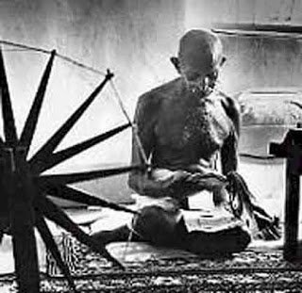
The picture above shows Mahatma Gandhi spinning his own cotton in protest of British colonization of India. When people see pictures of Gandhi they often ask themselves “why is he wearing only underwear?” The answer to this time honored question is due to the relationship of the two countries and globalization.
During Gandhi’s life he thought a lot about how and why the British were ruling India. The following five steps allowed Britain to take advantage of cheap Indian cotton and make enough money to keep control of all India.
Step 1: English people buy Indian cotton in the field where it is grown, picked by Indian workers, at seven cents a day.
Step 2: This cotton is shipped on British ships, a three-week journey across the Indian Ocean, down the Red Sea, across the Mediterranean, through Gibraltar, across the Bay of Biscay and the Atlantic Ocean to London. The British make a 100% profit on this shipping.
Step 3: The cotton is turned into cloth in Lancashire. You pay $20 wages instead of Indian pennies to your workers. The English worker not only has the advantage of better wages, but the steel companies of England get the profit of building the factories and machines. Wages; profits; all these are spent in England.
Step 4: The finished product is sent back to India at European shipping rates, once again on British ships. The captains, officers, sailors of these ships, whose wages must be paid, are English. The only Indians who profit at this step are the workers who lift the boxes out of the ship. They are only paid a few cents a day.
Step 5: The cloth is finally sold to people around the world. Including territories controlled by the British Empire. In order to protest these five steps Gandhi led a series of peaceful protests.
In order to protests these five steps Gandhi wore clothes only made by Indians. This way the money that he spent and the power that went with it stayed in India.
Directions: Make a poster that explains why the British were able to rule India and why Gandhi wears only underwear.

