Colonialism, Nationalism, Independence Lesson Cycle (12 Days Set Aside)
Callanan Middle School
Patterson

(W) Means on website
Underline what should be said to the class
If there is a blue word click on it while holding down “ctrl”

Purpose
The purpose of this lesson cycle is for students to understand how African countries earned their independence after World War II. Students will learn about the ideas of nationalism, cultural diffusion, and reparations. Students will create a PowerPoint that examines a specific African country, a thematic map using raw data, and take a stance on the long-term impact of colonization on indigenous cultures. In the culminating rigorous task, students are asked to connect colonization to issues in modern African countries. Students are asked to take a stance on reparations.

Standard Assessed
3C – Assess the impact of colonization on indigenous cultures around the world (SS.7.14).

Students will examine how colonization impacted indigenous cultures through cultural diffusion.

Topic | Resources
Fight for Independence | Link
Coup D’états and the Legacy of Colonization | Link
Assessment/Rigorous Task | Link

Musings
Create an on going PowerPoint for each section, shared with the teacher.
Teach: Cultural diffusion of languages, religion, food
Teach independence then coup
Teach: Assimilation of cultures
Teach: Spread of democratic ideas
-Ghana and bananas?
-Buy/read African trilogy,
Burner Boys/Reggie Yates extension?
See African history overview bookmark
Documentaries: Makala (coal miner in Africa), Democrats (Zimbabwe politicians)
Documentaries: Shake the Dust (diffusion of break dancing), Miners Shot Down (Unrest in South Africa)
Check History Oversimplified, John Oliver
Bookmark: Rwandan drone video

Fight for Independence Home Next

Success Criteria

Overarching Learning Goal for Lesson Cycle
Knowledge Utilization – Investigating: Examine how a specific African country gained its independence. Take a stance on whether the African country was ready for independence. Share and defend stance on the timing of African independence with other teams. Conduct further research and take a position on whether reparations for colonization are owed and what would this would look like.

Daily Success Criteria
Retrieval – Executing/Recalling: Research and answer who, what, when, and where questions about a modern African country. Use and organize this information in a professional PowerPoint presentation.

Comprehension – Integrating: Within the PowerPoint, describe the relationship between important symbols (flag and national anthem) to the country’s past.

Days 1-4
Open Discussion – See below*
Day 1  Opening discussion about independence/using visuals  African Countries Independence – Colonization Link  Create and rename PowerPoint  Create and title slides  Day 2  Culture Grams research, Paper with boxes for notes.  Shake the Dust Trailer - Link  Vocab Cultural Diffusion  Day 3  Snipping Tool  Use data/research to work on PowerPoint  Shake the Dust - Documentary - Link  Day 4  Connect the pictures/reflection  Work on PowerPoint  Shake the Dust – Debrief/Discuss how it connects to cultural diffusion | Resources/Materials/Extension  Computers, Snipping Tool  -Get students to log in to OneNote in order to share PowerPoints with you  -Instructions, Snipping Tool

Logic Flow*
Display the visuals for the students and have a discussion about how the pictures are connected. Ask students about their prior learning and the book The Boy in the Stripped Pajamas. You want to explain that after Europeans conquered most of the world for natural resources, they became so powerful that they began to fight amongst themselves. In Germany, there was this leader that thought the German people were the smartest and best fighters. Since they were the best, it was their job to conquer as much as possible. So Hitler made friends and attacked the countries around him. For a while, it was basically Britain vs. Germany, but the British were outnumbered. The British asked the people that they colonized, “Hey, this guy is going to come, take over your land, and steal all your stuff.” (Which is in essence what the British did to their African territories.) Some Africans went and helped Britain win the war but afterwards much of Europe was destroyed and weak. The Africans, now trained to fight, and feeling proud about what they accomplished, declared independence. The Europeans were too weak to stop them so they said that it was okay. Kind of like this guy starting and stopping the subway train. You can pretend to control it but the African people were beginning to realize their power. Link. Link

Don’t talk about coups, religion, and other problems yet. Save for when doing thematic map.

OneNote John Green Video Link
1:45 – 2:30 WWII European countries couldn’t ask help against Hitler and the turn around and keep taking advantage of them
9:20 – 12:48 African countries weren’t ready, university, schools, roads, lead to fighting
1. Why did Europeans give up control of their colonies after World War II?
2. Were African countries ready to receive independence?

Flocabulary Imperialism Song Link

Additional Resources/Videos
West Wing Social Justice Video link
Why does Larry Wilmore have his map upside down? See picture in visuals
Country Suggestions
Britain - Nigeria (136-141), Kenya (178-182),
France - Mali (150), Algeria (118)
Germany - Tanzania (171-175)
Portugal - Choose another African country
Spain, Belgium - Congo (200),
Independent Countries – Ethiopia (167-170)

Your Project Needs
PowerPoint – Africa Research Project

History: Analyze and evaluate how events in the past have changed a country.

Using Information from Sources: Creates a product by integrating visual information (i.e. charts, graphs, maps, etc.) with other information in print text by clearly showing connections between them. Product created uses a variety of relevant sources and refers to each source used.

Directions: Create a PowerPoint that explains what is going in a modern Africa country. Every slide needs to have a title and pictures. Each part can be multiple slides. Use your CultureGrams research to help.

Part 1 – Title Slide: Name, Block, Teacher, Name of Country
Suggested PowerPoint Components

Part 2 – General Information: How many people live in the country? How much money does the average person make? What languages do you people speak? What religion do they practice?

Part 3 – History/Independence: Who are some of the important leaders of your country? Are they still alive? What country colonized your African country? Describe their rule. How did your African country gain its independence/freedom? Who were the people the people that helped your country gain its independence? Describe what happened.

Part 4 – Flag and National Anthem: What do the colors and shapes on your flag mean? What does your country’s national anthem want you to think about? How has your country’s past influenced the national anthem and flag?

Part 5 – Why this country? Why did you choose this country? Have you visited this country before?

Part 6 – Interesting Facts/Pictures: What is the fashion like in this country? Most popular movie in 2019? Most popular song in 2019? What animals live there? What other cool and interesting things are going on? What things do people do when they visit?
Suggested Research Questions

Directions: Start to gather research on the African country you selected. You don’t need to write in complete sentences when you do your research.

What African country did you decide to work on? Include basic facts about the country. How many people live in the country? What language do they speak? What religion do they practice? CultureGrams – People and Places, Homepage

Who are some of the important leaders of your country? Are they still alive? CultureGrams – History
What do the colors and shapes on your flag mean? What does your country’s national anthem want you to think about? CultureGrams- Homepage

What country colonized your African country? Describe their rule. CultureGrams – History
How did your African country gain its independence/freedom? Describe what happened. CultureGrams – People and Places

What are some examples of cultural diffusions can be found in your country? What religion do most people practice in your country practice? What language do most people speak? CultureGrams – People and Places

CultureGrams Research Day

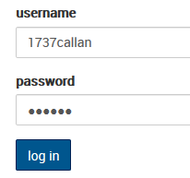
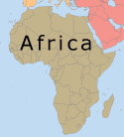
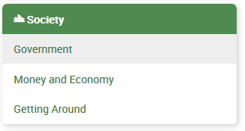
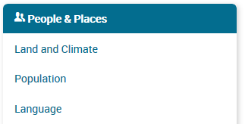
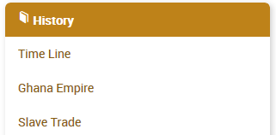
haea11
Class Copy – Make connections between the pictures

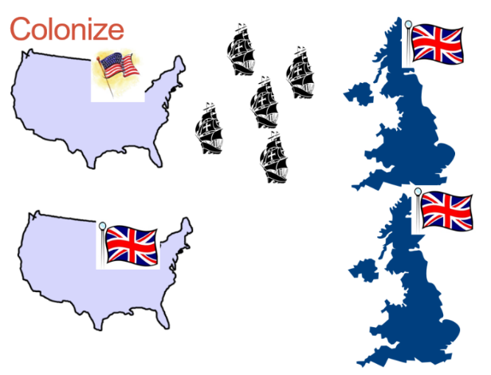
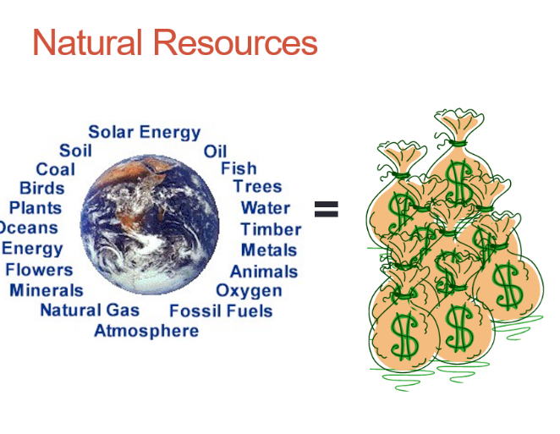
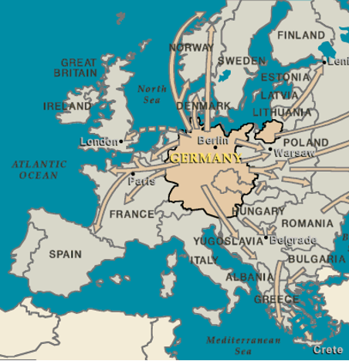
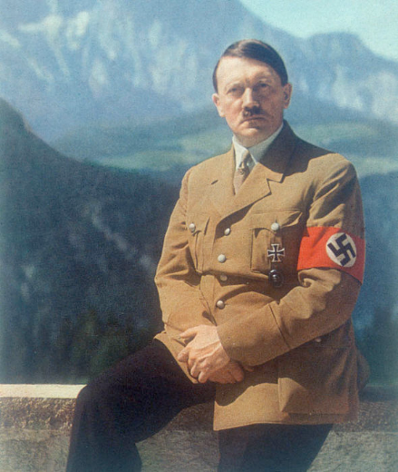

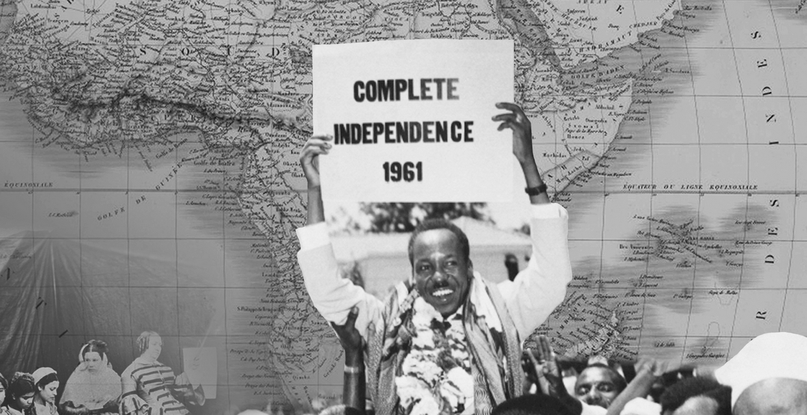
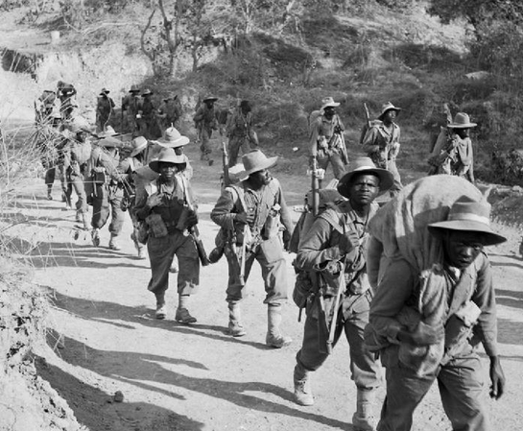
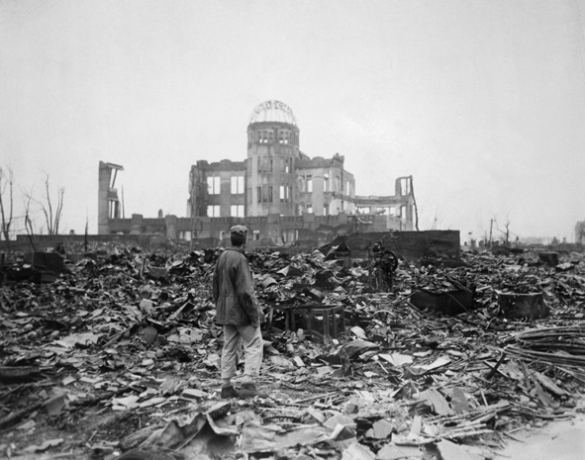
Coup D’états and the Legacy of Colonization Previous Home Next

Overarching Learning Goal for Lesson Cycle
Knowledge Utilization – Investigating: Examine how a specific African country gained its independence. Take a stance on whether the African country was ready for independence. Share and defend stance on the timing of African independence with other teams. Conduct further research and take a position on whether reparations for colonization are owed and what would this would look like.

Daily Success Criteria
Retrieval – Recalling/Executing Students will use data to accurately create a thematic map of African coup de ’tats.

Analysis – Generalizing Teams will examine thematic maps to notice trends and patterns of coup de ’tats. Teams will share out hypotheses about reasons for these patterns. Teams will investigate/research African history and share their finds with the class.

Day 5
Opening Discussion – See Logic Flow*
Create Coup D’état Thematic Map (W)  CNI Visuals (W) | Resources/Materials/Extension  What is a coup de ’tat? 3 minute video link

Logic Flow*
Show this video link. Explain to students that you are going to show a video of a man telling a story about an important event in African history. In the story he mentions a phrase called coup d’état during the video (write phrase on board). Have students watch video, process in groups, and share out what they think is going on and what the phrase means. You might need to explain the difference between coup d’état and revolution. Warm Up: If we had a coup d’état in this classroom, what would that look like?
Day 6
Opening Discussion – See logic flow*
Create Coup D’état Thematic Map (W)  CNI Visuals (W) | Resources/Materials/Extension  -deck of cards, markers/colors

Logic Flow*
At the start of the period, pass out playing cards to each student without looking at the card. Have tables look at their cards. How many tables have all of the same suit? How many tables have everything they need to be successful? Warm Up: If Mr. Patterson wanted every table to have the same suit, what could he have done differently?

Most students would suggest something about looking at the cards before I passed them out but that would require the teacher to care about each group getting what they wanted. When European countries colonized Africa, they weren’t trying to group people based on what was best for them, what motivated Europeans? Getting natural resources. So what happened is that as Europeans took land, sometimes put together people who didn’t get along. This became a problem when the Europeans left and the land that they took, became the borders of new countries.

Revisit why Mali wasn’t powerful after Mansa Musa because how power was passed down through children. This caused diffusion of power.

Day 7
Opening Discussion – Why are most coup d’états led by someone in the military?
Create Coup D’état Thematic Map (W)  -Save maps for summative project  CNI Visuals (W) | Resources/Materials/Extension**  Have students connect pictures of independence in writing.

Day 8
Opening Discussion –
CNI Visuals (W)  Create Coup D’état Thematic Map (W)  -Students analyze thematic maps and answer reflection questions.  -Class Discussion to come up with broad, overarching questions to investigate. | Resources/Materials/Extension**  Extension needed for time, possibly video  Is there a correlation between the number of coups and total deaths?

Logic Flow*
Some of the African countries weren’t ready to function properly. Some people were mad at people that had helped the Europeans. There weren’t a lot of people who had graduated college or had experience. This led to problems.

Possibly talk about coup d’états and religion. Possibly include a still frame from video that shows subway and use as warmup. Revisit Reddit video showing independence days.

Using the CNI visuals, have students start to analyze what the coup d’état map is showing. Use the EPSON in the back of the room. Where are the places that have the most coup d’états? Are they concentrated in certain areas? What about the size of the countries? Does being a bigger country or smaller make a difference? Why would it be easier to have a coup d’état in smaller countries? Have students open red Africa books to page 228, have them look at South Africa. What is unique about South Africa? (It has three capitals in order to make coup d’états harder.) Discuss why it would be hard for the United States to have a coup d’état.

Show timeline video where religion spreads. LINK Have students watch the area where most of the coup d’états take place. What do they notice?

Days 9 - 11
Opening Discussion – Why do most people in North Africa practice Islam?
CNI Visuals (W)  Students investigate why patterns of coup d'états exist in Africa.  Add Coup section to PowerPoint  Define coups  Explain patterns of coups in Africa  Pictures of coups, and why it happened in your African country  Connect modern issues in African countries to coups  Issue of reparations by European countries, what should this look like? | Resources/Materials/Extension  YouTube video need to break modality  Computers, poster paper  Language Thematic Map  Use South Sudan as an example of how coup d’états have split the country. Possibly use it as an extension.  Internet Scamming Link Vice, watch in entirety  Plastic Bags Link  Election Fraud Mugabe?  Independence  Weapon Sales Link

PowerPoint – Coup D’état Section
Directions: Add the following information to your African country PowerPoint. When you think you are finished, reshare to Mr. Patterson at Andrew.patterson@dmschools.org.

-Define and provide an example of a coup de ’tat. Explain why most coups involve military leaders. Explain why having coup d’état’s would be bad for a country.
-Using your thematic map of coups in Africa, what patterns/trends do you notice? Why do you think those trends/patterns exist?
- Connect modern issues in African countries to coups, cultural diffusion, and colonization.
-Reparations is the payment of money (or other help) to those who have been wronged. In your opinion, should European countries be forced to pay reparations to the countries that they colonized? If countries did agree to reparations, what programs/things would bring the most help to average person in a country?

PowerPoint – Coup D’état Section
Directions: Add the following information to your African country PowerPoint. When you think you are finished, reshare to Mr. Patterson at Andrew.patterson@dmschools.org.

-Define and provide an example of a coup de ’tat. Explain why most coups involve military leaders. Explain why having coup d’état’s would be bad for a country.
-Using your thematic map of coups in Africa, what patterns/trends do you notice? Why do you think those trends/patterns exist?
- Connect modern issues in African countries to coups, cultural diffusion, and colonization.
-Reparations is the payment of money (or other help) to those who have been wronged. In your opinion, should European countries be forced to pay reparations to the countries that they colonized? If countries did agree to reparations, what programs/things would bring the most help to average person in a country?

PowerPoint – Coup D’état Section
Directions: Add the following information to your African country PowerPoint. When you think you are finished, reshare to Mr. Patterson at Andrew.patterson@dmschools.org.

-Define and provide an example of a coup de ’tat. Explain why most coups involve military leaders. Explain why having coup d’état’s would be bad for a country.
-Using your thematic map of coups in Africa, what patterns/trends do you notice? Why do you think those trends/patterns exist?
- Connect modern issues in African countries to coups, cultural diffusion, and colonization.
-Reparations is the payment of money (or other help) to those who have been wronged. In your opinion, should European countries be forced to pay reparations to the countries that they colonized? If countries did agree to reparations, what programs/things would bring the most help to average person in a country?
Assessment/Rigorous Task Previous Home

Success Criteria – Traditional Assessment
Retrieval – Recalling Students will answer who, what, when, and where questions about cultural diffusion, colonization, and class activities from this lesson cycle.

Comprehension – Integrating Students will describe the relationship between colonization and modern African countries.

Rigorous Task
Knowledge Utilization – Investigating Conduct an inquiry into coup de ‘tats in America. Create and defend an argument about why there were less coups in the United States than in certain African countries.

Day 12
Opening Discussion – Why do most people in North Africa practice Islam? Mansa Musa and the spread of Islam.
Traditional Assessment/Bourdain  Parts Unknown – Steam on Amazon  Season 10, Episode 3, Lagos  Stance on reparations owed to African countries  Level 4 – Rigorous Task  -page | Resources/Materials/Extension**  Extension needed for time, possibly video instructions after reflection? Has there ever been a coup d’état in the United States?

Level 4 - Research Question
Congratulations, due to your hard work and the quality of assignments that you turned in, you don’t need to take the test the rest of the class is going to work on. Instead, Mr. Patterson is going to have you try and find the answers to the questions below. You can type your answers in OneNote, online word, or you can handwrite it on a piece of paper. The important thing is that you need share it with Mr. Patterson when you are finished. Andrew.patterson@dmschools.org. If you want to work together with other students that received this paper, that is up to you.

Research coup de ’tats in the United States. How successful were they? How come coup de ’tats were a bigger problem in African countries than the United States? Both were colonized. What was the difference? What happened to the indigenous (local, original, and native) people who lived in the United States?

Level 4 - Research Question
Congratulations, due to your hard work and the quality of assignments that you turned in, you don’t need to take the test the rest of the class is going to work on. Instead, Mr. Patterson is going to have you try and find the answers to the questions below. You can type your answers in OneNote, online word, or you can handwrite it on a piece of paper. The important thing is that you need share it with Mr. Patterson when you are finished. Andrew.patterson@dmschools.org. If you want to work together with other students that received this paper, that is up to you.

Research coup de ’tats in the United States. How successful were they? How come coup de ’tats were a bigger problem in African countries than the United States? Both were colonized. What was the difference? What happened to the indigenous (local, original, and native) people who lived in the United States?

Level 4 - Research Question
Congratulations, due to your hard work and the quality of assignments that you turned in, you don’t need to take the test the rest of the class is going to work on. Instead, Mr. Patterson is going to have you try and find the answers to the questions below. You can type your answers in OneNote, online word, or you can handwrite it on a piece of paper. The important thing is that you need share it with Mr. Patterson when you are finished. Andrew.patterson@dmschools.org. If you want to work together with other students that received this paper, that is up to you.

Research coup de ’tats in the United States. How successful were they? How come coup de ’tats were a bigger problem in African countries than the United States? Both were colonized. What was the difference? What happened to the indigenous (local, original, and native) people who lived in the United States?

Name:

Block: Coup D’états

Teacher:

1. What is a coup de ’tat? Why would people want to have coup de ‘tats? If there was a coup de ’tat at Callanan, what would it look like?
______________________________________________________________
______________________________________________________________
______________________________________________________________
______________________________________________________________
______________________________________________________________
______________________________________________________________
______________________________________________________________
______________________________________________________________
______________________________________________________________
______________________________________________________________

Name:

Block: Coup D’états

Teacher:

1. What is a coup de ’tat? Why would people want to have coup de ‘tats? If there was a coup de ’tat at Callanan, what would it look like?
______________________________________________________________
______________________________________________________________
______________________________________________________________
______________________________________________________________
______________________________________________________________
______________________________________________________________
______________________________________________________________
______________________________________________________________
______________________________________________________________
______________________________________________________________
______________________________________________________________

2. Why are there so many coup de ’tats in Africa countries? In your answer, you should write about the colonization of Africa, explain how borders of countries were formed, discuss natural resources, and reference the card game we played.
______________________________________________________________
______________________________________________________________
______________________________________________________________
______________________________________________________________
______________________________________________________________
______________________________________________________________
______________________________________________________________
______________________________________________________________
______________________________________________________________
______________________________________________________________
______________________________________________________________
______________________________________________________________
______________________________________________________________

2. Why are there so many coup de ’tats in Africa countries? In your answer, you should write about the colonization of Africa, explain how borders of countries were formed, discuss natural resources, and reference the card game we played.
______________________________________________________________
______________________________________________________________
______________________________________________________________
______________________________________________________________
______________________________________________________________
______________________________________________________________
______________________________________________________________
______________________________________________________________
______________________________________________________________
______________________________________________________________
______________________________________________________________
______________________________________________________________
______________________________________________________________

Poster - How was Africa shaped by its past? Old resource, use if not enough computers are available or students lose computer privileges
Geography: Explain how and why people move from one part of the world to another and how it impacts communities.

Using Information From Sources: Creates a product by integrating visual information (i.e. charts, graphs, maps, etc.) with other information in print text by clearly showing connections between them. Product created uses a variety of relevant sources and makes reference to each source used.
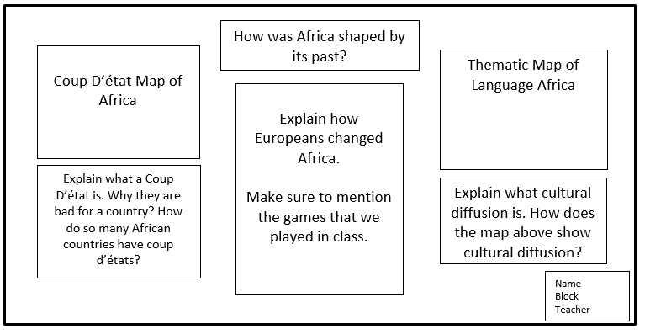
Part 3
Part 2
Part 1

Directions: Create a poster that explains how modern Africa is shaped by its past. Make sure that your name, block, and teacher are in the bottom right hand corner. Only write on one side of the poster. Before you start putting information on your poster, you need to start gathering information for all three parts.
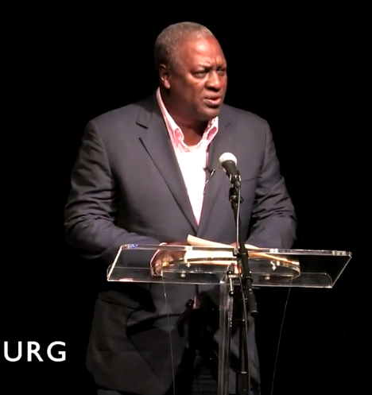
Part 1 – Coup D’état
Explain what a Coup D’état is. Why are they bad for a country? Why do so many African countries have coup d’états?
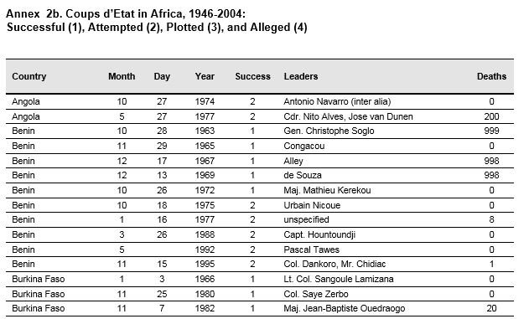
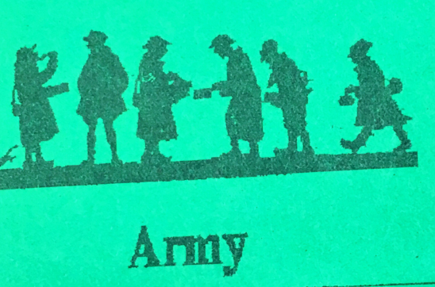
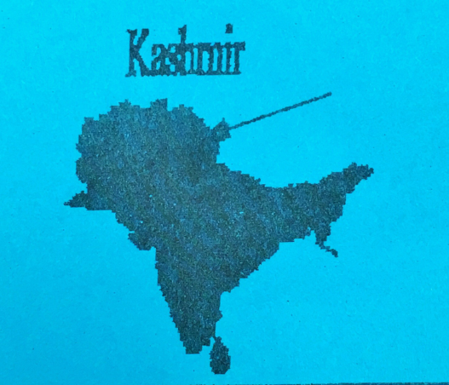

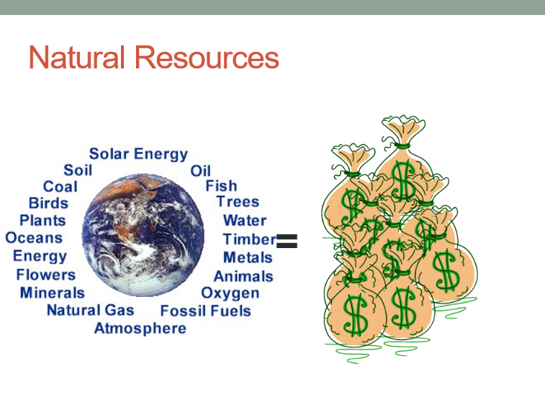
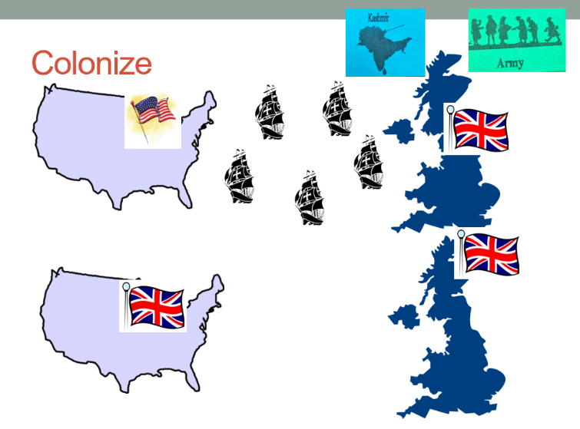

Part 2 – Colonization of Africa
Explain the war game that we played together in class. How did countries become powerful?
What does it mean colonize? Why would countries want to colonize an area? How did this affect Africa?

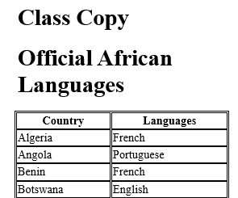
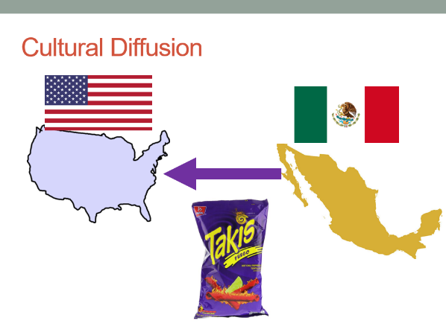

Part 3 – Languages of Africa
Explain the idea of cultural diffusion. Why do some people in Africa speak a European language?

Name of Country

Map of Country

Flag of Country

Description of how your country gained its independence.

Include definition of nationalism, mention specific leaders.

General Information about the Country

What do the colors and shapes on your flag mean? What does your country’s national anthem want us to think about?

Name
Block
Teacher

Thematic Map of Language Africa

Explain what cultural diffusion is. How does the map above show cultural diffusion?

Coup D’état Map of Africa

Explain what a Coup D’état is. Why they are bad for a country? Why do so many African countries have coup d’états?
How was Africa shaped by its past?
Name
Block
Teacher

Explain how Europeans changed Africa.

Make sure to mention the games that we played in class.

