Name: _________________________________ Block: __________ Date: __________________________

(Title)_______________________________

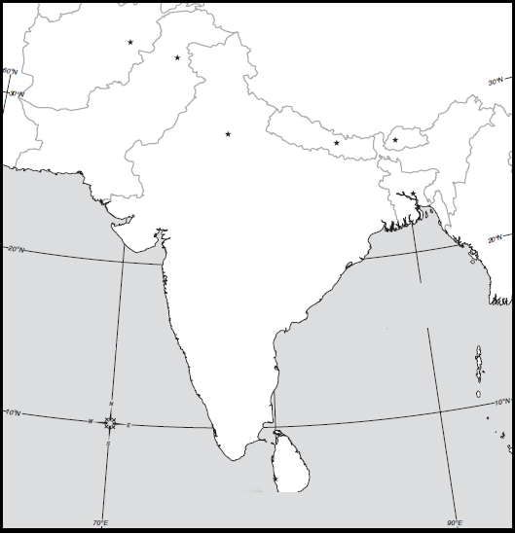

Map Key:

Directions: Include the following details on your South/Central Asia physical and political map. To help you label these details you may use an atlas or purple Asia book using pages 260, 261, and 31. If the color you are supposed to use is being used by someone else than use a different color.

Map Features:
- Map Key
- Compass
- Title

Political Features:
- India
  - Label and color orange
- Pakistan
  - Label and color green
- Afghanistan
  - Label and color purple
- Sri Lanka
  - Label and color red
- Nepal
  - Label and color pink
- China
  - Label and color grey
- Bangladesh
  - Label and color yellow

Physical Features:

- Ganges River
  - Label and color blue
- Indus River
  - Label and color blue
- Himalaya Mountains
Label with triangles
- Khyber Pass
  - Label
- Hindu Kush Mountains
  - Label with triangles

Extra Credit:
- Label other countries in the region
- Label with a star the countries capitals.
- Paste map on poster paper
- Draw a picture of tourist attraction(s) for different countries on the edge of the poster paper.

- Indian Ocean
  - Label
- Bay of Bengal
  - Label

