Burner Boys Lesson Cycle
Sub-Saharan Africa
Patterson

(W) Means on website
Underline what should be said to the class
If there is a blue word click on it while holding down “ctrl”

Yellow = still needs work
Blue = side thoughts

Iowa Core Language
SS.7.18. Explain and evaluate how economic decisions affect the well-being of individuals, businesses, and society.

District Language
SS.7.18 Explain how economic choices impact individuals, businesses, and communities.

Callanan Specific:
Explain how decisions made by leaders can impact the quality of life of people for decades.

This lesson cycle requires students to create an action plan to improve the average quality of life in a traditionally marginalized community. Students will determine if their action plan has been implemented in Skid Row, Los Angeles. Students will revise their action plan and outline steps leaders should take. Students will also reflect on the validity of information that is averaged from millions of data points.

Day 1/2
Learning Target – I will examine research to determine how the average quality of life in Ghana compares to the rest of Africa.

Warm Ups –
Day 1: Make a list of the things that the government pays for that we use daily for “free.” Write on large scratch paper, tell students we will come back to it.

Day 2: -What is the best possible ranking a country can have? What is the worst possible ranking a country can have?

Burner Boys Visuals (W)  -Vocab for average life expectancy, GDP per capita, and literacy rate.  -Show how to rank data and plot on timeline, see pictures  -Discuss the disclaimer of rich country for this area | Resources/Materials/Extension  Have instructions ready for students that finish in one day to start documentary.  Extension, students start looking at exemplars in Africa for these categories.

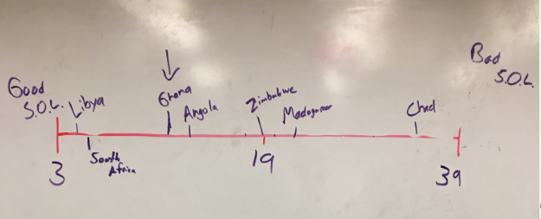

Day 3/4
Learning Target – I will watch Burner Boys to create an action plan to improve the quality of life in Ghana. Include looking at exemplars from Africa.

Warm Up
Day 3 - How does Ghana’s standard of living compare to the rest of Africa?
Day 4 – Question about what an action plan is. Find a video of failing to park. Let’s improve this.

Show students a video of someone failing to park etc… Have them create a goal for helping the person park. What specific things do they need to know how to do? List underneath. Link Make sure to get time clips

Optional: It is in my opinion that if you want to be happy in Ghana, all you have to do is work hard, and you will live a long and happy life.

Burner Boys Visuals  -there are two different types of reflections included in this document. Have students create an action plan to help the Burner Boys. Make sure that each class has the same action plan goal. Come up with common searches.  -reflection, research, action plan | Resources/Materials/Extension  Link  The Insider, Reggie Yates, Ghana, Burner Boys  If blocked, use a VPN (VPN unlimited, change IP to England, and then use IBBC player). Have this ready on a second computer.

Potential Discussion Questions from Summative Test
Provide a brief summary of what the documentary was about. Where did it take place? Approximately how long did Reggie stay with the boys? Describe the camp that Reggie stayed in.

Do you agree with the quote?
It is in my opinion that if you want to be happy in Ghana, all you have to do is work hard, and you will live a long and happy life.

What do the Burner Boys do for a living? Describe the process.

Why are the Burner Boys getting sick? Describe how they are getting sick, the symptoms, and what the doctor suggests that they do to take care of them.

Why do the Burner Boys choose to burn copper? Why don’t they work a different job? What goals do they have? What do they want to do with their money?

How does the Ghana’s overall quality of life compare to other African countries? Why would that be important to understand when studying Africa?

What should happen next? Should the U.S. and U.K. stop sending broken electronics to Ghana? What should the Ghanaian government do to help the young men?

Day 5
Learning Target – I will determine if my action plan has been implemented in Skid Row, Los Angeles.

Warm Up – Debrief question about doucmentary

Burner Boys Visuals  Watch clip to determine if it should be used link  -Students will research Skid Row and try and determine if their action plan is being put in to affect. | Resources/Materials/Extension  Mancala

Day 6
Learning Target – I will examine research to determine how the average quality of life in California compares to the rest of America.

Warm Up – If all you knew about California was Skid Row, what would you assume about the quality of life there?
USA State Research  -Debrief what we found out and lessons  -Have students that finish early, watch other Reggie Yates episodes. Possibly add menu of options | Resources/Materials/Extension  -Have students that finish early, watch other Reggie Yates episodes. Give example searches and descriptions of episodes. Reflect on quality of life and how it relates to GDP per capita, literacy, and life expectancy.  -Assessment?

Give students cut up notecards, have them write a number on it between 65 - 85, have them make a line to the board. As student come up, record the numbers on the board. Come up with an average. Use dice/sticks to have students change their numbers based off things that negatively impact health of population. These include: Gender (riskier behaviors), genetics (history of disease in family), money, education, lifestyle (working out/diet), security, and access to healthcare (living in the country, not having a car, or being able to pay for it).

What happened to the average life expectancy after we made the changes?

Day 7
Learning Target – I will explain how decisions made by leaders can impact the quality of life of people for decades.

Warm Up – What city is this? Discuss why Reggie Yates didn’t film there. Make connection to how Iowa is portrayed. Link)
Summative Assessment on page  -Have students that finish early, watch other -Have students that finish early, watch other Reggie Yates episodes . | Resources/Materials/Extension

Example Rankings

Country | GDP per Capita | Life Expectancy | Literacy Rate | Total
Narnia | 5  1 | 80  2 | 80  1 | 4
The Shire | 4  2 | 70  3 | 50  2 | 7
Azkaban | 3  3 | 110  1 | 50  2 | 6

Narnia Azkaban The Shire
9
3

Name:

Block: Africa – Quality of Life

Teacher:

Country | GDP per Capita | Life Expectancy | Literacy Rate | Total
Egypt

Ghana

Angola

South Africa

Kenya

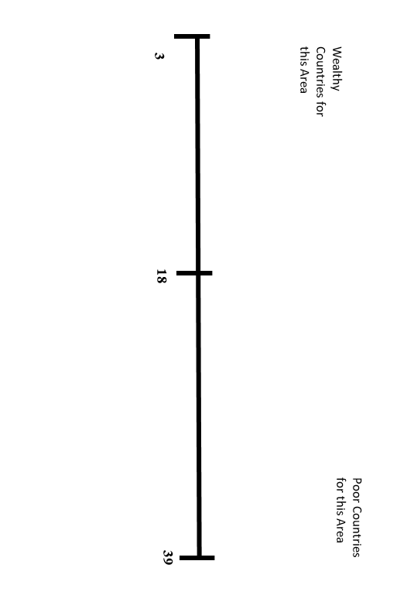
Class Copy
How do you find GDP per capita of a country?

1. Go to Google.

2. Type in GDP per Capita followed by the name of the country.

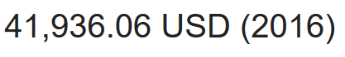
3. If you do this correctly, the answer should appear in bold.

How do you find the average life expectancy of a country?

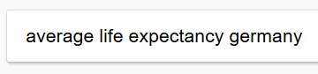
1. Go to Google.

2. Type in average life expectancy followed by the
name of the country.
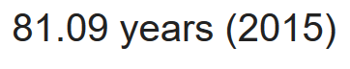
3. If you do this correctly, the answer should appear in bold.

How do you find the literacy rate of a country?
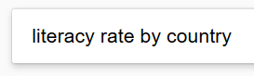
1. Go to Google.

2. Search literacy rate by country.

3. Click on this one.

4. Use the search function to find the country’s literacy rate. The easiest way to access the search tool is by pressing ctrl and f at the same time.

Name: Block: Teacher:
Burner Boys Documentary Reflection
Write a three sentence summary of what you watched today. (Write three sentences about what happened in the documentary.)

_____________________________________________________________________________________________________________________________________________________________________________________________________________________________________________________________________________________________________________

Choose two of the following to write about:
- Do you like the documentary so far? Explain.
- Ask a question about something you don’t understand.
- Predict or say what you think is going to happen next.
_____________________________________________________________________________________________________________________________________________________________________________________________________________________________________________________________________________________________________________

Name:

Block: Burner Boys Quiz

Teacher:

1. Provide a brief summary of what the documentary was about. Where did it take place? Approximately how long did Reggie stay with the boys? Describe the camp that Reggie stayed in.
________________________________________________________________________________________________________________________________________________________________________________________________________________________________________________________________________________________________________________________
2. What do the Burner Boys do for a living? Describe the process.
________________________________________________________________________________________________________________________________________________________________________________________________________________
3. Why are the Burner Boys getting sick? Describe how they are getting sick, the symptoms, and what the doctor suggests that they do to take care of them.
________________________________________________________________________________________________________________________________________________________________________________________________________________
4. Do you agree with the quote?
It is in my opinion that if you want to be happy in Ghana, all you have to do is work hard, and you will live a long and happy life.
________________________________________________________________________________________________________________________________________________________________________________________________________________
________________________________________________________________________________________________________
5. How does the Ghana’s overall quality of life compare to other African countries? Why would that be important to understand when studying Africa?
________________________________________________________________________________________________________________________________________________________________________________________________________________
7. What should happen next? Should the U.S. and U.K. stop sending broken electronics to Ghana? What should the Ghanaian government do to help the young men?
________________________________________________________________________________________________________________________________________________________________________________________________________________
8. What is Skid Row? How big is it? Why does it exist? Where is it located?
________________________________________________________________________________________________________________________________________________________________________________________________________________
9. What can leaders do to help people like the Burner Boys and Skid Row? In your opinion, why haven’t this done this already? What suggestions would you give the leaders of these countries to help people?
________________________________________________________________________________________________________________________________________________________________________________________________________________________________________________________________________________________________________________________
10. Why do T.V. shows and documentaries usually focus on the poorest and most outlandish parts of a country? Is this a bad thing?
________________________________________________________________________________________________________________________________________________________________________________________________________________

Reggie Yates Episodes – Class Copy

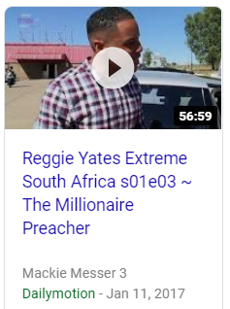

The Millionaire Preacher
Reggie Yates spends a week with Prophet Mboro, a controversial
self-styled prophet.
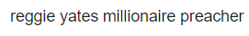

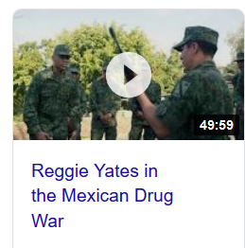
In the Mexican Drug War
Reggie Yates joins the army in Acapulco, Mexico, to fight war against drugs.

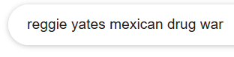

In a Refugee Camp
Reggie Yates spends a week living and sleeping the largest refugee camp in Iraq.
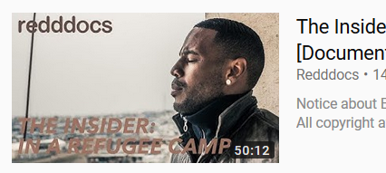

US Jail Guard
Reggie Yates spends time working as a guard at Guilfor Country Jail in North Carolina.

