Name:

Block: Boot Camp Assessment

Teacher:

Part 1
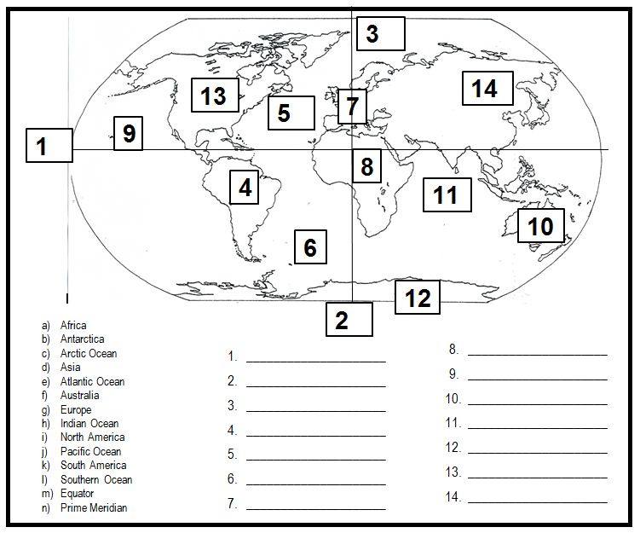
Part 2

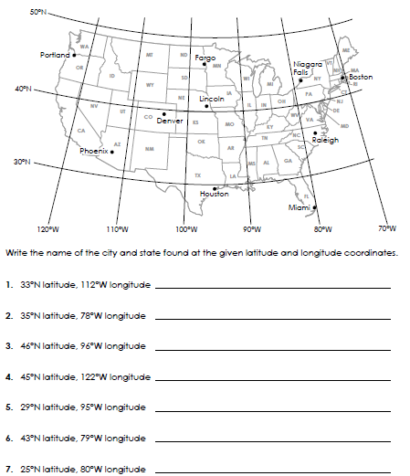

Part 3
Directions: Define the following vocabulary words. Your definitions must show mastery of the definitions to receive credit.
Geography-

Relative Location-

Absolute Location-

Latitude-

Longitude-

Equator-

Prime Meridian-

Part 4
Get a blank piece of paper and a ruler. On the piece of paper do the following:
1. Create a grid .5 inches by .5 inches.
2. Label the Equator and Prime Meridian.
3. Put directions for each corner of the map.
4. Label the lines by 10 degrees
5. Plot the following coordinates
30 N, 20 W
10 S, 20 W
6. Staple your map to this assessment

