Name:

Block: Author’s Point of View - Cartoon

Teacher:

Topic | 2 | 3 | 4
Author’s Point of View | Identifies author’s purpose or point of view, but with some misconceptions within the context/unit of study. | Demonstrates the ability to accurately identify and explain an author’s purpose or point of view using textual and/or contextual evidence. | Demonstrates the ability to accurately identify and explain an author’s purpose or point of view using textual and contextual evidence and can justify or challenge it.

1. Political cartoon artists often use symbols to get their points across. A symbol is a something that stands for something else. For example, the American flag often stands for America. Circle and number any symbols you recognize in the cartoon above.

2. What point is the artist trying to make in this political cartoon? In your response you should explain and cite the symbols found in the cartoon.

3. Who (individuals or groups) would agree/disagree with the above political cartoon?

4. Do you agree with the author’s message? Explain your answer.
____________________________________________________
____________________________________________________
____________________________________________________
____________________________________________________
____________________________________________________
____________________________________________________
____________________________________________________
____________________________________________________
____________________________________________________
____________________________________________________
____________________________________________________
____________________________________________________

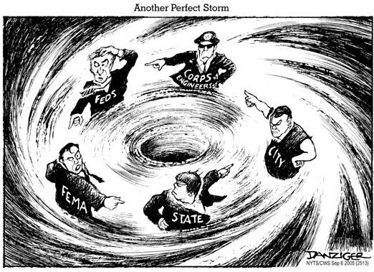
http://goo.gl/J9S2ZR

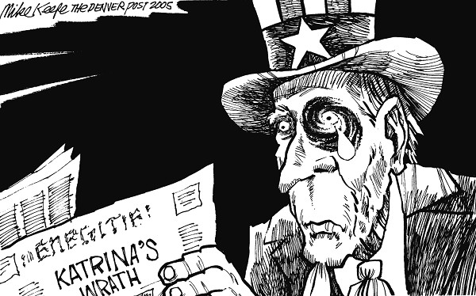
http://goo.gl/J9S2ZR

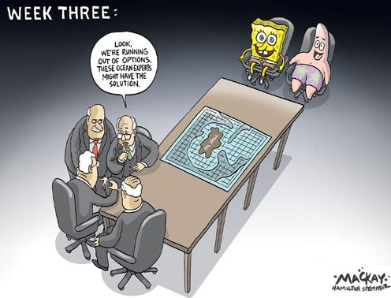
https://goo.gl/Hx2dke

https://goo.gl/Hx2dke

