Name

Block: Nile Graphs

Teacher:

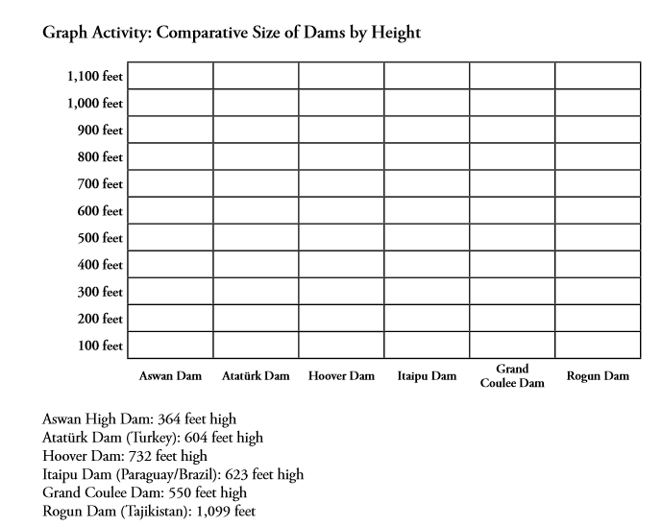
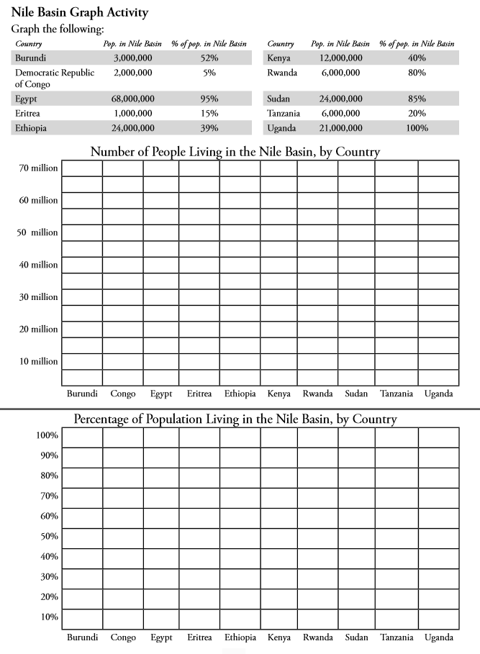

The Aswan High Dam: Egypt’s Giant Leap Forward
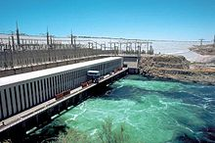
Located about 10 miles south of the city of Aswan, Egypt, the Aswan High Dam is a major feat (project) of engineering and is one of the marvels of the modern world. Completed on July 21, 1970, the Aswan High Dam cost over $1 billion and took 10 years to complete.
A reservoir is the lake that forms behind a dam. The reservoir behind the Aswan High Dam is named Lake Nasser, after the president of modern Egypt who first ordered its construction.
The Nile River is the base for the Aswan High Dam. The world’s longest river, the Nile runs 6, from its source in Burundi, in Central Africa, to the Mediterranean Sea. The Nile Valley basin covers nearly 3 million square kilometers between its three main branches: The White Nile, the Blue Nile, and the Atbara River. The Nile Valley basin covers 10 countries in northeastern Africa. The branches of the Nile come together in Sudan, and flow north across the Sahara Desert into Egypt.
Most of the water contributed to the Nile comes from the Blue Nile, which starts at Lake Tana in Ethiopia. Heavy rainfall washes away the rich, fertile soil of Ethiopia’s highlands and sends it down-river in the form of silt/dirt, which eventually collects in the Nile Delta in Egypt. Only a small percentage of the water carried down the Nile eventually makes reaches the Mediterranean. The rest either evaporates or is used to grow crops, as drinking water, or for other purposes.
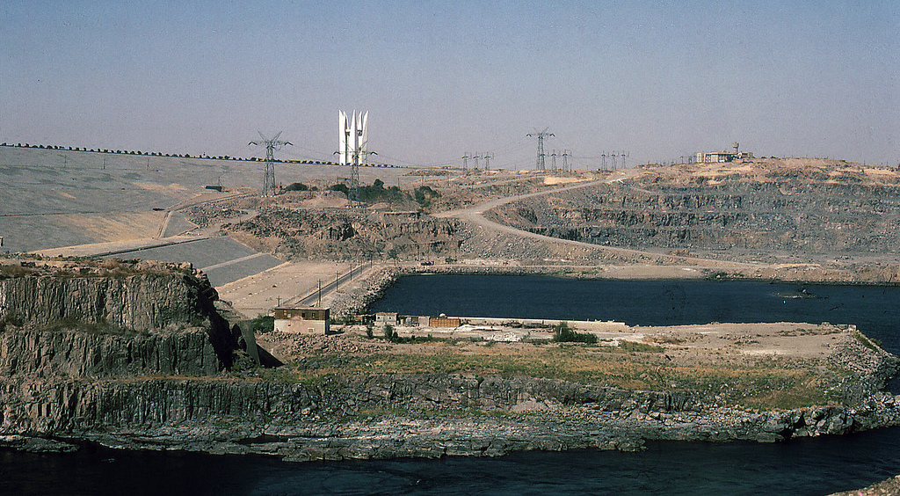

There were several reasons that the government of Egypt wanted to build a dam across the Nile. Since the days of the pharaohs (old kings), the Nile has flooded every year, putting a layer of rich, fertile dirt washed downriver from Ethiopia. But the flooding wasn’t steady/consistent—one year, the floods might be low, resulting in weak soil that produced few crops. The next year, the floods might be high, destroying building, homes, roads, and washing away important features of the land. At the beginning of the twentieth century, the British colonial administration built a dam near Aswan to control the flooding. By the 1950’s, however it was clear that this dam wasn’t going to help with the needs of a growing country.
The construction of the Aswan High Dam has many positive effects on Egypt. The dam is also a hydroelectric power plant, and is equipped with 12 turbines, each capable producing 175 megawatts of electricity, or 2.1 gigawatts total. The power plant began operating in 1967, and by the mid 1970’s, allowed many villages to have electricity for the first time. The Aswan High Dam is still a major part of Egypt’s electrical supply, and produces about 15% of the country’s needs each year.
Another benefit of the construction of the Aswan High Dam is that farming can now take place year round. Since the Nile floods have been stopped, many farmers can now grow three different times year, tripling the amount of crops that can be harvested. In a country that is 94% desert, the ability to triple wheat and cotton and each year has been a huge benefit.
Some people have questioned whether the Aswan High Dam has created a dangerous situation. Although earthquakes are not common in Egypt, they do happen from time to time. If the Aswan High Dam were to be destroyed, the Nile Valley would be hit with a wall of water that would not be able to stop until it reached the Mediterranean Sea. A destructive wall of water moving north would reach every major city in Egypt, and afterwards the country would have little access to clean water. Others point out that the dam was built to withstand strong earthquakes and that there is very little chance that the dam would ever be destroyed either by natural or human forces.

- List/explain three benefits (good things) that have come from the construction of the Aswan High Dam.

- Why are some people worried about the Aswan Dam?

The Down Side of Building Massive Dams

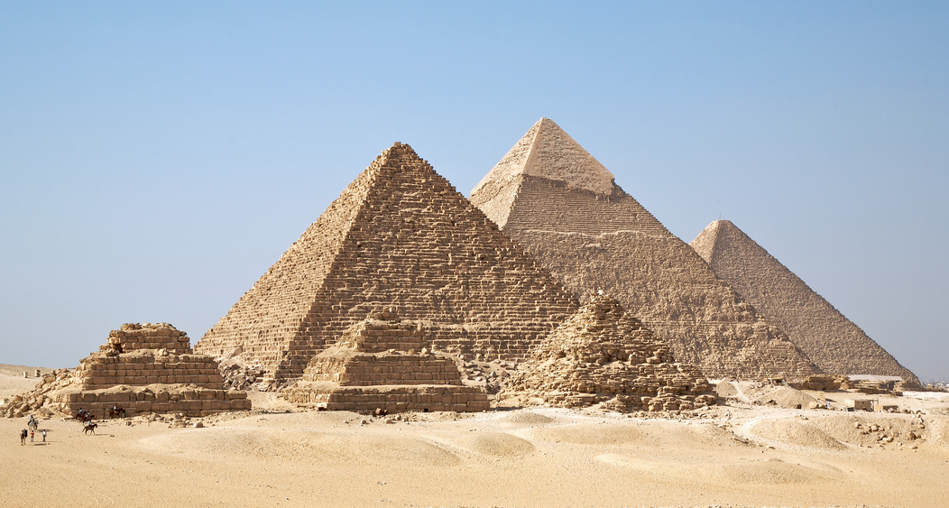
Rising Underground Water
If you dig a hole almost anywhere, you will eventually find water. Places where you do not have to dig that far are usually swampy and marshy. Places where you have to dig along ways are usually dry and located in desert.

In many places in Egypt, the underground water is rising much closer to the surface than before and, in many places, the rising levels are threatening ancient monuments and buildings. This is not the only danger of rising water.

Dangers of Salt
Another danger is the amount of salt that is now collecting in the water and on farmland. The sand and soil of the Nile River are naturally salty. Before the Aswan High Dam was built, the yearly flooding of the Nile would wash the salt into the Mediterranean. Now that the flooding has stopped, the natural salt, along with salt added from chemicals used in farming, has been building up over time.

There are two problems with the buildup of salt in the soil. First, the salty soil makes the ground water salty, which means that it cannot be used for drinking or watering crops. Too much salt is harmful to humans, animals, and plants. Second, salt causes rocks to breakdown much quicker than normal, and most of Egypt’s ancient monuments/buildings are built of limestone. Archaeologists, people that study old things, fear that the rising water table could cause the destruction of many of these structures, from the temples of the pharaohs (kings) in Luxor to the great Sphinx in Giza.

There are several possible solutions to having too much salt. These include making wells to lower the level of ground water, replacing the foundation stones with other materials, or injecting a chemical glue between buildings and the soil to create a barrier. All of these are very expensive and risk possible damage to the old buildings.

Soil and Fertility (the ability to grow things)
One of the good things that come from the Aswan High Dam is the ability of farmers to grow crops year round. However, even this has had bad consequences. The yearly flooding put a layer of rich, fertile soil that was excellent for growing crops on the shores of the river. Without the flooding, farms in Egypt have had to begin using artificial fertilizer to enrich the soil every year. Many fertilizers consists of harsh and dangerous chemicals that can leak into the ground and drinking water if not used properly.

Disease
Another side effect of the construction of the Aswan High Dam is an increase in the number of people infected with a disease called Bilharzia. Bilharzia is caused by a parasite or bug carried by snails that drills itself into the skin of humans, and it grows in standing water. Bilharzia has been a problem in Egypt for thousands of years.

The flow of the Nile once helped with the problem, because Bilharzia needs slow moving or standing water to develop. However, with the construction of the dam, the bug has found a new home in the standing water of Lake Nasser. From there, the virus is carried downstream with the Nile water and drills into the feet of farmworkers.

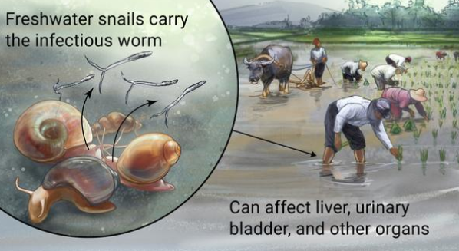
Bilharzia is a disease that is easy to treat if it is caught in its early stages. The problem is that it can take as long as 20 or 30 years for symptoms to develop, at which point the disease is incurable and can eventually lead to death. By the 1980s, a pill was created was created, finally bringing the disease under control.

When doctors were trying to stop the spread of Bilharzia they accidentally created a new problem. In the mid-1980s, it was still not known that blood-borne diseases such as AIDS and Hepatitis C could be spread by using needles that were not \ cleaned properly between users. It is estimated that 12-15% of Egypt’s population has contracted/gotten Hepatitis C, one of the highest of infection rates in the world.

Directions: Answer the following questions in complete sentences. You need to have text evidence in the answer in at least one question.

- What is bad about rising underground water?

- Why is salty soil bad? What solutions does the article mention?

- What is bilharzia? How do people get the disease?

- How did the construction of the Aswan High Dam contribute to higher rates of bilharzia infection? Why are there so many cases of Hepatitis C in Egypt?

Burundi
Burundi hosts the southernmost source of the Nile. From a spring 500 km south of the equator, the Nile begins its long journey of almost 7,000 km to the Mediterranean Sea.
Growing from a trickle to a stream, it soon becomes a river that moves through a lush, hilly landscape of forests and wetlands until is flows into Rwanda as the Kagera River.
There are many sources of the Nile, in Burundi and other countries, all coming together to form one mighty river.
In total, the waters from half of my country drain into the Nile. Although Burundi is a tropical country and our average rainfall is high, water can be scarce in some drought-prone areas.
Because the soils are rich and the climatic conditions are relatively good, most of my people are farmers and peasants who settle on the hilly countryside, to grow food for their families and for sale in local markets.
Population densities, however, are very high and people are very poor. With more people needing land, food, and fuel, the watersheds are becoming degraded—trees are being cut down for firewood, as only 2% of the population have access to electricity, and more and more top soil is washed away every year.

Rwanda
Water from the Nyungwe rainforests in the southwest and Volcano Park in the north flows out of the reserves, which are famous for their wildlife, particularly the gorillas.
The waters swell the flow of the Kagera River turning it into the mightiest river to flow into the great Lake Victoria, contributing about a third of the total inflow into the lake.
The Kagera River, the infant River Nile, is central to Rwanda’s past and future, with 90% of our country within the basin. Our people use the water of the Kagera for farming, drinking, and cooking. Everyone depends on the river.
Rwanda is a land of mountains and lakes. Today, population pressures are forcing people to settle on ever-steeper slopes, where they have to work even harder for less and less return.
As the slopes are cultivated, the soil washes into the river, turning it from blue to red-brown, ad it races downstream. Despite the speed of the water, Rwanda is plagues by the water hyacinth—a weed that clogs lakes, waterways, and infrastructure.
As the Kagera River plunges through cataracts on its way towards Lake Victoria, we have long been inspired to harness the power of the water for development.
By managing our land and our water carefully, I am confident that we will be able to preserve Rwanda’s special nature and beauty for the benefit of future generations, and at the same time, the Kagera River will bring food, power, and other benefits to Rwanda and our neighbors.

Tanzania
My country lies at the southern half of Lake Victoria, and includes about half of the area of the Lake Victoria basin. Lake Victoria is the very heart of Africa, and is the second largest freshwater lake in the world. It stores the waters of the White Nile and balances its flows.
Lake Victoria is an environmental asset of great value to the region; it is also an important economic asset, as its fish provide 30% of the protein needs of the countries around the lake.
In the northeast of the country lie the vast plains of the Serengeti, populated by large wildlife herds—and drained by several rivers into the Nile system.
Many rivers snake their way into the lake through Tanzania: the Kagera, shared with Burundi, Rwanda and Uganda; the Isanga; the Simiyu; the Grumeti; and the Mara, shared with Kenya.
While the Lake Victoria basin is a little more than one tenth of my country, it is home to one-fifth of the population. The people fish in the lake and farm the land as subsistence farmers. There are three major towns on the lake: Bukoba, Mwanza, and Musoma, where light industry flourishes.
My people have hopes that Lake Victoria can support our development needs through improving water supplies, agriculture, and transport.

Kenya
When people think of Kenya, they think of Nairobi, Mombassa, and the Great Rift Valley. However, Kenya shares a stretch of the shore of Lake Victoria. As with our neighbors, there are a number of our rivers that flow into the lake: the Mara, the Nyando, the Yala, and the Nzoia.
Although only 10% of the country lies within the Nile basin, nearly half of all Kenyans, some 12 million people, live here. Much of this area is rich with dark fertile soils, watered by tropical rain, while over 80% of the country is mostly arid and semiarid.
Management of our natural resources along the lake is a challenge. Many of the watersheds face degradation, wetlands are being threatened, and the shoreline is often infested with waterweeds.
Despite all these problems, the lake is a rich resource. Fish from the lake are a major source of food and income for the country. The waters that feed the lake provide us with electric power and irrigate both cash crops and small farm holdings.

Uganda
Almost 100% of my country and our people are in the basin.
The waters of Lake Victoria leave through its only outlet, popularly known as the “source of the Nile,” at Jinja, into the Victoria Nile, on its long journey to the Mediterranean Sea.
After cascading over a number of falls, some 100 km downstream, the Victoria Nile reaches Lake Kyoga. The lake provides the livelihood for many farmers and fisherman.
Below Lake Kyoga, the river flows through more wetland areas, dispersed by rapids and falls, culminating in the magnificent Murchison Falls in the Murchison Falls National Park. About 200 km downstream from Kyoga, the river enters Lake Albert, where it is joined by flows from other rivers, the largest of which is the Semiliki River, which joins Lake Albert and Lake Edward, shared with the Democratic Republic of Congo.
The flow leaving Lake Albert forms the Albert Nile, which heads to Nimule at the border between Uganda and Sudan, where it becomes the Bahr el Jebel.
Rainfall in the Equatorial Lakes region is generally high, with two distinct rainy seasons. The relatively high rainfall, coupled with the large natural storage effects of the equatorial lakes, means that outflow from the region is fairly constant throughout the year.
All of the water that my country uses comes from the Nile--- this includes water for domestic purposes industry, agriculture, fisheries, hydropower production, and the environment
The first hydropower pant on the upper Nile was constructed in the 1950s at Owen Falls, which producers most of the electricity consumed in the country. But only 5% of our people have electricity. There is considerable potential to meet our growing demands as well as contributing to the needs of our neighbors.

Democratic Republic of Congo
Our vast country has abundant water resources provided mostly by the Congo River, whose flow is almost 20 times that of the Nile.
The eastern region of my country feeds the waters of the Nile through Lake Edward, the Semiliki River, and Lake Albert, all of which we share with Uganda. Most of Lake Edward and the Semiliki River are part of the Virunga National Park, where game roam as they have since ancient times.
About 1% of our country’s total area, approximately the surface area of Rwanda, falls within the Nile basin. The rainfall here is not as high as in other parts of the country, but the solid are fertile and it is home to many people, with a population density five times higher than the rest of our country. But our people here are poor, and their future is tied to that of our neighbors, as development requires joint management of out watershed and shared fisheries.

Ethiopia
From high on the Ethiopian plateau, steeped in history and the great beauty, comes more than four-fifths of the flow of the Nile. Ethiopia hosts the source of the Blue Nile, Sobat, and Atbara Rivers.
Rainfall is concentrated in the months of June through September and then the country remains dry for the reminder of the year. During the heavy rains, the Blue Nile thunders and rages, carrying loads of slit.
In the south, the Baro and Akobo Rivers join the Pibor River at the boarder with the Sudan and form the Sobat River, a major tributary of the White Nile. In August and September when the Baro River is swollen with the waters of the rainy season, it spills into an extensive swamp area, the Machar Marshes.
The Tekezie River, the northernmost tributary of the Nile, originates in the highlands of Ethiopia, the land of the old kingdom of Axum, and, as with the Blue Nile, it is characterized by an annual flood.
The Nile gives us two-thirds of our country’s water resources ,with a third of our 60 million people living in the basin =. However, only very little of our agriculture is irrigated and drought and famine are unwelcomed but frequent visitors to Ethiopia.
There are many challenges, yet also many opportunities to work with the people living downstream to enhance the efficiency of water use in the basin, to grow more food, to turn the power of the water into electricity, to protect against floods and droughts, and to and to manage the watershed to reduce erosion and sedimentation. Our hope to contribute to the world is linked to the development of these rivers.
Eritrea
When people think of Eritrea they might visualize the Red Sea and the coastal areas. But Eritrea is also part of the Nile River basin.

My country shares upper drainage basin of the Tekeze River, or Setit River as we call it in Eritrea, with Ethiopia. The river then enters Sudan, where it becomes the Atbara River, one of the main branches of the Nile.

Our most fertile land lies in the Nile Valley basin, in the Gash-Setit plains, where there is great potential for intensifying agricultural and livestock production. This land and its production are important to the survival of our country.

We are a young nation and we have dreams to work with our neighbors to build a common future, a land of peace and prosperity, using and protecting our natural resources.

Sudan

My country is vast, the largest on the continent of Africa. It contains two-thirds of the Nile basin and is characterized by great diversity from the vast wetlands of the south to the great tracts of desert in the north.

North of the border with Uganda, at Mongalla, the Bahr el Jebel enters the Sudd wetlands, the largest wetland area in Africa.

Khartoum sits at the confluence of the White and Blue Niles. From Khartoum the main Nile, or Lower Nile, still has over 3,100 km to travel on its journey to the delta and the Mediterranean Sea in Egypt. The only inflow to the river is the Atbara tributary from the east.

The Nile is our main source of freshwater in the Sudan. We use it for everything, our drinking water, to irrigate our land and to generate our electricity.

The Nile is our lifeblood, but it is also a times a threat. During the last years, we have had major floods that have caused damage. The river, which bring us life, also brings dirt that causes damages to our clean water services.

Egypt
Finally, on it as long journey to the sea, the Nile reaches Egypt. Egypt is home to more than 60 million people, most of whom live in a narrow strip along the banks of the river. The Nile enters Egypt at the top of Lake Nasser, the reservoir of the Aswan High Dam.

On its way through Egypt, the Nile passes by the legacies of ancient civilizations: the temples of Luxor, the Valley of Kings, the Pyramids, as well as the towns and villages, farms and fields of modern Egypt, until it reaches Cairo with its 18 million in habitants. North of Cario, the river fans out into a huge delta as it approaches the Mediterranean. Two main channels are formed: the Damietta and the Rosetta branches. The area includes fields of crops an several lakes, many towns, and our second city, the ancient port of Alexandria.
Apart from the Nile, there is no other surface water in Egypt. The country receives hardly any rainfall and almost all the water we need for agriculture, domestic and industrial supplies, navigation, and tourism comes from the Nile. All along its banks, the desert has been turned green by the waters of the Nile. We depend upon the flow of the Nile. For our people, the management of the river is essential for survival.

How many people have bilharzia, Hepatitis C, and AIDS in Sudan?
How much does it cost to treat each of these diseases?
Who should/who can pay for the treatment?
How much money does Egypt make from electricity created by the Aswan Dam?

