Apartheid Lesson Cycle (11 Days set aside)
Callanan Middle School
Patterson

(W) Means on website
Underline what should be said to the class
If there is a blue word click on it while holding down “ctrl”

Purpose
The purpose of this lesson cycle is for students to understand the relatively abstract concept of apartheid by playing a simulation, watching a movie to understand context and analyzing poetry. Students also start to understand the significance of symbols, flags, and national anthems to encourage solidarity.

Standards
3C – Assess the impact of colonization on indigenous cultures around the world (SS.7.14).

Students will assess the long-term impact of apartheid on the people of South Africa.

Topics | Resources
Apartheid Simulation | Link
Long Walk to Freedom | Link
Mandela’s Legacy | Link

Link Buy enough of these books so each table has one. After watching the movie, have students read the book and decide if it’s an accurate portrayal since it leaves so many things out.

Apartheid Simulation Home Next

Students will play a game by following specific rules for their roles. Students will show empathy towards each other, regardless of roles (Retrieval – Executing).

Students will identify major takeaways from the game and make connections to real life (Analysis – Generalizing).

Students will read an article about apartheid in South Africa. Students will create and follow a writing outline (Retrieval – Executing).

Day 1
Opening Discussion – See simulation description on pages 3/4
Apartheid Visuals (W)  Apartheid Simulation  -pages 3-6 | Resources/Materials/Extension

Day 2
Opening Discussion - Discuss key points from reflection. Show pictures townships and taped area. Talk about how some Europeans came to South Africa for farmland. How it meant that they stayed even after the British left. What that means. Make sure to discuss the number difference between muggles and wizards. Show picture of MLK, Malcom X, and other civil rights leaders along with Mandela. Explain that we are going to learn how this man, Mandela, achieved freedom and equality for his people.
Apartheid Visuals (W)  Apartheid Article (W)  -help students plan a paragraph after reading, Include pictures to accompany article, also talk about the importance of having a captive buyer, use the example of lunch prices or prison. | Resources/Materials/Extension  If modality switch is needed, show trailer to students. Link  Use the reflection on pages 7-8, if students aren’t participating in the class discussion

Simulation Description
The teacher overview was found on the internet and is largely unedited. The student directions have been revised. This simulation/game should only be played in classes where to peer to peer conflict is minimal. The teacher has to be a muggle. Students chosen as the wizards should represent different races, genders, and friend groups in the room. Make sure before you start, the wizards understand boundaries to not cross. If these boundaries are crossed, students would switch roles.

As an incentive for muggles to keep working, wizards can give them pennies. Every five minutes or so, the muggles have to go back to their area and pay taxes. This prevents muggles from becoming too rich. Wizards should have nametags or some sort of distinctive marking. Also, be very clear about expectations.

With about 15 minutes left of class. Have everyone freeze. Explain that they when you say go, everyone needs to help clean and return to their seats. When they are sitting down in their desk, they will get a blank piece of paper. For the rest of class, students needs to sketch/draw the game that they just played. Their picture needs to include muggles, wizards, taped areas, pennies, etc… Teacher should collect drawings at the end.

_________________________________________________________________________________
Apartheid Simulation Activity Teacher Overview

Goals/Objectives
Students will gain an understanding of apartheid not simply as segregation but as a system by which a minority denies the majority access to land, income, power and rights.
Students will consider why people might rebel in such a situation
Students will begin to understand why a system of injustice inevitably becomes dependent upon force and repression

Materials
Pennies
Student handouts – Wizards and Muggles
Masking tape
Envelope
Timer

Procedures
Mark off a large rectangle on the floor with the masking tape. Inside the rectangle mark several smaller areas and one isolated area in the corner of the room which will represent a prison (used for ‘uncooperative’ muggles).

Choose about 15% of students to occupy almost 90% of the rectangle (or classroom). Give this group the Wizard handout and send them off to read it over and discuss some strategies.

Squeeze the rest of the students into the smaller areas of the rectangle (or similar arrangement depending on the space). Explain to these students that under no circumstances must they go outside of their designated area unless they are given permission to do so by the other group. Give them the Muggle handout.

Check in with the Wizard group and explain to them the area marked off as a prison. Explain that most represent their own food and income but a little bit can be given to majority members for labor they do for the Wizard. Make suggestions such as: You can write some rules on the board for the majority if you want (no talking back, no talking between groups etc. and new laws can be enacted as needed. If they disobey, they are sent to jail.
Introduce Wizards to the rest of the class. Tell students this group gets to wander freely. Hand out pennies to the Wizards (I usually give each of them fifteen), giving only one to each muggle and explain that these represent resources and income.

Explain that in this country, some people have more than others. If you don’t have any, you can work for the group that does. Suggest some possible jibs: Sweeping the floor, emptying the garbage, moving books, straightening desks, even policing fellow group members, pointless organizing, sharpening crayons, ripping up paper, etc…

Observe what happens…. Expect some competition, disobedience, shoving and recognitions of injustice….people will be sent to prison, things may escalate, some may just obey and receive their candies, etc. etc. Whatever happens can in some way be related to South Africa.
The teacher should start the simulation and then join the Muggle group.

The teacher should set a timer, when the timer goes off two things happen. The wizards receive an envelope labeled Trade with other Countries filled with pennies. Muggles must pay a penny representing feeding their family, if they can’t pay they could either borrow or go to prison. The timer should be reset.

Wizards (Powerful Group)
- In this game, there are two groups. The muggles and the wizards. You are a wizard. You are smart, powerful, and rich. You must make sure the muggles don’t try and be like you.

- You will not be forced to squeeze into a small taped off area with the smelly muggles.

- You may walk around the classroom with complete freedom.

- You will receive a handful of pennies. These pennies represent resources, income, and power. Some pennies will be for your own enjoyment and some will be to hire muggles to work for you. You decide what this work will be (moving desks, books from one area to another, clean things, etc.)

- Use pennies to get the muggles to work for you. You can talk with other wizards to decide on potential jobs, and to decide how much to pay them. Make sure you don’t make them happy and pay them too much for a job.

- The muggles can’t be trusted with this freedom. Make sure the muggles do not leave the taped area unless it is to work for you and you give them permission to do so. When they finish working, they need to return their area. Remember, they must treat you with respect at all times.

- If anyone fails to obey, steps out of the tape area, shows disrespect to you or seems to have a problem with anything you ask them to do, you can send them to prison. If they complain, explain that you can send their friends and family to prison. If a muggle gets sent to prison, hire someone to guard the troublemaker.

- There will be a timer going in the classroom. When the timer goes off, the muggles need to stop working and return to their areas. Muggles will have to pay money to the government aka Mr. Patterson. Since wizards control the government, you will get the money that Mr. Patterson collects.

Muggles (Group that isn’t powerful… yet!)
- In this game, there are two groups. The muggles and the wizards. You are a muggle. The wizard group has most of the power and the money for now. You are determined to work hard to become wealthy.

- During this game, all muggles must stay in the taped area in the classroom for their own protection.

- The people in the area with you are called “muggles.”

- You have a large family and need to earn money so you can pay for food, clothes, and a home. In order for you to get money, you need to work for the wizards. They should have lots of work for you!

- There will be a timer going during the game. When the timer reaches zero, everyone needs to go back to where they started. At this time you will have to give up some pennies. This represents the amount of money necessary to keep your family alive.

- If you can’t feed your family/pay taxes, then you will be sent to prison…

- If you misbehave, you can be sent to prison…..

- There is no escaping prison. (No, prison isn’t lunch with Mr. Daugherty.)

Name:

Block: Apartheid Simulation

Teacher:

Directions: Answer the below questions, make sure to use complete sentences and proper punctuation. Also, remember to use the underlined part of the question in your writing.

1. The powerful people during the simulation were called wizards. How did they act during the simulation/game? Provide examples.
____________________________________________________
____________________________________________________
____________________________________________________
____________________________________________________
____________________________________________________
____________________________________________________
____________________________________________________

2. The group of people that didn’t have power were called muggles. How did they act during the simulation/game? What were they forced to do?
____________________________________________________
____________________________________________________
____________________________________________________
____________________________________________________
____________________________________________________
____________________________________________________
____________________________________________________

3. What did the pennies represent in the simulation? Who had the pennies to start with? Why did the muggles need pennies?
____________________________________________________
____________________________________________________
____________________________________________________
____________________________________________________
____________________________________________________
4. The game we played in class unfortunately mirrored what life was like during Apartheid in South Africa. The Wizards were the whites/Europeans and the muggles were blacks. The whites could move wherever they wanted and had access to the majority of pennies. When the timer went off, what did the wizards receive in the envelope? What do you think this envelope represent?
____________________________________________________
____________________________________________________
____________________________________________________
____________________________________________________
____________________________________________________
____________________________________________________
____________________________________________________
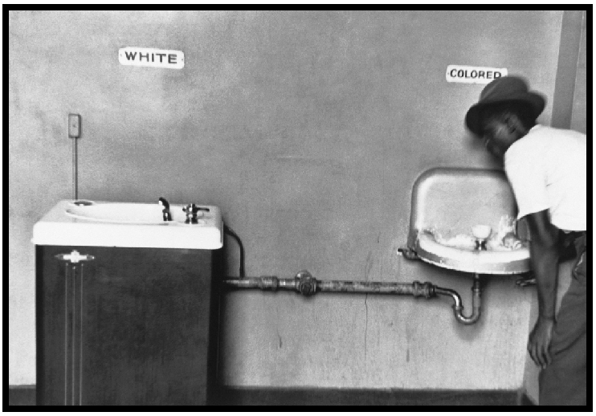

5. What do you notice about the two drinking fountains? Is this fair? What does this have to do with the game we played?
____________________________________________________
____________________________________________________
____________________________________________________
____________________________________________________
____________________________________________________
____________________________________________________
________________________________________________________________________________________________________
____________________________________________________

Long Walk to Freedom Previous Home Next

Students will watch the movie Long Walk to Freedom and record important information from critical scenes (Retrieval – Recalling).

As a class, students will making connection, specifically with role of Mandela/use of symbols, about the long-term impact of colonization (Analysis – Generalizing).

Day 3 – 6
Opening Discussions – see below
Long Walk to Freedom Student Sheet and Visuals (W)  -page 4-7  -141 minutes - 35 minutes a day  It’s important to set up the idea of a flawed hero. Should we have statues of Nelson Mandela? He helped his people but made mistakes in his personal life? Should students learn that he is perfect man? Where is the balance? Discussion question  Talk with students about how the movie is supposed to cover decades, that they should pay attention to Mandela’s hair and face.  When Mandela or one of his friends wanted to get people excited about something, how do they get people excited? Revisit the drawings and the simulation we did from class. Analyze political cartoon and/or protest posters. What did you notice about how the guards are treating Mandela throughout the movie? What did Nelson Mandela and Winnie, his wife, want for South Africa? How did they each go out try and accomplish this?  -Focus on symbols, colors, and flags that are present in the movie. | Resources/Materials/Extension  -Possibly take extra time to enforce that the article from Day 2 is perfect during the movie  -Students can analyze/discuss political cartoons from that area.  When watching the movie as a class, make sure to write 1 through 15 on the board. Move magnet as we progress along.  Scenes to Potentially Skip  3:45 Implied indigenous nudity  9:00 Intense police violence  12:00 intense kissing, implied sex  17:50 – 19:00 intense kissing, implied sex, domestic violence  28:00 – 28:44 intense kissing, implied sex  32:40 – 33:36 shooting by police officers on unarmed protestors  1:12:18 – 1:12:33 Strip search of Winnie Mandela  1:31:32 – 1:32:10 Mob burns collaborator and hits with him machete  1:42:10 Child hit by tear gas canister, dies  1:56:40 – 1:56:51 Violence against white South Africans.  2:02:45 – 2:04:51 violence between blacks including graphics scenes with dead bodies and machetes. Incredibly graphic scene.

Name:
Block: Central Idea of Cartoon

Teacher:

Topic | 2 | 3 | 4
Summary of Source | Demonstrates the ability to identify evidence from a source. | Demonstrates the ability to describe specific evidence and determine the main idea of a source by providing an accurate summary. | Demonstrates the ability to analyze the importance of the source as related to the concepts.

1. Political cartoon artists often use symbols to get their points across. A symbol is a something that stands for something else. For example, the American flag often stands for America. Circle and number any symbols things that you recognize in the cartoon above.

2. Make an inference (a guess based on evidence) as to what point the author is trying to make in this document? What shaped your thinking?

3. What is the lasting impact of what the documents is showing?
Why should we as Americans care about this cartoon? Why are we looking at this cartoon in Global Studies?
____________________________________________________
____________________________________________________
____________________________________________________
____________________________________________________
____________________________________________________
____________________________________________________
____________________________________________________
____________________________________________________
____________________________________________________
____________________________________________________
____________________________________________________
____________________________________________________
____________________________________________________
____________________________________________________
____________________________________________________
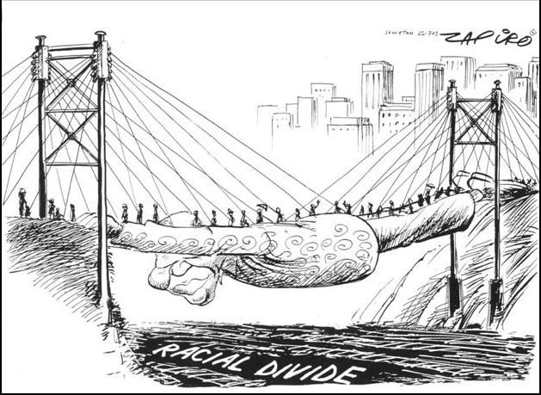

Mandela’s Legacy Previous Home

Students will create a poster that uses symbols and simple phrases to convey the importance of solidarity (unity) when fighting oppression (Comprehension – Symbolizing).

Students will answer who, what, when, where, and why questions about a poem written after Mandela’s death (Retrieval – Executing/Recalling).

In teams, students will determine how Mandela should be remembered by writing a memorial that reflects his good and bad qualities (Knowledge Utilization – Decision Making).

Day 7
Opening Discussion -
Apartheid Visuals (W)  Students will create posters to remember Mandela  And his work to end Apartheid. Write slogans if they are not good artists, sketch then color. Save for February, laminate. Display examples. | Resources/Materials/Extension

Day 8
Opening Discussion -
Apartheid Visuals (W)  The Black Pimpernel Student Reflection Link  -pages 16-19  -read/discuss the first page of the article  After listening to the poem, discuss…  What is repeated throughout the poem?  What does it mean we are all Mandela?  Break down questions... | Resources/Materials/Extension  Videos for the end of class…  Jimmy Kimmel Describes what is happening  https://www.youtube.com/watch?v=X-DxGoIVUWo  SNL makes fun of interpreter, borderline inappropriate, stop when Clinton comes on.  https://www.nbc.com/saturday-night-live/video/obama-mandela-cold-open/n44342

Day 9
Opening Discussion - In teams, students will determine how Mandela should be remembered by writing a memorial that reflects his good and bad qualities. If possible, use copies of this book to have a discussion about whether or not description is accurate. Link Visuals needed if book is used.
Apartheid Visuals (W) | Resources/Materials/Extension  Memorial to Mandela, page 13  Students could price out a Mandela poster, frame, and plaque to put in the school. Write letter/proposal to raise money. GoFundMe?

Memorial to Mandela – Class Copy
Every year, Callanan receives money to make the school a more inviting place to learn. In years past, these resources have bought new computers and cafeteria tables. It is now time that our school/hallways reflect the important people and ideas that we are learning about in our classrooms.

We just spent several weeks learning about Nelson Mandela. A man that is important to South Africa and the world. There are many students and teachers at Callanan who don’t know who Mandela was and what he fought for.

Your team’s goal is to determine how Mandela be remembered by writing a memorial that reflects both his good and bad qualities (Knowledge Utilization – Decision Making). Your team should figure out what the memorial should be and what should be said on it. Your team should figure out how much this memorial would cost, where it should go at Callanan, and write a proposal about why your idea should be selected.

Memorial to Mandela – Class Copy
Every year, Callanan receives money to make the school a more inviting place to learn. In years past, these resources have bought new computers and cafeteria tables. It is now time that our school/hallways reflect the important people and ideas that we are learning about in our classrooms.

We just spent several weeks learning about Nelson Mandela. A man that is important to South Africa and the world. There are many students and teachers at Callanan who don’t know who Mandela was and what he fought for.

Your team’s goal is to determine how Mandela be remembered by writing a memorial that reflects both his good and bad qualities (Knowledge Utilization – Decision Making). Your team should figure out what the memorial should be and what should be said on it. Your team should figure out how much this memorial would cost, where it should go at Callanan, and write a proposal about why your idea should be selected.

Memorial to Mandela – Class Copy
Every year, Callanan receives money to make the school a more inviting place to learn. In years past, these resources have bought new computers and cafeteria tables. It is now time that our school/hallways reflect the important people and ideas that we are learning about in our classrooms.

We just spent several weeks learning about Nelson Mandela. A man that is important to South Africa and the world. There are many students and teachers at Callanan who don’t know who Mandela was and what he fought for.

Your team’s goal is to determine how Mandela be remembered by writing a memorial that reflects both his good and bad qualities (Knowledge Utilization – Decision Making). Your team should figure out what the memorial should be and what should be said on it. Your team should figure out how much this memorial would cost, where it should go at Callanan, and write a proposal about why your idea should be selected.

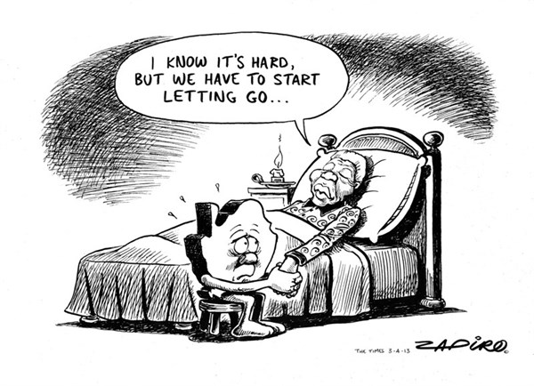
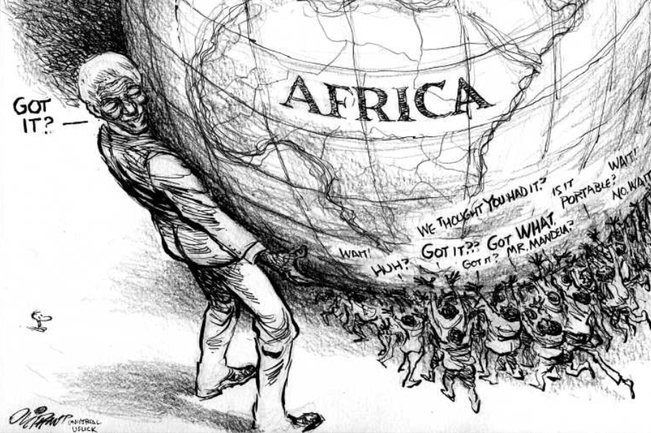
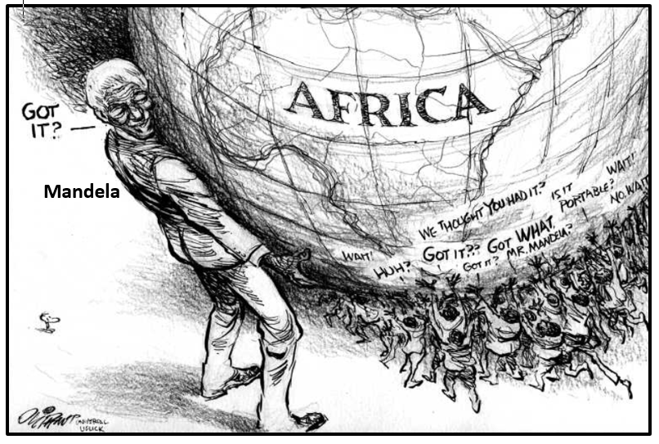
Mandela

The Death of Nelson Mandela Class Copy
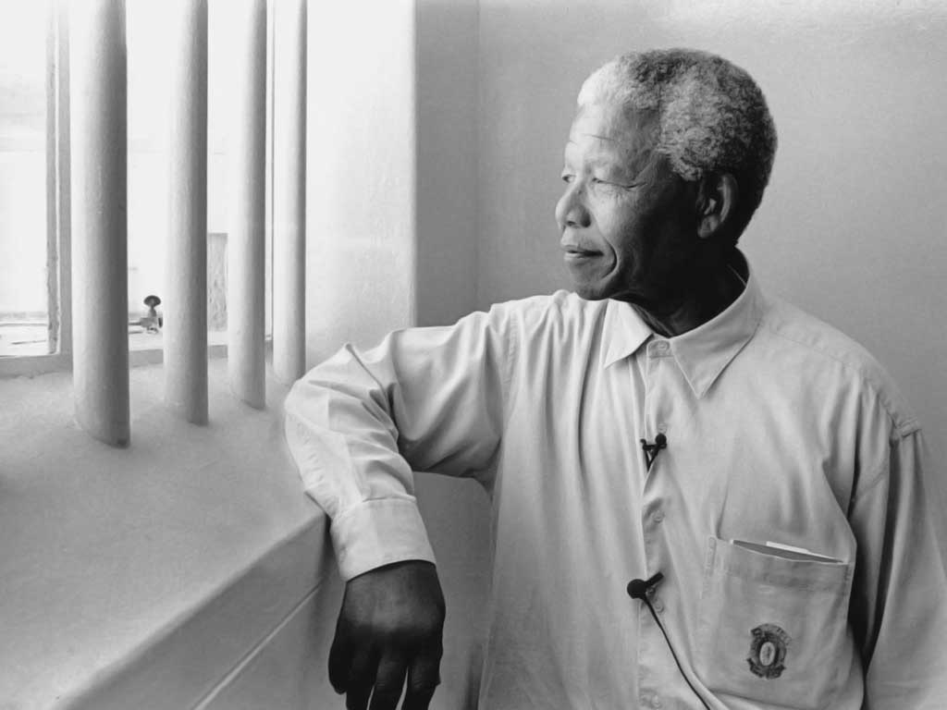
When he was young, Nelson Mandela had a lot of swagger and confidence. He had strong ideas, and sometimes broke the law. By the early 1960s, the white police were trying to arrest him. At this time, he also had a nickname; he was known as the Black Pimpernel.
Mandela’s nickname came from a character in a book called The Scarlet Pimpernel, a book set in France during a time of violence. Like the character in the book, Mandela was a master of hiding. He'd appear suddenly to deliver a great speech, then disappear — as Mandela himself put it, "to the annoyance of the police and to the delight of the people that liked him."
Mandela's criminal years ended eventually. He was imprisoned for many years but went on to become an important politician/leader, loved around the world; he died on Dec. 5, 2013. It was that young, outlaw Mandela, the man charged with trying to destroy the government, that the police were always looking for that is the subject of the poem we are about to hear, called "The Black Pimpernel."
Vilakazi, a South African poet who won last year's Poetry Games on Morning Edition, spoke with NPR's Renee Montagne about her poem. In it, she calls on the next group of South African leaders to "make [their] own meaning" of struggles yet to come.

Poem | Translation/Notes from Mr. Patterson
The Black Pimpernel  This hour upon the horizon is its own song; a dirge  But this is not the hour of yesterday  This is not the time for tears  Nor celebration  We have our work to do.  And we have been shown:  Wind of life blown without roots  Into exile and iron fire grieving  Blood and shackled love  And those other things —  Those that remain undone  We have always been reaching  Before the smoke machines  And statues of bronze, and invention  Before martyr and metaphor  Before the truth, and the lies  Before ambiguous  And surface scraped clean  Of complexity  There were regular swoops on your Orlando home then.  There were the workman's blue overalls and the Mazzawati tea glasses  And there was you —  The Black Pimpernel.  The fearsome shadow of purposeful stride  An AK-47 grip on necessity  A chauffeur's hat and your pocketful of 'tickeys'  You have always had your way.  Black fist of words raised beyond the precipice  You bore the burden:  Hammer, rock and  The lime quarry in your eyes  They say it affected your sight.  'I am not a saint' you said.  A man who seeks the hands of children in the crowd.  The terrorist and the statesman  The paradox comes home here  Where we remain.  Where a daughter will remember how she could not touch you  Behind the glass  Behind your smile  Mortal, man, one amongst many  You led yourself and lead us to the same.  Of what you could not give  We will remember that you did not take.  We will make our own meaning.  This hope, it belongs  It is ours  We claim it.  This is the hour of tomorrow.  And if we have stood on the shoulders of giants,  We are giants still  And giants, we will come again  Because we are all Nelson Mandela  And because the struggle continues.  "The Black Pimpernel" by Mbali Vilakazi. Copyright 2013 by Mbali Vilakazi. | Dirge means a funeral song  Exile means being kicked out of your home  Shackled means trapped  Martyr is someone who dies for a cause  Metaphor is a literary device that Mr. Patterson doesn’t really want to explain right now because it’s rather complicated to fully understand. If you really want to know, you can ask.  Ambiguous means unclear  Tickeys is South African slang for a local candy  Black fist represents power of African people.  Precipice is similar to a cliff edge.  Paradox means that there are two conflicting sides. For example, “I get better at basketball the less I practice.”  Mortal means that person can die.

The Black Pimpernel - Student Reflection
Directions: Answer the below questions in complete sentences. Also, remember to use the underlined part of the question in your response along with text evidence when possible. Write your answers on a separate piece of lined paper.

Part A – Background Knowledge
- Who was the Black Pimpernel and why did he have that nickname? How do you know this?

Part B – Check for Understanding

“The terrorist and the statesman
The paradox comes home here
Where we remain.
Where a daughter will remember how she could not touch you
Behind the glass
Behind your smile”

- Make an inference about the paragraph above, what scene in the movie does the author want us to think about?
- - - - - - - - - - - -- - - - - - - - - - - - - - - - - - - - - - - - - - - - - - - - - - - - - - - - - - - - -- - - - - - - - - - - - - - - - - - - - - - - -

“And if we have stood on the shoulders of giants,
We are giants still
And giants, we will come again

Because we are all Nelson Mandela
And because the struggle continues.”

- Make an inference about the paragraph above, what does the author mean by writing that “we are all Mandela?” What does she want us to do with our lives?

- - - - - - - - - - - -- - - - - - - - - - - - - - - - - - - - - - - - - - - - - - - - - - - - - - - - - - - - -- - - - - - - - - - - - - - - - - - - - - - - -
Part C – Meaning of Poem
- What words do you notice repeated throughout the poem? Why would the author choose to repeat these words? How do repeated words help us to identify the intended meaning of the poem?

Callanan Middle School Student Name:
Permission Form
PG -13Movie

Parents/Guardians,

We are nearing the end of our 7th grade Sub-Saharan Africa Unit. In a couple of weeks we will be watching parts of the film Nelson Mandela: A Long Walk to Freedom, to help further our understanding of the struggle to end Apartheid. The film was given a PG-13 rating, and DMPS policy requires parental permission to be given before students can view a film of this nature. If you do not give permission for your student to watch the film, an alternative assignment will be provided.

____ I do not give my child permission to watch Nelson Mandela: A Long Walk to Freedom.

____ I give my permission for my student to watch the film.

____________________________________________ _______________
Parent Signature Date

Callanan Middle School Student Name:
Permission Form
PG -13Movie

Parents/Guardians,

We are nearing the end of our 7th grade Sub-Saharan Africa Unit. In a couple of weeks we will be watching parts of the film Nelson Mandela: A Long Walk to Freedom, to help further our understanding of the struggle to end Apartheid. The film was given a PG-13 rating, and DMPS policy requires parental permission to be given before students can view a film of this nature. If you do not give permission for your student to watch the film, an alternative assignment will be provided.

____ I do not give my child permission to watch Nelson Mandela: A Long Walk to Freedom.

____ I give my permission for my student to watch the film.

____________________________________________ _______________
Parent Signature Date

