Name:

Block: African Religion Map

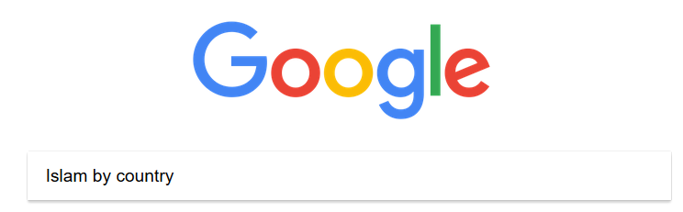
Teacher:

1. Go to Google and search
for Islam by country.

2. Click on this link:
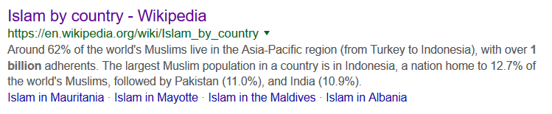
3. Write down the Muslim percentage of total population for each African country.

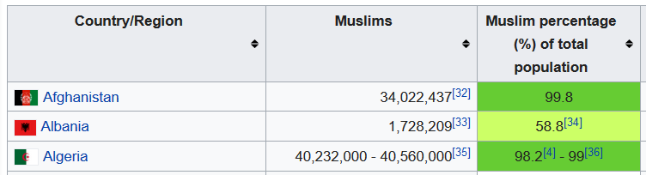

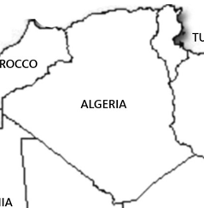
For example:
99%

Block:
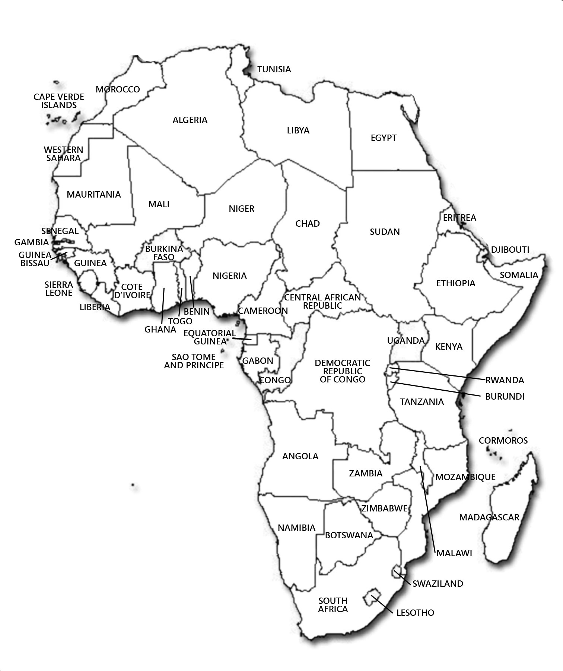
% of Population in African Countries that is Muslim
90%
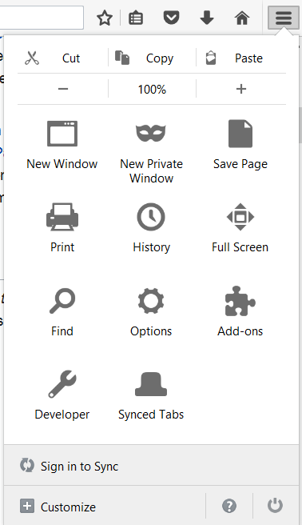
Name: Old Resource

Block:

Teacher:

Directions: Use the link in OneNote to figure out the percentage of people that are Muslim in certain African countries. Make sure to use the find/search button. Use the number in this column.
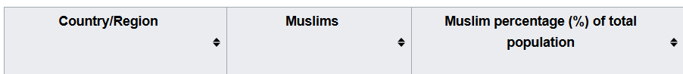

Country | % of Population that is Muslim |  | Country | % of Population that is Muslim
Egypt | 90%
Tunisia

Algeria

Mali

Burkina Faso

Nigeria

Cameroon

Angola

Zambia

Botswanan

South Africa

Display this map, use in discussion

