Name: Block: Teacher:

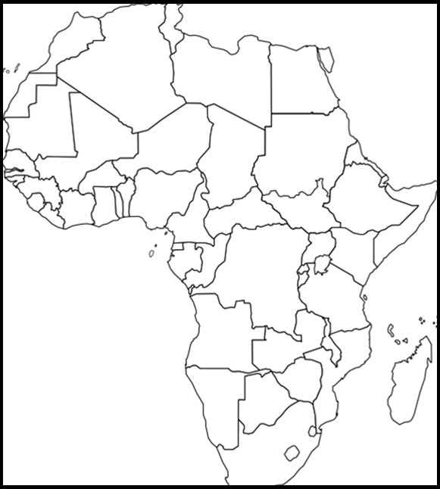
(Title) _______________________________________________

Map Key:

Africa - Political Map

Directions: Include the below details on your Africa political map. To help you label these details you may use a red Africa book using page 228. If the color you are supposed to use is being used by someone else, use a different color.

Make sure your map is presentable. Please do not rush while doing this assignment. Make sure you include a map title and key. Names of countries should be in CAPS. Capitals should be marked with a small star and circle around it .

Color | Label Country & Capital
Red | Somalia
Yellow | Ethiopia
Green | Sudan
Purple | Democratic Republic of Congo
Green | South Africa
Purple | Mali
Purple | Zimbabwe
Red | Madagascar
Purple | 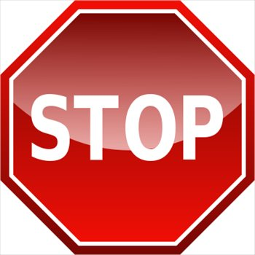  Kenya
Purple | Cameroon

Latitude and Longitude
1. Nouakchott, Mauritania Latitude- Longitude-

2. Antananarivo, Madagascar Latitude- Longitude-

3. Cape Town, South Africa Latitude- Longitude-

4. Luanda, Angola Latitude- Longitude-

5. Khartoum, Sudan Latitude- Longitude-

6. Libreville, Gabon Latitude- Longitude-

7. Addis Ababa, Ethiopia Latitude- Longitude-

8. Mogadishu, Somalia Latitude- Longitude-

