Five Broken Cameras 7 Days Set Aside

Middle East
Patterson

(W) Means on website
Underline what should be said to the class
If there is a blue word click on it while holding down “ctrl”

Standards: SS.7.13. Identify social, political, and economic factors that can influence our thoughts and behavior.
Callanan Specific: Students will identify the (social, political, and economic) issues that result in conflict between Israeli and Palestinian communities.

Students will watch a biased, pro-Palestinian documentary that uses propaganda techniques to manipulate viewers. Students will identify the issues that shape the thoughts and behaviors of stakeholders. Students will analyze the role of media, individuals, and governments over the course of the documentary. Students will hone their personal feelings by debating settlers (other students) about the core issues in the documentary. This lesson cycle also helps students understand how a community’s past shapes the average standard of living.

Context to Five Broken Cameras – Success Criteria
1. Identify the locations and strengths of the different groups in the documentary by examining an article and a radio podcast. When possible, students will use text evidence to add strength to their writing (Retrieval – Recalling).
2. Compare the military strengths of Israel and Palestine to speculate on the relationship between the two groups (Analysis – Matching).
3. Examine your team’s reasoning of who would win in a fight between Israel and Palestine (Analysis – Analyzing Errors).

Day 1
Opening Discussion -
Five Broken Camera Visuals  -pages 2- 4  Disclaimer email (Raphael’s mom)  -page 5  Students will read an article about the main stakeholders in the documentary we will watch. Have the students vote if we read as a group, or individually. Students use text evidence to answer questions, listen to NPR podcast for five minutes, and then compare the military strengths of both sides. | Resources/Materials/Extension  NPR Link  5 Broken Cameras Documentary Link  Discuss how Israel is surrounded by Muslim countries. This mindset is…  Reserve conference room/another classroom for students to debate from.  At the end of the class, discuss readings, draw on EPSON showing where border is, and discuss military differences. If time allows, show the trailer to documentary.
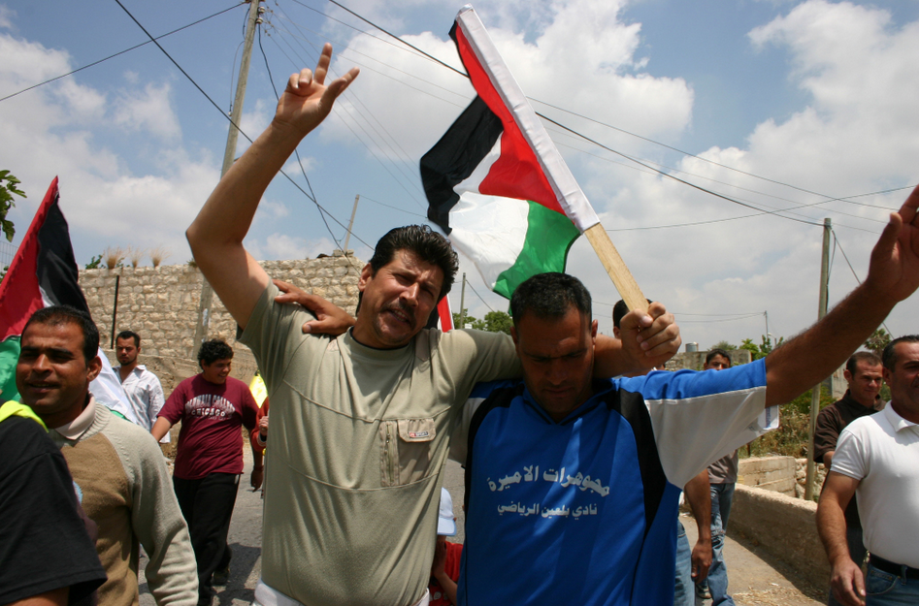
Five Broken Cameras Summary
Patterson
Class Copy

Bil’in is a small Muslim village with approximately 2,000 people located in the country of Palestine. Bil’in’s farmland started being taken away in the 1980s and early 1990s in order to build the Israeli town called Modi’in Illit. As more Israeli citizens began to move to their new town, they realized they wanted to have more land. The Israeli government said that it had to build a wall/security fence to protect its people from attack. However, the wall separated Palestinians from much of their farmland. Palestinians need to get to their farmland so they can grow olive trees.

In response to the building of the wall, Palestinians living in Bil’in created an organization/group to protest the actions of the Israeli/Jewish government! The villagers of Bil’in were joined in their struggle by a small group of Israelis, and people from counties like Brazil and the United States. Bil’in’s resistance to the wall quickly became recognized for its creativity.

For instance, in response to the building of a new Israeli settlement on village land, villagers created their own “settlement” in order to show laws were only being used to support Israelis. They wanted to show that Palestinians were simply not being treated fairly.

Demonstrations often included different themes (think of Callanan’s spirit week). For example, the villagers of Bil’in had a musical protest where people played their instruments. The Israeli military has occasionally responded to these protests with violence, resulting in the deaths of two villagers and many more have been injured.

In an attempt to stop the demonstrations/protests, the Israeli military declared Bil’in a “closed military zone,” in an attempt to keep out people who didn’t live the area. However, outside activists have continued to sneak into the village to help the protests that continue to this day. The Israeli military regularly arrests people who don’t do things that they like.
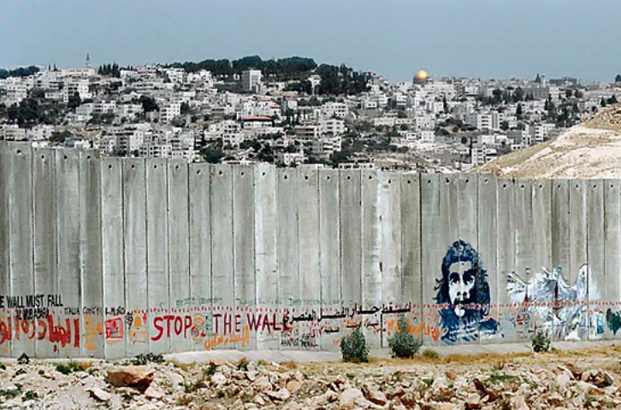
Bil’in has become a major symbol for popular resistance movements in Palestinians. Other villages across Palestine have joined Bil’in in protesting the continued colonization of their land. Eight years after the first demonstration, Bil’in continues to actively engage peaceful protests in the hope that Israel will leave them alone.

Name:
Block: Map of Bi’lin and Modi’in Ilit

Teacher:

2
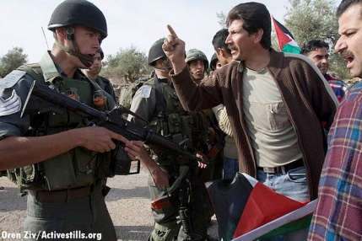
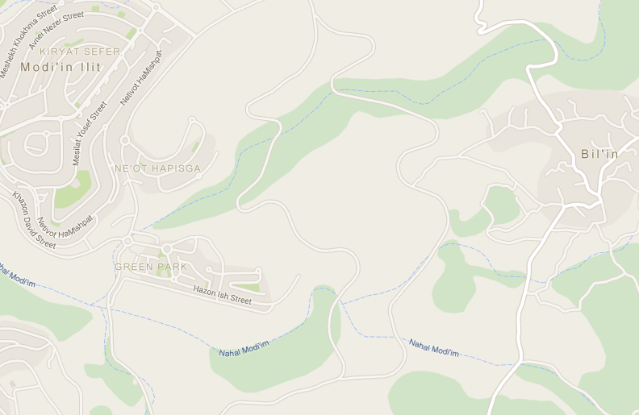
Map Key
Security Fence
Farmland
3
4
5
1

1. | What is Bil’in? Who lives here?
____________________________________________________________________________________________________________________________________________________________

2. | What is Modin Illit? Who lives here?
____________________________________________________________________________________________________________________________________________________________

3. | What is the Security Fence? Who is building it? Why are they building it?
____________________________________________________________________________________________________________________________________________________________

4. | What do people grow on this farmland? What is threatening this?
________________________________________________________________________________________________________________________________________________________________________________________________________________

5. | Who is protesting? Why are they protesting?
________________________________________________________________________________________________________________________________________________________________________________________________________________
Listen
According to the interview, the Palestinians say…
________________________________________________________________________________________________________
According to the interview, the Israelis say…
________________________________________________________________________________________________________

Good morning! I believe that we had a chance to meet at conferences in the fall. My name is Andrew Patterson, I am NAME Global Studies teacher at Callanan Middle School.

Good morning! I hope that your family had a relaxing spring break. It always surprises me when I blink and it is almost over.

I wanted to take the opportunity to touch base concerning the next unit of study in NAME”S Global Studies class. When we left for break, we just finished learning about the similarities and differences between Judaism, Christianity, and Islam. As a class, we traditionally examine the Israeli and Palestinian conflict following our mini religion unit.

In years past, some students have found this topic daunting due to its complexity. Understanding this, I usually have shown excerpts from a documentary called Five Broken Cameras. The documentary follows a Palestinian town protesting a nearby Israeli settlement/wall. Students tend to sympathize with the Palestinians and initially don’t understand how they are being carefully manipulated by editing techniques. After we watch parts of the documentary, we usually have a structured debate where students are encouraged to reflect on their thinking and identify areas where they need to learn more about before considering themselves to be informed on the issue.

Personally, I think that NAME would thrive in this unit. She is a gifted scholar and is one of my classroom leaders. However, I want to be respectful of your wishes as a family. If you don’t feel comfortable with her watching a pro-Palestinian documentary, I completely understand and will discreetly provide her with an alternative assignment.

Please let me know your thoughts.

Andrew Patterson

Five Broken Cameras Documentary – Success Criteria
1. Students will watch Five Broken Cameras and will respond to viewing questions based on their observations (Retrieval – Recalling).
2. In teams, students will identify the social, political, and economic issues that prevent the Israelis and Palestinians from getting along based on their observations (Analysis – Generalizing).

Day 2
Opening Discussion - What languages are we going to hear in the documentary? Discuss how we are going to hear Arabic, English, and Hebrew. Discuss how Judaism and Islam generally have their own languages. Link
(45 minutes of Documentary)  5 Broken Cameras View Guide  -pages 9 - 11  Five Broken Cameras is on Netflix or Amazon. Need to watch about 45 mins a day to finish in three days. | Resources/Materials/Extension  21:00 Camera is shot, someone yells F word  1:02 funeral procession shows dead boy  1:14 Killing of a goat, GRAPHIC  1:16 Phil gets shot in the chest, GRAPHIC  1:18 Phil is buried, dead body in coffin visible  1:29 Narrator gets staples in his chest removed

Day 3
Opening Discussion - How is the Palestinian SOL compared to Americas? What did you see that shaped your opinion? Or Cycle of Violence question from visuals
(45 minutes of Documentary)  5 Broken Cameras View Guide  -page 9 - 11 | Resources/Materials/Extension  Political Settlement Cartoon  - Age 7

Day 4
Opening Discussion - Question about going to Israeli hospital instead of Palestinian one, see visuals
Have a discussion about political, economic, and social issues. Identify the issues and what’s preventing both sides from resolving it.  45 minutes of Documentary)  5 Broken Cameras View Guide  -page 9 - 11 | Resources/Materials/Extension  Access to Netflix  Different POV of Banksy artwork, page  - Page 8
*Identify about 6-7 gifted students in each class for them to be undercover Israelis during the documentary. During enrichment/study hall, explain that to them that after the documentary is finished, the class is going to be have an online debate where they think they are debating Israeli settlers (they are going to be debating the small group in a different room.) Show them and talk through proper etiquette when responding to other students via OneNote. Including the expectation of using evidence and talk about having a respectful tone. See page

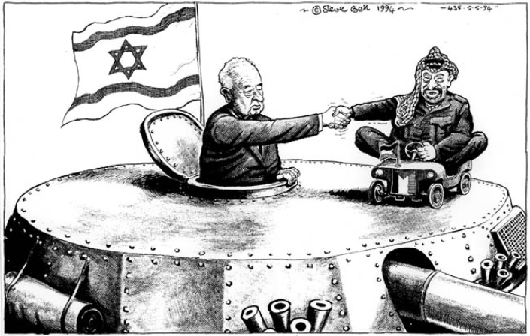
Name:

Block: Security Fence - Perspective
Teacher:

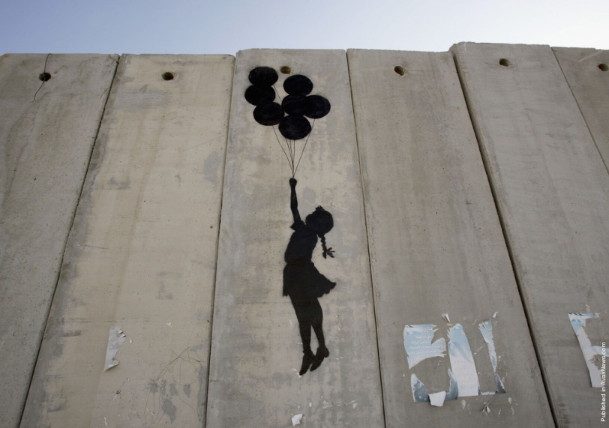

As a Palestinian, I think the fence…  ________________________  ________________________  ________________________  ________________________  ________________________  ________________________  ________________________  ________________________  ________________________  ________________________  ________________________  ________________________  ________________________  ________________________ | As an Israeli, I think the fence…  _________________________  _________________________  _________________________  _________________________  _________________________  _________________________  _________________________  _________________________  _________________________  _________________________  _________________________  _________________________  _________________________  _________________________

Name:

Block: Five Broken Cameras - Documentary

Teacher:

1. Why is this documentary called Five Broken Cameras?
______________________________________________
2. What did the narrator (person talking) used to do with his father?
______________________________________________
3. What are the bulldozers doing after the Israeli surveyors (engineers) come?
______________________________________________
4. How many sons does the narrator of the film have?
______________________________________________
5. What is Mod ‘in IL Lit?
______________________________________________
6. What is the barrier/fence supposed to do?
______________________________________________
7. When the woman is hanging laundry, what can be heard in the background?
______________________________________________
8. How many swords does the man try and juggle?
______________________________________________
9. When you see the first protest, there is a sign that says “Hands off our…”
______________________________________________
10. What separates the village from their olives?
______________________________________________
11. What do the protesters carry in their hands?
______________________________________________
12. What is the name of the man who hugs the tree?
______________________________________________
13. What does a solider do when he drives up to the Palestinian kids?
______________________________________________
14. How long did the narrator’s brother stay in jail?
______________________________________________
15. What does “Jeesh” mean?
______________________________________________
16. What countries have joined the Bi’lin villagers in the Middle East?
______________________________________________
17. Why do you think they have signs in English if the people holding them speak Arabic?
______________________________________________
18. What are the villagers picking?
______________________________________________
19. Where is the narrator’s wife from?
______________________________________________
20. What happens if the Israelis put a trailer down?
______________________________________________
21. What do the Palestinians decide to do with their yellow trailer?
______________________________________________
22. What is the difference between the first trailer and the second trailer?
______________________________________________
23. According to their own laws, what can the Israeli army not destroy?
______________________________________________
24. What do the Israelis do to the villagers in response to them constructing a concrete building?
______________________________________________
25. What hits Yisreal?
______________________________________________
26. What is Daba trying to do?
______________________________________________
27. Why do you think the Israelis want the narrator to stop filming?
______________________________________________
28. What does the narrator’s wife tell Gibreel to do when there is tear gas?
______________________________________________
29. What happens to the soldiers when they drive their jeeps in to Bi’lin?
______________________________________________
30. Why do the Israeli soldiers come at night to Bi’lin?
______________________________________________
31. What do the children chant as their slogan?
______________________________________________
32. What happens when the kids start throwing rocks?
______________________________________________
33. What is a closed military zone?
______________________________________________
34. Why did the Israeli military arrest the narrator/person talking?
______________________________________________

35. What saves the narrator’s life?
______________________________________________
36. What does the narrator do to help boost morale/make people feel better?
______________________________________________
37. Where is someone shot dead?
______________________________________________
38. What happens to Naba? Is it an accident?
______________________________________________
39. What makes it hard to stick with nonviolent protests?
______________________________________________
40. Do the men and women dance together?
______________________________________________
41. What does the boy in the “Fox” sweatshirt kick?
______________________________________________
42. How is the fourth camera destroyed?
______________________________________________
43. Where is the narrator taken to when he gets hurt?
______________________________________________
44. How long is the narrator unconscious for? ______________________________________________
45. What does the narrator no longer do? What does he have to worry about now?
______________________________________________
46. How long have people from Bi’lin been protesting?
______________________________________________
47. What do the people do in memory of their friend that died? ______________________________________________
48. What does the boy ask his dad when they are fixing his car?
______________________________________________
49. Why does he want this to happen?
______________________________________________
50. What does the narrator receive in the mail from the Israeli government?
______________________________________________
51. How long has Adeeb been in jail?
______________________________________________
52. What happens after five years of protest?
______________________________________________
53. What does Gibreel want to go see?

Responding to Settlers – Success Criteria
1. Students will identify the social, political, and economic issues that prevent the Israelis and Palestinians from getting along (Analysis – Generalizing)
2. Students will gather evidence that explains the disparity between the two sides (Retrieval – Executing).
3. Students will use evidence to respond to radical Israeli settlers in an attempt to change their opinions (Analysis – Analyzing Errors).

Day 5
Opening Discussion - – Display picture of separation wall, get students to think about how both sides view the wall or question about Gabreel wanting to kill soldiers.
OneNote Discussion, See OneNote  -page 15  -Display SOL of Israel and Palestine from Visuals, talk about, this is why.  -Read article with them.  Create visuals of where to post, have them write out their response in Microsoft online. Have students create a page in OneNote’s collaboration section. Have students type out response. Make sure to label blocks in title and have today’s meet set up and displayed in the back room.  Use collaboration page in OneNote as an area for students to debate. Have pages set up/figure out how to export. Train/show students to respond. Reserve conference room, library or Ryan’s office. | Resources/Materials/Extension  -computers  Possibly have students include visuals to add strength to their writing  Have students talk about the bad things that happen in the documentary. As a class, find timestamps.  Role of media, government, individuals in documentary. What problems are best solved by each group?

Day 6
Opening Discussion -
Students should respond to Israelis in a back and forth.  While they are waiting for a response, work on Middle East Political Map (W) Or Culture Collage, or YouTube video | Resources/Materials/Extension  -computers

Class Copy – Doc. A

Jewish settlers threaten Palestinians Olives

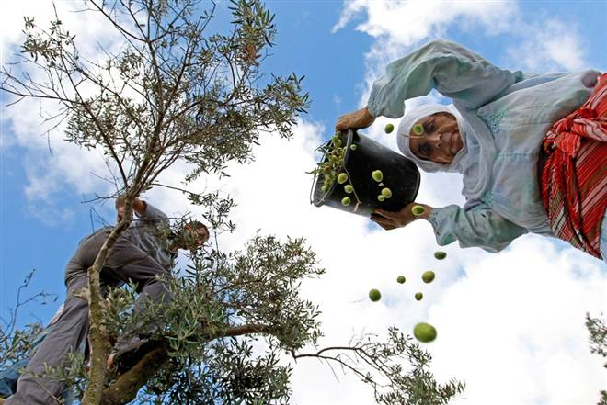
SALEH, West Bank — Every fall, hundreds of thousands of Palestinian famers/people go to the fields to pick olives. Children take time off school and adults take time off from work to get up at sunrise and walk through the olive trees.

Not only is the olive tree an important symbol of the Palestinian people and culture, olive oil is important to how they earn enough money to eat and take care of their families. Olive trees alone help around 80,000 families. However, this important tradition and source of income is under threat.

"There have been cases of arson (people intentionally burning) and tree uprooting (tearing down trees) by the Israeli settlers," said Hamdan, who has farmed land in the village of Saleh, in Palestine. "Usually Israeli settlers stop us from getting to the trees, just this morning they scared off farmers with their acts of violence."

According to a report issued by the Palestinian government, an estimated 800,000 olive trees have been cut down since 1967; resulting in a loss of around $55 million to the Palestinian communities! For a country that has a low standard of living, this is extremely hurtful.

Most countries consider the settlements (colonization) Israel has built in land captured in a 1967 Middle East war to be illegal under international law. Israeli Prime Minister (president) Benjamin Netanyahu, a longtime supporter of the settlers, has agreed that a limited stop on construction should take place but has refused to follow through on his promise.

According to our research, around 40 percent of the West Bank is effectively off limits to Palestinians because Israeli walls/settlements prevent them from accessing certain areas.

Israeli settlements, police stations, and military bases and 73 barrier gates in the West Bank prevent Palestinians olive farmers from reaching their trees, the report said. The limited access and constant threats have made regular orchard and tree farming impossible for many local people who just want to feed their families.

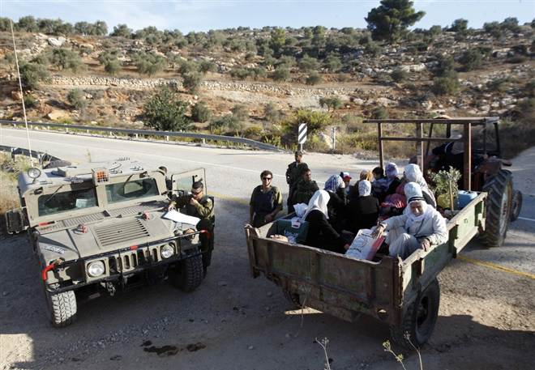
When presented with evidence that Israeli settlers (citizens) and military had attacked Palestinian farmers, the Israeli Army told NBC News that they were “going to look in to the situation while also protecting their people from acts of violence.”

The drama surrounding the yearly harvest/collection has attracted people from around the world that want to help the Palestinians.
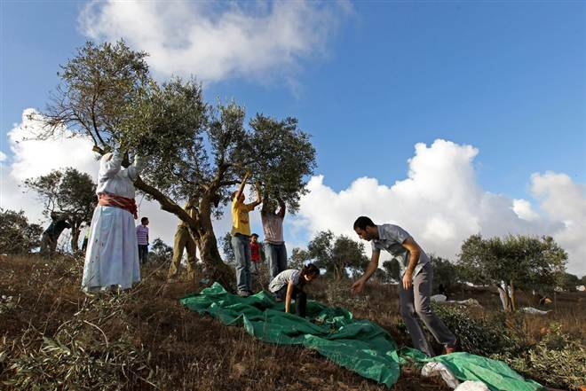
"I collect olives as a way to stand up to the Israeli government taking over the Palestinian land,” said Maria Baff, a 26-year-old from Germany who has helped with five harvests/collections over the years. "I want to help farmers in achieving their rights to collect olives and to protect them from the violence. I also want to help stop people from burning/destroying trees.

Baff said she has seen no improvements in the argument between farmers and the Israeli settlers over the years. This must change! We will get our way. “Separate we are weak, together we are strong!”

Why do Palestinians care about the olive harvest?

Alternate Instructions in Visuals
Mr. Patterson has purposely shown the class a biased Palestinian documentary. The other students in the class think that they are going to be arguing/debating the Israelis settlers that have been depicted as antagonists in the film. In reality, they are going to be debating you. You are going to have one day to prepare and another day to secretly debate your classmates. Please don’t tell them that this is the plan! It will take away some of the fun! The students that will be helping you in the debate are listed below. Students whose names are in bold, Mr. Patterson has explained things to in person.

Block 2- Jonah, Eli, Judith, Audrey, Esra,
Block 3- Mya M., Ivan K., Jake L., Norah N., Vivienne C., Blythe K., Mike H.
Block 4- Julian, Abatte, Najmo, Delaney, Calvin, Gerald, Ian
Block 5- Alanna, Ellie, Addie, Lilly, Xavier, Lill K, Selena G

Instead of going to Mr. Patterson’s class, you should just go straight to Mr. Daugherty’s office for the next two days. There will be papers and computers waiting for you. Make sure you keep an eye on the time, so you know when to pick up. At points, Mr. Daugherty may have you work in the conference room, his office, or the library.

Instructions for Day 1
Students in class are going to respond to the question and quote below. It is going to be your job to counter whatever argument they come up with. In your response, you should explain why the Israelis have to build a security fence, how it is effective, and how the Five Broken Cameras is a biased, Palestinian documentary that you can’t believe people are taking seriously. By the end of class on Day 1, you should have your main debate points completed along with pictures to copy and paste to add strength to your argument. Using YouTube, you can find specific scenes from the documentary that prove your points.

"I don't understand why Palestinians are pretending to care so much about their olive trees. Honestly, I think they are just throwing a tantrum because they can no longer attack us with suicide bombers. Why don't they use that energy to improve their standard of living instead of having "peaceful protests?"

Instructions for Day 2
Get to OneNote
Collaboration Section/Debate
On Day 2, students will start to post in the collaboration section. Wait until their title includes the word Done before responding to the post. After you respond to the post, change Done to Read Me. This will let the student know that you have responded to them. It is important for you to work together as a group. Make sure you come up with a plan on who is responding to who. We don’t need five people responding to one person’s post. Highlight your response in a different color so it stands out. Make sure to copy and paste pictures and to prove your point. It may be helpful to ask student

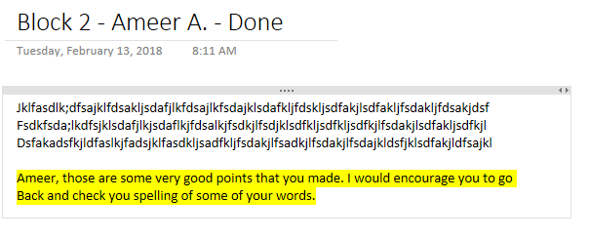
Mr. Patterson has chosen you because he respects your intellectual prowess but also because he trusts you. Please make sure that you don’t betray this trust. If you have questions, ask Mr. Daugherty or call up to Mr. Patterson’s room at 4291. Please don’t tell people outside of the group that you are the ones debating them.

Faulty Logic
Error | Description | Example
Contradiction | Presenting conflicting information. | I am vegetarian, but I always eat meat if it is offered to me at a party.
Accident | Basing an argument on an exception to a rule. | Smoking doesn’t have anything to do with cancer. My grandma is 90, and she smokes a pack a day.
False Cause | Confusing an order of events with causality or oversimplifying the reasons behind some event of occurrence. | A basketball player has a lucky pair of socks that he always wears, believing that the socks contribute to his good free-throw percentage.
Begging the Question | Making a claim and then arguing for the claim by using statements that are the equivalent of the original claim. | Everybody now smoking causes cancer. The smoke from cigarettes is a carcinogen.
Evading the Issue | Changing the topic to avoid addressing the issue. | Mom asks Sally how she did on her algebra test, and Sally immediately change the subject to the cute boy that sits behind her in algebra.
Arguing the Ignorance | Arguing that a claim is justified simply because its opposite has not been proven. | A person argues that UFOs do not exist because there’s no proof that they do.
Composition | Asserting something about a whole that is true of only its parts. | A person asserts that all police officers use excessive force because one officer has used excessive force.
Division | Asserting about all of the parts something that is generally, but not always, true of the whole. | A person asserts that a particular news reporter is liberal because all reporters are liberal.

Errors of Attack
Error | Description | Example
Poisoning the Well | Being so committed to a position that opposing positions are ignored. | I don’t really care what the research says about the importance of vaccinating children. I know for a fact that vaccinations are dangerous.
Arguing Against the Person | Rejecting a claim using derogatory facts about the person making the claim. | I have a difficult time believing anything she says about global warming. Did you know that she flunked out of college?
Appealing to force | Using threats to establish the validity of a claim. | I could have you fired. The board president is a close friend.

Errors of Weak Reference
Error | Description | Example
Source that Reflect Bias | Accepting information that supports whatever we already believe to be true or rejecting information that goes against what we believe to be true. | I only rad the National Enquirer because their reporters always give you the straight scoop on what’s happening in the world.
Sources that Lack Credibility | Using a source that is not reputable for a given topic. | Well, I trust the salesperson at the health food store. She is an expert on how to lower high blood pressure.
Appealing to Authority | Invoking authority as the last word on an issue. | I know you don’t agree with the school policy, but the board of education is the last word on this issue.
Appealing to People | Using authors, texts, or speakers showing the popularity of a decision so support a claim. | I feel quite sure about this curriculum decision. Many of the best and biggest districts are using it.
Appealing to Emotion | Using a sad story as proof for a claim. | I heard about a woman whose daughter died because her new health policy refused to honor the prescriptions she needed to live.

Errors of Misinformation
Error | Description | Example
Confusing the Facts | Using information that appears factual but has been changed to the extent that is no longer accurate. | Telling a news story with key details missing from the description.
Misapplying a Concept or Generalization | Wrongly applying a concept or generalization to support a claim. | Believing that individuals who lose a civil case should go to jail.

Name: Extra Assignment

Block: Summary of a Source – Doc. B

Teacher:

Topic | 2 | 3 | 4
Summary of Source | Demonstrates the ability to use evidence to identify the main idea. | Demonstrates the ability to describe specific evidence and determine the main idea(s) of a source by providing an accurate summary. | In addition to the level 3, the response demonstrates the ability to analyze the historical significance of the source as related to the concept(s).

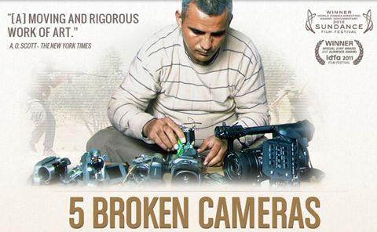
5 Broken Cameras tells the story of a Palestinian town called Bil’in. This town decided to protest the building of an Israeli security border and settlements on their land, through the use of nonviolence. Many people find the documentary interesting because it presents a side of Palestinians that isn’t normally in the news. Most news channels seem to ignore the Palestinians and their problems, until there is violence. One of the goals of 5 Broken Cameras is to provide a voice for those who aren’t normally heard.

It is important to understand what happened in Bi’lin has happened ever since the creation of Israel in 1948. Most people know of Palestinian efforts to stop Israel with guns, the equally important history of nonviolent resistance is largely untold. Nonviolent resistance is the practice of achieving goals through symbolic protests, civil disobedience, or other methods, without using violence.

Nonviolent resistance can mean several things. At times it conforms to a traditional American view of what nonviolent protest looks like—protest marches, hunger strikes, work stoppages, tax revolts, protest villages, economic activism, etc. At other times this resistance is less obvious and perhaps harder for Americans to understand. This is the daily resistance of workers who have to sneak around Israeli army units to find work, of families who build homes without permits knowing that they risk having their house destroyed, of villagers who remain on their land despite being denied access to water, electricity, health and education services, and other basic needs. This is the resistance of average people who refuse to accept and cooperate with unfair policies and laws.

While news channels only want to highlight acts of violence, the truth is that Palestinian resistance to the Israeli’s has been overwhelmingly nonviolent. Not only has Palestinian nonviolence been largely ignored, but has also had their leaders thrown in prison, killed, or kicked out of their country. Nevertheless, nonviolent resistance continues. When one group sees its attempts to stop the Israeli occupation stopped, there is always another group ready to try again.

Part 1 - Read the entire article, then underline/highlight the text that answers the following questions.
1. What is 5 Broken Cameras about?
2. What is nonviolent resitance?
3. How do Palestinians use nonviolence resistance againt the Israelis?
____________________________________________________________________________________

Part 2 – Directions: Using the article and what you highlighted, fill in the boxes below. There is no need to write in complete sentences. When possible, use text evidence from the article.

What is the article about?

Who is the article about?

Where is this taking place?

Why is this happening?

When is this happening?

How is it happening?

_____________________________________________________________________________________
Part 3 – Directions: On a lined piece of paper, explain what the central idea of the article was. Make sure that you have a proper heading, indentation, text evidence, and at least five sentences. Make sure that you use text evidence once. Mr. Patterson suggests that you create an outline before you write.
When you finish writing your response, staple it to the back of this paper.

